Monday
Writing task:
We need to get the treasure off of Captain Patch!

Task:
Create a plan to steal the treasure!

What to include in your plan?
Time conjunctions (first, next, second, then, after, last, finally).
Adjectives to describe in detail how you would take the treasure.

Remember:
full stops, capital letters, adjectives and similes!

Daisy challenge: to join up your handwriting.

Reading / phonics task:

Task

Read your favorite book. Draw a new front cover for your book and write a short blurb about the book.

Daisy challenge: to include a review statement on the back of the book.
Example: Mrs Mantle from Poverest Primary said “this book made me laugh from start to finish”

Maths task:
We are going to continue looking at making change by taking away

Task:
You can use either 10p, 20p or 30p as the total you are paying with. Gather 10, 20 or 30 objects to help you find the correct change for the given prices. You can record this however you want to (photos, drawing, number sentences)

If you have picked 10p you are finding change when spending these amounts:

4p 9p 2p 6p 5p 7p

If you have picked 20p you are finding change when spending these amounts:

10p 13p 1p 5p 14p 12p

If you have picked 30p you are finding change when spending these amounts:

26p 19p 20p 13p 5p 21p

Daisy challenge: Make your own price tags to work out the change from your amount

Science:
We are going to find out about the animal group reptiles today.

Task
Watch the clip https://www.bbc.co.uk/bitesize/topics/z6882hv/articles/zp9pfg8

With your new knowledge make your own reptile.
What would it do?
What would it look like?
What does it eat?
Where would it live?

Pe:
We are going to be working on our times tables with Supermovers! Pick the times table you feel you need more practice on or go through each one and practice them all!

2 times table:
https://www.bbc.co.uk/teach/supermovers/ks1-maths-the-2-times-table-with-bridget-the-lioness/zrrx92p

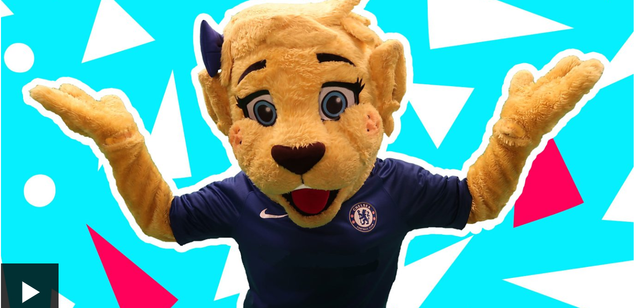

5 times table:
https://www.bbc.co.uk/teach/supermovers/ks1-maths-the-5-times-table/zhbm47h
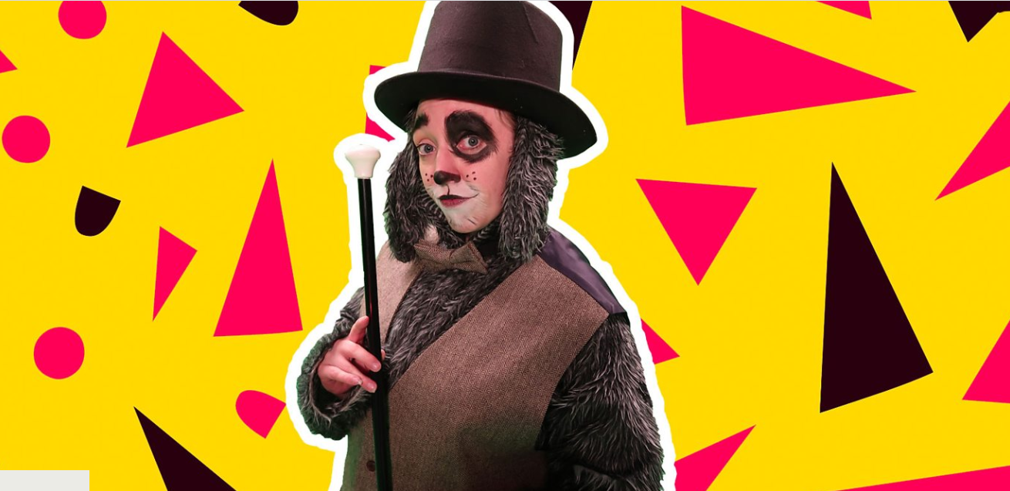

10 times table:

https://www.bbc.co.uk/teach/supermovers/ks1-maths-the-10-times-table-with-webster-the-spider/zm32cqt

