Tuesday
Writing task:

Listen to the next part of the story
This week we are going to create our own pirate poem using words that rhyme!

Rhyming words are words that have the same ending sounds
e.g. fluff stuff
However the sounds don’t have to be written the same way
E.g. snail whale

Use this video to help you rhyme https://www.youtube.com/watch?v=UfrXW2q1M38

Can you write a list of words that rhyme with each of these pirate words?
Map
Gold
Ship
Parrot
Treasure

Daisy challenge: Can you think of your own pirate word and words that rhyme with it?

Reading task:
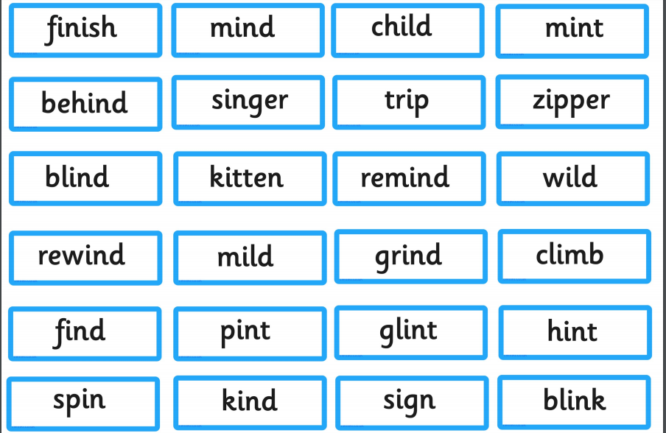
This week on spelling shed there is a list of words which all have the long i sound. We know that i makes an ‘i’ sound in most words like ‘fish’ but sometimes an i on it’s own makes an ‘igh’ sound like ‘kind’.

Task:
Read through these words and sort them into the long ‘igh’ sound and short ‘i’ sound? Try and use some of these words in your writing!

Daisy challenge: Can you spot the long i in any books you have read?

Maths task:
Task:
To find the change from an amount.
When finding correct change, we can either draw out the amount paid and then cross out the amount spent (like we did on our whiteboards at school when subtracting)

5p - 3p = 2p change

Or - you can find the difference - count up from the money you have spent to the amount you have paid with

1p spent
1
2
3
4
5p - 1p = 4p change

Can you work out the change you’d get from the prices below if you pay with a 10p coin?
Now you are going to use 15p to pay for all your items

Daisy challenge: Pick a price to start with between 5-19.
Now choose the price of your item by selecting a smaller number card than your starting price. Now find the change. Write the number sentence if you can!
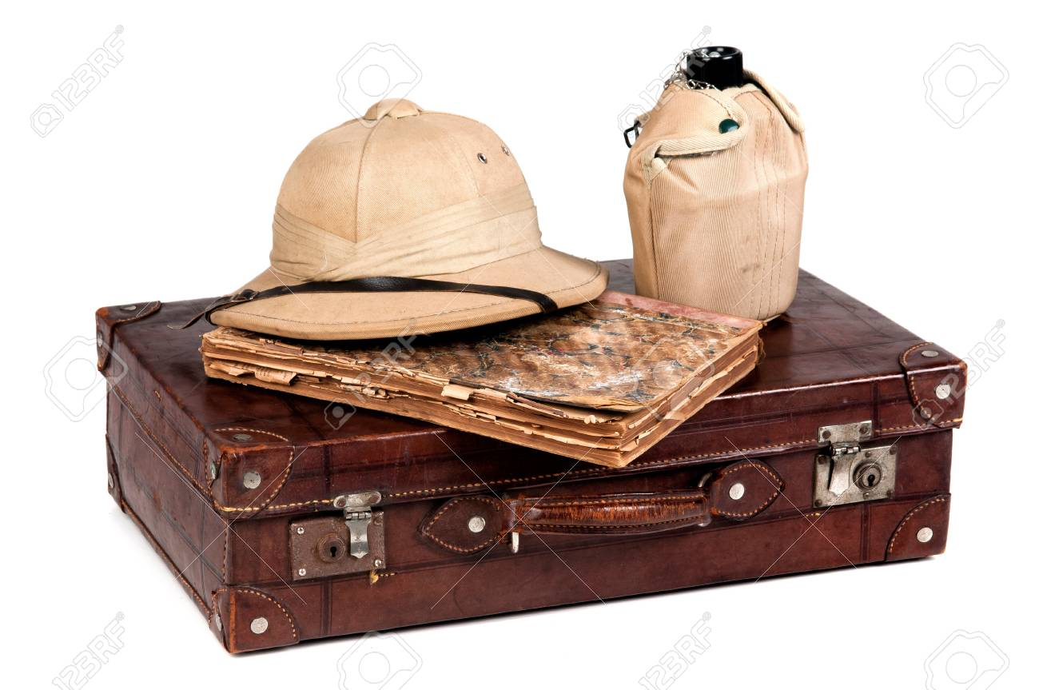
Geography:
Our topic this term is all about explorers! We’ve researched and built our own landmarks. Now we are going to prepare for an expedition to them.

Task:
Draw and label all the objects you will need to pack to visit the country your landmark is in!

These questions will help you decide what you should pack:

How will you find your way around?
What is the climate of the country? (arid, temperate or polar?)
Do you need to climb anywhere to find your landmark?
Is there food and water near your landmark?

Daisy challenge: Write sentences saying why you have decided to take those items with you on your expedition. Also find out:
What continent is your landmark in?
Which ocean is near your landmark?

