Music
Music is taught by BYMT weekly.
In Year 4 the children will be learning to play the ukulele. In addition to this there will also be singing assemblies, composing and listening sessions.

Computing
We will be using our Chromebooks for our computing lessons, where we will learn how to create and design websites. We will also be learning about HTML.

Science
We will learn about materials, including the states of matter, e.g. solids, liquids and gasses, and different processes such as freezing, melting, evaporation etc. We will also be learning about energy, sound and vibration.

Spanish
This term we will learn the names of pets and some adjectives to describe them, as well as some phrases and sentences we can use when visiting a cafe.

RE

This term we will be learning about sacred texts from different religions and what makes them holy. We will also be discussing why our beliefs are important, and what they mean to us.

Year 4 Spring Term
PE is every Monday, Wednesday and Thursday. Please bring in reading books every day. Homework is due on Thursdays and new homework will be given every Friday.

English
Our Core texts for this term are The Iron Man, Cinnamon, Until I Met Dudley, Odd and the Frost Giants and Jabberwocky.
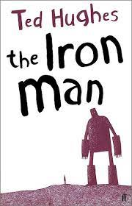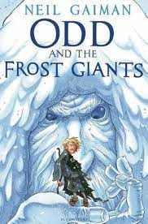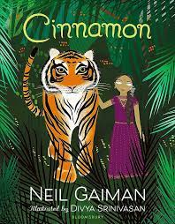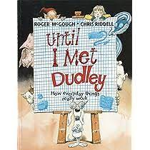

PE
This term we will be doing lacrosse and gymnastics.

PSHE
Our PSHE topics are Citizenship, and Safety and the Changing Body. We will talk about why diversity in the community is important, as well as how our bodies change as we grow older. In Year 4 we are also learning mindfulness through a course called Paws B.

Geography
In Geography, we will be learning about where our food comes from, including the impact that our food has on the environment, how chocolate is made and fair trade.

History
Our History topic is titled “How hard was it to invade and settle in Britain?” We will learn about the Anglo-Saxons, the Scots and the role of King Alfred.

Art/DT
In Art, we are going to be exploring tints and shades using paint, and using different painting techniques to create 3D effects. In Design and Technology we will be making slingshot cars using a range of materials.

Maths
This term, we will learn about Multiplication, Division, Length and Perimeter, Fractions and Decimals.

