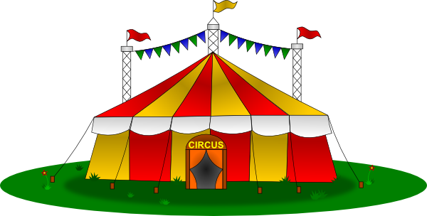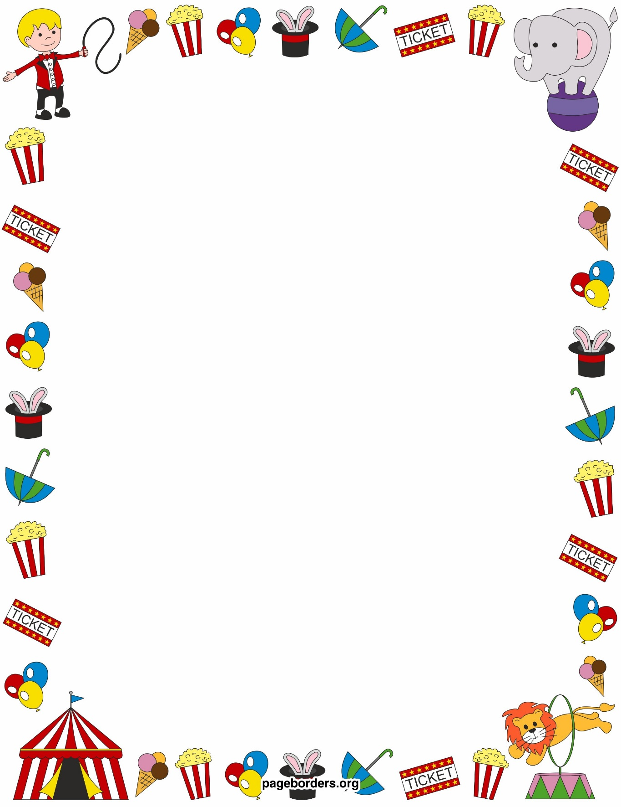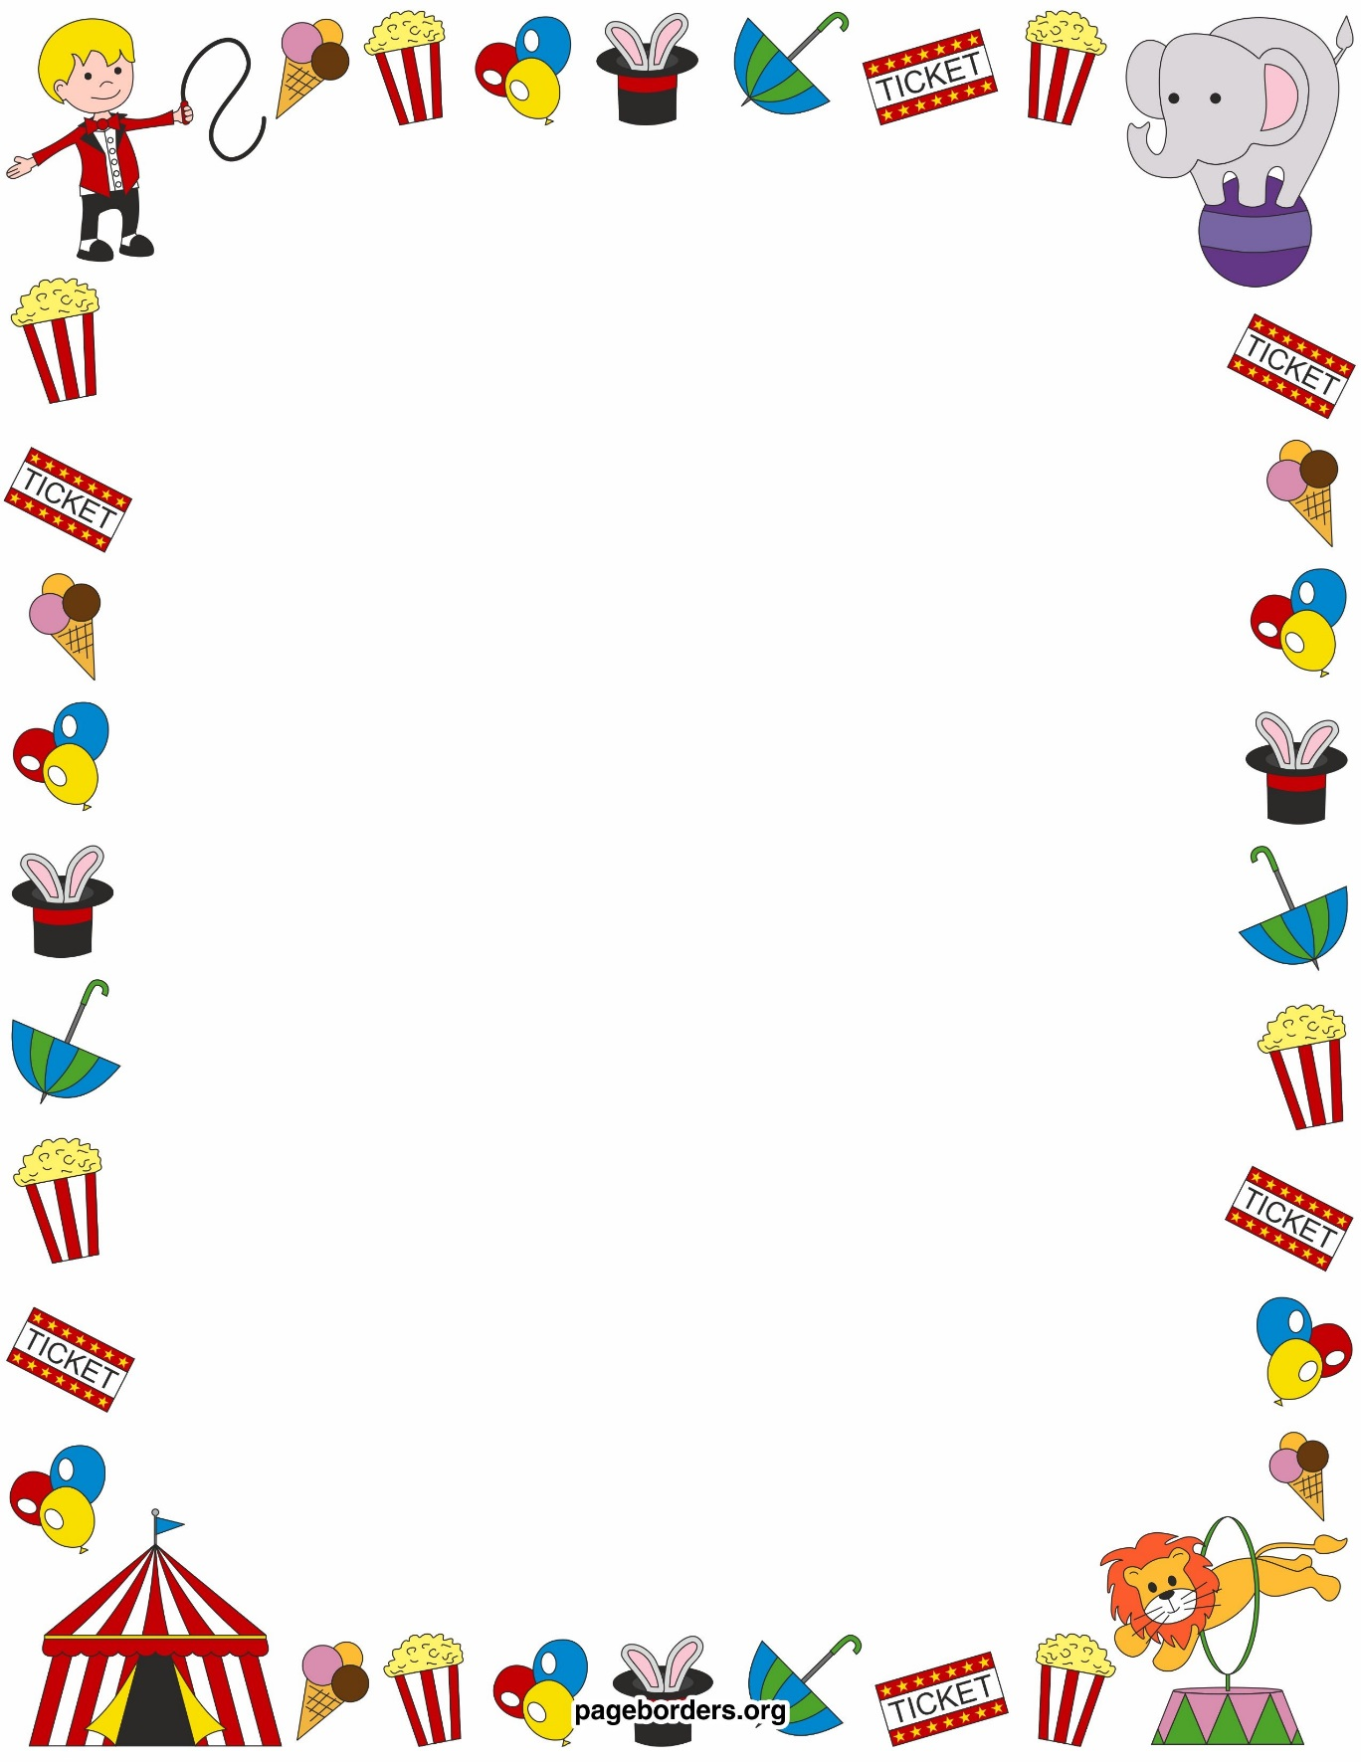

Art

We are going to design and create a clown mask. We will also research art based on the circus.

.

PE

We will be covering a whole range of PE skills, from dance, to ball skills and team games, through our circus topic.

Please ensure your child has a white t-shirt, black shorts and trainers/plimsolls. We have PE on a Tuesday and Wednesday.

.

Science

In science, we will be continuing our plants topic, before moving our focus back to materials.

.

RE & PSHE

In RE, we will focus on ‘Why are some things special?’ and Christianity.

Computing

In computing, we will continue to apply our computing skills to all areas of the curriculum.

Topic

History of the circus

Clowns

Circus acts

Circus animals

English

We will be using lots of different texts to support our writing about the Circus and will write poetry, letters, stories, information booklets and newspaper reports.

Supporting at Home

Please read every day, support your child with their home learning and use maths in everyday life.

Maths

In maths we will focus on:

Statistics

Multiplication and division

Fraction

Measurement

Problem solving and investigations

and much more!

Circus Topic

Summer Term