Monday 8th June
Spellings for the Week – On Spelling Shed
(Linked to our new book)
- confusion
- protrusion
- adoration
- sensation
- tension
- comprehension
- electrician
- injection
- realisation
- creation
Reading Activity
This is our 2nd week of Reading Bingo! It has been wonderful to see so many of you taking part. This is your chance to cross off some more squares.
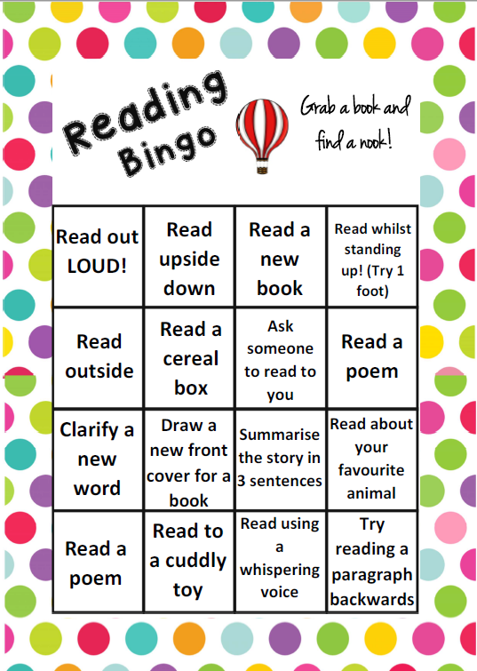

Writing Activity
Please watch/read the end of Matilda to find out what happened to her!
It happened that a few Weeks later
Her Aunt was off to the Theatre
To see that Interesting Play
The Second Mrs. Tanqueray.
She had refused to take her Niece
To hear this Entertaining Piece:
A Deprivation Just and Wise
To Punish her for Telling Lies.
That Night a Fire did break out--
You should have heard Matilda Shout!
You should have heard her Scream and Bawl,
And throw the window up and call
To People passing in the Street--
(The rapidly increasing Heat
Encouraging her to obtain
Their confidence) -- but all in vain!
For every time she shouted 'Fire!'
They only answered 'Little Liar!'
And therefore when her Aunt returned,
Matilda, and the House, were Burned.
This week, we are going to write our own Cautionary Tale. We will write a class one, which you can use and magpie our ideas, or you can write your own.
Hilaire Belloc’s tales include the following features:
- Rhyming couplets
- Each line usually has 8 syllables
- The title is the name of that boy or girl, who…
- Something tragic happens
- The reader is taught a lesson, eg – not to tell lies.

As a class, we are going to write a Cautionary Tale about Pete. It will be called, Pete, who ate too many sweets. If you’d like to write about Pete (& his sweet eating habit) then you can follow along.
However, you might like to think of your own tale. You might write about a girl who doesn’t brush her hair, a boy who doesn’t tidy his toys or a girl who doesn’t do her homework. We are more than happy for you to follow along with Pete if you want to.
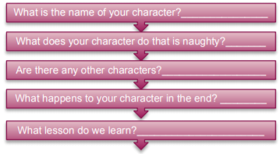
Use this planning frame for your tale. You can fill in the gaps for Pete or use it for your own tale.

Once you have filled in the planning frame, write the title for your tale.
(Name of child), who….
Try to rhyme the name of the child with what they do which is naughty.
Eg – Pete sweet
Blaire hair
Moy toys

Maths Activity
Start by watching this BBC video as an introduction to symmetry.
https://www.bbc.co.uk/teach/class-clips-video/maths-ks2-finding-lines-of-symmetry/zktfgwx
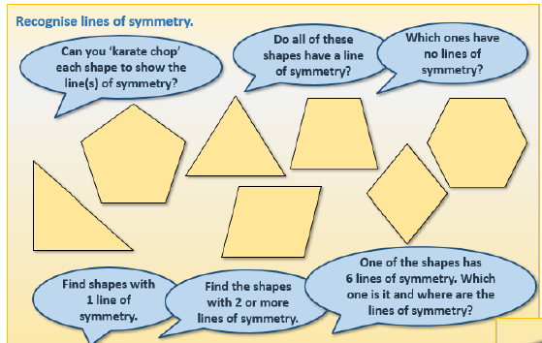

Go on a shape hunt around your house for objects which have a line of symmetry. Write a list of the objects and how many lines of symmetry you can find!
Object | Shape | How many lines of symmetry?
Eg - Bed | Rectangle | 2

Afternoon Activities
We are continuing our Crime and Punishment learning. Last week, you researched and sketched historic criminals. One of them was Dick Turpin, this Horrible Histories video is funny & great to watch.
https://www.youtube.com/watch?v=WYU-vSh7ORA
Today, we are going to be learning about Anglo Saxon court.
Anglo-Saxon England was a very well-run kingdom. The King was the ruler but throughout the 9th and 10th centuries, the government was developed to collect taxes and maintain law and order.
This included grisly methods of deciding guilt or innocence such as trials by fire and water, but also the development of fairer trials by jury in court.
In the 10th century, a promise was taken by all freemen from the age of 12 to promise they would not commit crimes and to report those that did.
If you broke the promise:
- you would be regarded as disloyal and a disgrace
- your family would be held responsible and could be punished
- you and your family could be forced to leave
- relatives of the victim could claim compensation (money) for injury or death
The Anglo-Saxons didn't have prisons. People found guilty of crimes were either executed or punished with fines.
If they ran away, they became 'outlaws' (outside the law), and anyone could hunt them down - unless they hid in a church. The fine for breaking into someone's home was five shillings (25p), paid to the home-owner. For minor crimes like stealing, a nose or a hand might be cut off.
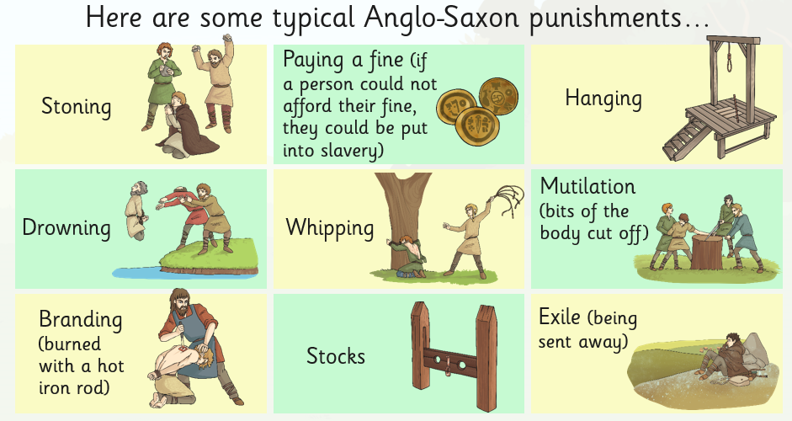

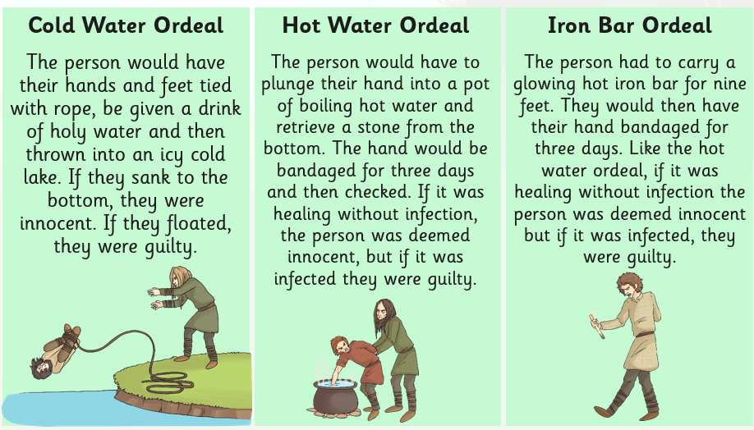
Court was developed as you could not always tell if someone had committed a crime. Court would decide whether they were innocent or guilty. However, Anglo Saxon court was very different to our modern courts. People who went to court, had to go through an ‘ordeal’.

There are two activities for you to complete below. You can choose one or complete both, it is up to you.
Activity One – Fair or Foul?
Read the crimes along with the punishments given. Decide whether you think the punishment is fair (right) or foul (wrong).
- Baldwine steals a pig from the market. Punishment: one of his hands are cut off. Fair or foul?

- Elfgar kills his neighbour, Wigmund, when they get into a fight. Punishment: Elfgar has to pay Wigmund’s family 100 shillings. Fair or foul?

- Mildburg is accused of doing magic and being a witch. Punishment: Mildburg is hung by the neck until he dies. Fair or foul?

- Alwin, a slave, tried to run away from his master. Punishment: he is whipped and his little finger is cut off. Fair or foul?

Activity Two – Missing Body Parts
As we discussed previously, if you injured someone then you would have to pay them money. Here is how much you would have to pay, depending on what you injured. This is called Wergild.
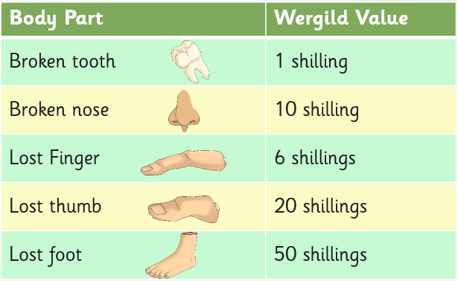

Calculate how much Wergild each person would receive.
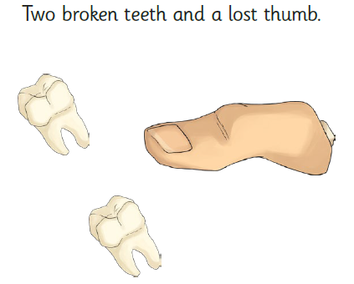
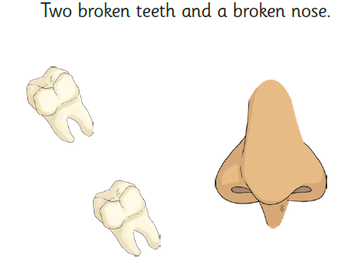

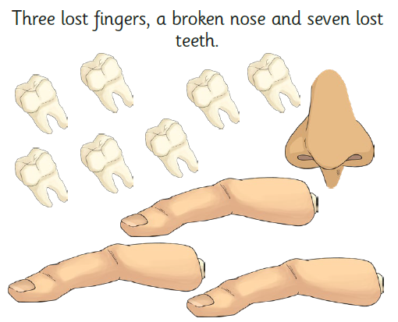
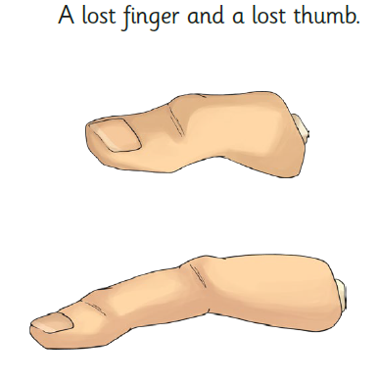

Joke for the day

What do you give a pig with a rash?

Oink-ment!
Thank you for the joke Ronnie!

