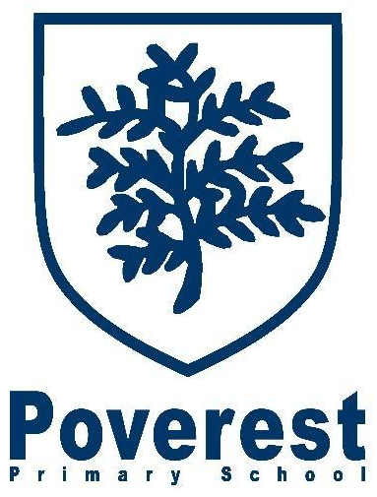

Curriculum 2019/2020
At Poverest we make the curriculum exciting and relevant, inspiring children by making use of our close proximity to a major European city. We create cross curricular links wherever possible to develop learning across all subject areas. All year groups follow our curriculum. Our curriculum has and will continue to evolve but keeps the 2014 Primary Curriculum at the core. Our curriculum uses topics, ideas and adapted plans form the Hamilton Trust and includes visits and other enrichment opportunities.
Children at our school enjoy a range of trips and visits, as well as exciting themed/experience days supporting their learning journey.

Please see below for some Highlights of our Curriculum in Previous Years
Reception: Visit to the Natural History Museum, Toasting Marshmallows, Easter Bonnets, Fire engines, Cinderella Ball.
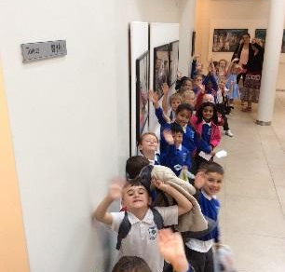 | 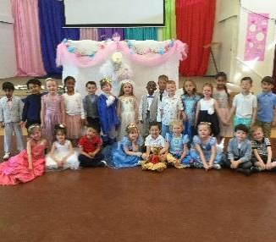 | 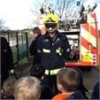 | 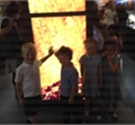 | 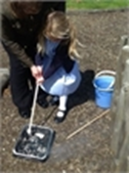 | 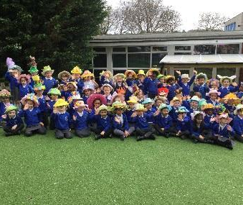
Year One: Pizza Express, Florence Nightingale Museum, London Transport Museum, learning in the school grounds, Toy Museum
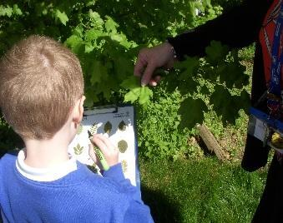 | 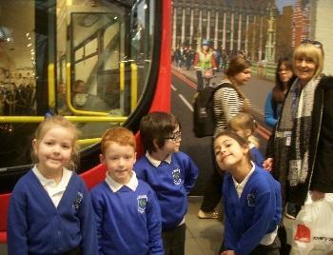 | 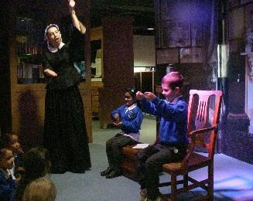 | 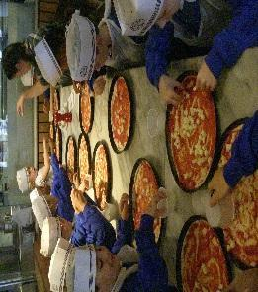 | 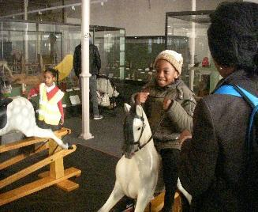
Year Two: Outdoor learning, Sports day, Making bread, Fire of London Exhibition at the Museum of Learning, Learning Circus skills, Aladdin Dance Workshop, Having an Animal Encounter, Trip to Drusillas Zoo, Overnight stay at Downe Scout Activity Centre
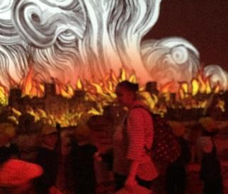 | 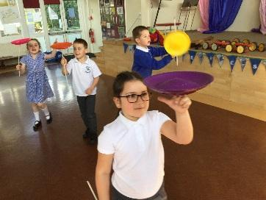 | 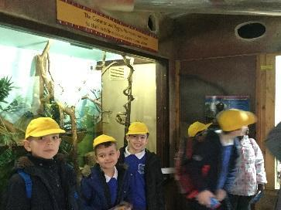 | 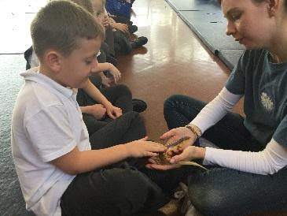 | 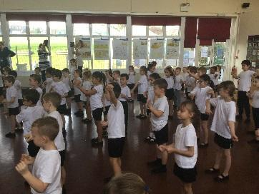 | 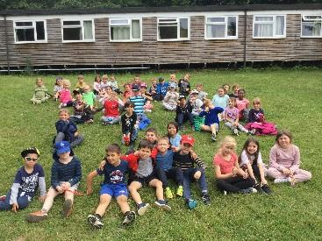

 | Year Three: Dancing through the decades, making Pizza at Pizza Express, Trip to visit Tesco, drawing Anglo Saxon artefacts, Art
 | 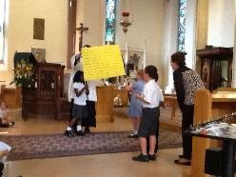 | 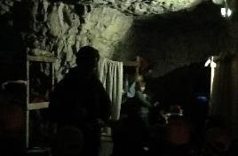 |  | 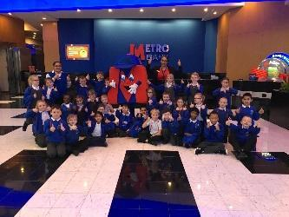 |  | 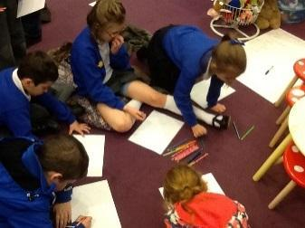 |  | 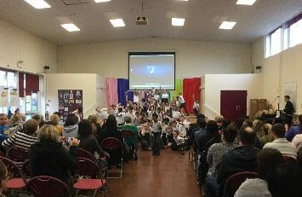 |  | 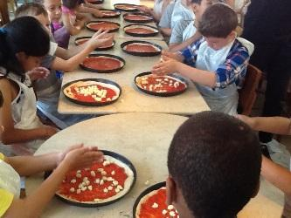
 | Year Four: Pirate day, brass rubbing and puppetry at Bromley schools church festival, Overnight stay on the Golden HInde, Making an Iron Man, Science and Multi-cultural weeks
 | 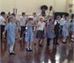 | 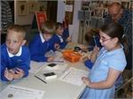 |  | 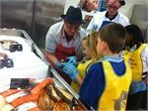 |  | 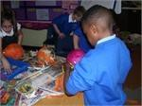 |  | 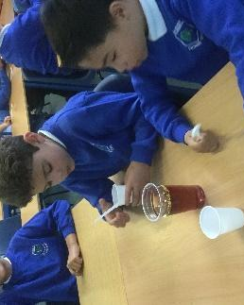 |  | 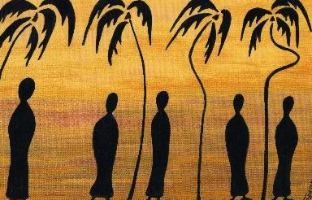
 | Year Five: Maths week – handshakes, health week, Horton Kirby River Study, Floodlands drama, Science Museum,
 | 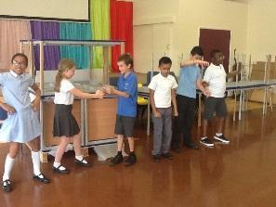 | 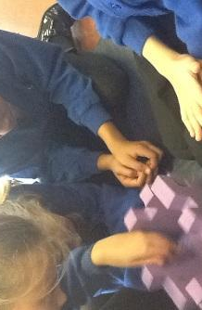 |  | 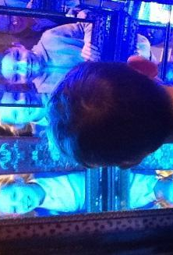 |  |  | 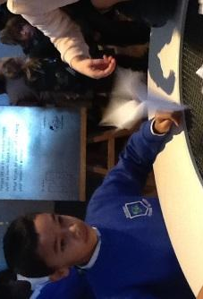 | 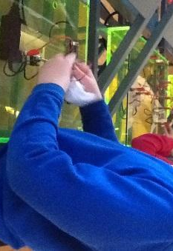 |  | 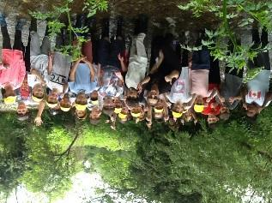
 | Year Six: Sayers Croft, The Globe, Junior Dragons / Young Enterprise, Lego animation, Junior Citizens, Bikeability, Madam Tussauds, Natural History and Science Museums
 | 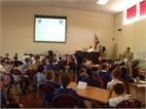 | 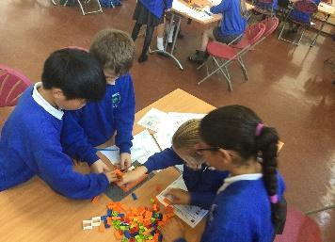 |  | 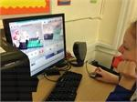 |  |  | 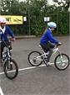 | 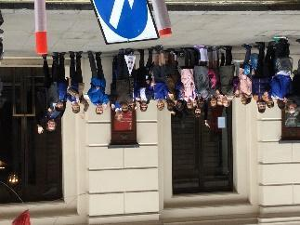 |  | 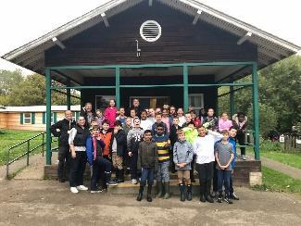
YEAR GROUPS |  |  | AUTUMN TERM |  | SPRING TERM |  |  |  | SUMMER TERM
RECEPTION  Enrichment Opportunities:  Autumn –  Visit a pantomime, father Christmas visits, Diwali and Hannakuh visitors.  Spring -  Weekly visits from a variety of people who help us. Bug man comes to visit. Coolings garden centre visit  Summer –  Cinderella ball, journey to a place of interest. |  |  | All about me  Learning about my family, drawing self-portraits, reading and using stories in our topics that are connected to ourselves. Learning counting songs, understanding our numbers. Developing social skills, making new friends, learning everyone’s name, adjusting to new routines in school life.  Let’s celebrate  We begin with Diwali, after that we celebrate all the different festivals that happen throughout this half term, for example Thanksgiving and Hanukkah. We will use role play to reenact SIkh and Christian weddings. We will be preparing for our Christmas assembly. |  | People who help us  Find out about the jobs people do. Where people work, what they wear to work, stories, songs, role play. Have a different job as a focus each week to find out about in depth and link all of the learning around.  Growing  Grow some runner beans, look at things that grow around us, listen to stories about plants and vegetables, write instructions about how to plant seeds, nurture caterpillars, hatch some butterflies and set them free. Visit from Coolings to plant seeds |  |  |  | Homes and fairy tales  We begin our journey by looking at homes from around the world, then we start with the three little pigs. We build igloos and mud huts. We write our own gingerbread man story. Create our own party invitations for our Cinderella ball.  Journeys  We visit a different country each week, learning about their culture, learn some words from their language, taste their cuisine.
YEAR 1  Enrichment opportunities:  Autumn –  Florence Nightingale  Pizza Express  Spring -  Aquarium  Local Area Walk  Summer -  National Maritime  Godstone Farm  Forest schools, outdoor education |  |  | Famous for more than 5 minutes (Block F)  Changes with Living Memory (Block E)  History –  - Learn about the lives of significant individuals in the past who have contributed to national and international achievements.  - Understand about changes in living memory.  - Understand historical concepts such as continuity and change and chronology.  - Begin to understand the chronology of change and the changes within and just beyond living memory.  - Identify similarities and differences between ways of life in different eras.  Geography –  - Use world maps, atlases and globes to identify the countries, continents and oceans studied at this key stage. (Jamaica)  Art –  - Experiment with art materials used in schools in the past.  - Create a portrait of a grandparent or great-grandparent based on an old photograph.  - Explore collage techniques and abstract art to create a collage using images of domestic technology past and present.  D&T-  - design purposeful, functional, appealing products for themselves and other users based on design criteria  - select from and use a wide range of materials and components, including and ingredients. (Fruit kebabs)  SMSC –  RE – Why are we thankful |  | Oceans and Seas (Block A and E)  Our School and Local Area (Blocks A,F,G)  History –  - Understand historical concepts such as continuity and change, cause and consequence, similarity, difference and significance, and use them to make connections.  - Learn about the lives of significant individuals in the past who have contributed to national and international achievements.  Geography –  - Interpret a range of sources of geographical information, including maps, globes and aerial photographs.  - Name and locate the world’s 7 continents and 5 oceans.  - Use basic geographical vocabulary to refer to key physical features, including ‘sea’, ‘ocean’ and ‘weather’.  - Use world maps, atlases and globes to identify the United Kingdom and its countries, as well as the countries, continents and oceans studied at this key stage.  - Use simple fieldwork and observational skills to study the geography of their school & its grounds + the key human & physical features of its surrounding environment.  - Use simple compass directions (North, South, East and West) and locational and directional language (near and far; left and right) to describe the location of features and routes on a map. Use aerial photographs and plan perspectives to recognize landmarks and basic human and physical features; devise a simple map; use and construct basic symbols in a key.  - Use basic geographical vocabulary to refer to key physical features, including: beach, cliff, coast, forest, hill, mountain, sea, ocean, river, soil, valley, vegetation and key human features including: city, town, village, factory, farm, house, office, port, harbor.  - Use world maps, atlases and globes to identify the countries, continents and oceans studied at this key stage.  - Understand geographical similarities and differences through studying the human and physical geography of a small area of the United Kingdom, and of a small area in a contrasting non -European country.  Art –  - Use a range of materials creatively to design and make products.  - Use drawing and painting to develop and share their ideas, experiences and imagination.  - Learn about the work of a range of artists, craft makers and designers, describing the differences and similarities between different practices and disciplines, and making links to their own work.  - Develop a wide range of art and design techniques in using colour, pattern, texture, line, shape, form and space.  D&T-  - Design purposeful, functional, appealing products for themselves and other users based on design criteria.  - Select from and use a range of tools and equipment to perform practical tasks [for example, cutting, shaping, joining and finishing].  - Evaluate their ideas and products against design criteria.  SMSC –  - How to cross the road safely, bicycles and the road.  RE –  - Christianity / Judaism |  |  |  | Famous for more than 5 minutes (Block B)  We are Britain - Seasides (Block C)  History –  - Learn about the lives of significant individuals in the past who have contributed to national and international achievements.  - Compare aspects of life, identifying similarities and differences between different periods.  - Pupils should be taught about changes within living memory; Where appropriate, these should be used to reveal aspects of change in national life.  Geography –  - Use simple fieldwork and observational skills to study the geography of their school and its grounds.  - Name and locate the world’s seven continents and five oceans.  - Use aerial photographs and plan perspectives to recognise landmarks and basic human and physical features.  - Name, locate and identify characteristics of the four countries and capital cities of the United Kingdom and its surrounding seas.  - Use basic geographical vocabulary to refer to key physical features and key human features.  - Use world maps, atlases and globes to identify the United Kingdom and its countries.  Art –  - Use a range of materials creatively to design and make products.  D&T-  - Select from and use a range of tools and equipment to perform practical tasks.  SMSC –  - how to stay safe, what is a pilgrimage, how to greet people in different languages, holidays in space  RE –  - Judaism / Hinduism
YEAR 2  Enrichment Opportunities:  Autumn  Museum of London  Spring  Drusillas Zoo  Summer  Circus Skills Activity Morning  Downe overnight stay |  |  | The Great Fire of London  History –  - Be taught about events beyond living memory that are significant nationally.  - Know where the people and events fit within a chronological framework and identify similarities and differences between ways of life in different periods.  - Ask and answer questions, choosing and using parts of stories and other sources to show that they know and understand key features of events.  - Understand some of the ways in which we find out about the past and identify different ways in which it is represented.  - Know that the songs: London´s Burning and Ring- a-ring-a-roses are based on historical events.  - Find out about the Great Fire of London and St Paul’s Cathedral.  - Compare fire fighting today and the 17th Century.  - Learn about fire fighting during the Great Fire of London.  - Recognise how the fire started.  - Understand what happened as a result of the fire.  - Understand that the ways we communicate today is different to the 17th Century.  - To understand historical concepts such as continuity and change.  - To identify similarities and differences between ways of life in different periods.  - To be taught about events beyond living memory that are significant nationally.  - To consider and use knowledge and facts gained about the Great Fire of London.  Geography – None  Art –  - Use drawing and imagination to develop their ideas about St Paul´s Cathedral.  - Use tone, pattern, line, and shape in charcoal pictures.  - Examine paintings and sculptures and use them to develop their ideas about St Paul´s Cathedral.  - Use shape and form when making clay models.  - Use potato printing to make a piece of abstract art.  - Learn about abstract art.  - Compare their own work to Paul Klee´s work  - Use drawing and imagination to develop their ideas of 17th Century London.  - Use tone, pattern, line and shape in pictures.  DT –  - Design purposeful, functional, appealing products for themselves.  - Generate, develop, model and communicate their ideas through talking, drawing, templates, mock- ups + ICT.  - Select from and use a range of tools and equipment to perform practical tasks.  - Select from and use a range of materials, including textiles according to their characteristics.  - Build structures, exploring how they can be made stronger, stiffer and more stable.  - Communicate their ideas in a group.  - Develop ideas through talking and mock-ups.  - Make a junk model Cathedral.  - To use the basic principles of a healthy and varied diet to prepare dishes.  - To understand where food comes from.  - To select from and use a range of equipment to perform practical tasks.  - Design purposeful, functional, appealing products.  - Create Great Fire of London souvenirs.  SMSC –  - Finding out about and comparing different festivals from around the world.  RE –  - Hinduism / Festivals of Light |  | Rainforests  Geography –  - To locate vegetation belts around the world.  - To identify the position and significance of latitude, longitude, Equator.  - To use maps, atlases, globes and digital/computer mapping to locate countries and describe features studied.  - Locate the world’s countries concentrating on their environmental regions, key physical characteristics.  - Understand types of settlement and land use, economic activity including trade links, and the distribution of natural resources including food.  - Understand geographical similarities and differences through the study of human geography of a region of the UK and a region of South America.  History – None  Art –  - Develop art techniques, including use of materials, with creativity, experimentation and an increasing awareness of different kinds of art.  - To improve their mastery of art and design techniques, including drawing, painting and sculpture with a range of materials.  - Produce creative work, exploring their ideas and recording their experiences.  DT –  - To generate, develop, model and communicate their ideas through discussion, annotated sketches and pattern pieces.  - To select from and use a wider range of tools and equipment to perform practical tasks.  - Use search technologies for locating information relevant to suggested themes.  - Design purposeful, functional, appealing products for themselves and other users based on design criteria.  - Select from and use a range of tools and equipment to perform practical tasks.  - Evaluate their ideas and products against design criteria.  - To use research and develop design criteria to functional products that are fit for purpose, aimed at particular individuals or groups.  - To apply their understanding of how to strengthen, stiffen and reinforce more complex structures.  - To use design techniques, consider the aesthetic appearance of an object.  - Select from and use materials, including construction materials and textiles, according to their functional properties and aesthetic qualities.  - Develop design criteria to functional products that are fit for purpose.  SMSC –  - How different countries and organisations are helping save rainforests.  RE –  - Christianity / Judaism |  |  |  | Circus  History – What circuses were like in the past, about some people who made circuses famous, how circuses have changed over the years.  Geography – How to draw maps and plans of a circus, |Using maps to find out about the countries some circus animals come from.  Art – How to draw faces and understand expressions. The work of artists who have painted pictures about the circus.  SMSC – How to stay safe in busy places, what it’s like to be a circus artist, what different people think about using animals for a circus.  PE – juggling balls, balance and movements used in a circus.  RE – Why are some things special / Christianity
YEAR 3  Enrichment Opportunities:  Autumn  The Roman Crofton Villa  The Museum of London/British Museum  Film fest (November)  Spring  Canal and river trust  River Cray  National Gallery  Summer  Warburtons  High Elms or Scadbury tour |  |  | The Romans in Britain  History –  - Develop a chronologically secure knowledge and understanding of world history, establishing clear narratives within the periods they study.  - Understand how our knowledge of the past is constructed from a range of sources.  - Devise historically valid questions about change, cause, similarity and difference and significance.  - Develop a chronologically secure knowledge and understanding of British history (what Britain was like before the Romans came).  - Begin to learn about Iron Age culture.  - Know about the Roman Empire and its impact on Britain (Roman entertainment).  - Select and organise relevant historical information.  - Note connections, contrasts and trends over time and develop the appropriate use of historical terms.  - Ask and address historically valid questions about change, cause, similarity and difference and significance.  - Understand Roman art and the power of the Roman army.  - Construct informed responses that come from the selection of relevant historical information.  - Begin to understand the legacy left by the Romans on Britain and its impact on our subsequent history.  Geography –  - Locate countries, using maps to focus on Europe.  - Understand key aspects of human geography (including types of settlement and land use).  - Develop use of geographical knowledge, understanding and skills to enhance locational and place knowledge.  - Name and locate counties and cities of the UK.  - Describe and understand key aspects of human geography including types of settlement and land use.  Art –  - Develop techniques, including control and use of materials.  - Understand the historical and cultural development of their art form. Including mosaics.  - Understand the historical and cultural development of art forms (3D portraiture).  - Understand how art and design reflect history.  - Evaluate and analyse their work and the work of others.  - Explore their ideas to improve their mastery of art and design techniques with clay and record their observations in sketch books to revisit.  DT –  - Research and develop design criteria to inform the design of innovative, functional, appealing products that are fit for purpose, aimed at particular individuals and groups.  - Generate, develop, model and communicate their ideas through discussion, annotated sketches, cross-sectional and exploded diagrams, prototypes, pattern pieces and computer-aided design.  - Understand and use mechanisms (e.g. wheels and axles) in their product.  - Select from and use a wider range of materials and components, including construction materials, textiles and ingredients, according to their functional properties and aesthetic qualities.  - Select from and use a wider range of tools and equipment to perform practical tasks accurately.  - Evaluate their ideas and products against their own design criteria and consider the views of others to improve their work.  - Understand how key events and individuals in design and technology have helped shape the world.  SMSC –  - Where dinosaurs have been found, rules of archaeology. The effects of invasions around the world.  RE –  - Christianity, Judaism, lifestyle and celebrations. Christmas. |  | Mountains, Rivers and Coasts  History –  - Study an aspect or theme in British history that extends pupils’ chronological knowledge beyond 1066.  - To address and sometimes devise historically valid questions about change, cause, similarity and difference and significance.  - To construct informed responses that involve thoughtful selection and organisation of relevant historical information.  - To understand that our knowledge of the past is constructed from a range of sources.  Geography –  - Understand and describe the key aspects of physical geography including: rivers, mountains and the water cycle.  - Use maps, atlases, globes and digital computer mapping to locate countries and describe the features studied.  - Use atlases, globes and digital/computer mapping to locate countries and describe features.  - Extend knowledge to include the location and characteristics of a range of the world’s most significant human and physical characteristics.  - Describe and understand key aspects of human and physical geography including land use and rivers.  - Describe and understand key aspects of human geography including, settlement, land use and the distribution of water.  - Describe and understand key aspects of: physical geography including rivers and vegetation belts.  - Describe and understand key aspects of physical geography, including mountains and volcanoes.  - Locate the world’s countries, using maps to focus on Europe, North America and South America, concentrating on their environmental regions, key physical and human characteristics, countries and major cities.  - Identify the position and significance of latitude, longitude, the Equator, the northern and southern hemispheres, the Tropics of Cancer and Capricorn, and the Arctic and Antarctic Circles.  - Understand geographical similarities and differences through the study of physical geography of a region in Europe and a region within North or South America.  - Name and locate the world’s 7 continents (KS1).  - Understand the processes that give rise to key physical and human geographical features of the world, how these are interdependent and how they bring about spatial variation and change over time.  - Describe and understand key aspects of physical geography including climate zones.  - To describe and understand key aspects of physical geography, including coasts, cliffs and beaches.  - To understand the processes that give rise to key physical and human geographical features of the world, how these are interdependent and how they bring about spatial variation and change over time.  - To use fieldwork to observe, measure, record and present the human and physical features in the local area using a range of methods, including sketch maps.  Art –  - Develop their techniques including their control and their use of materials (collage) with creativity and experimentation.  - Use sketch books to record observations and use them to review and revisit ideas  - Improve mastery of art and design techniques (painting)  - Learn about the life and work of a great artist (Claude Monet)  - An understanding of the historical and cultural development of their art forms  - An understanding of how art and design reflect history  - To evaluate and analyse creative works using the language of art, craft and design.  - To create sketch books to record their observations and use them to review and revisit ideas.  - To improve their mastery of art and design techniques, including drawing and printing.  DT –  - Select from and use a wide range of tools and equipment to perform practical tasks [for example, cutting, shaping, joining and finishing], accurately.  - Select and use a wider range of materials and components, according to their functional properties and aesthetic qualities.  - Shaping, joining and finishing], accurately; select and use a wider range of materials and components … according to their functional properties and aesthetic qualities.  - Apply their understanding of how to strengthen, stiffen and reinforce more complex structures.  SMSC –  - Legends, associated with volcanoes, why people continue to live in volcanic regions, international organisations that work after natural disasters.  RE –  - Christianity – Easter, palm leaves, Judaism – authority and worship |  |  |  | Meet the Artists  Crime and Punishment  History –  - Study an aspect or theme in British history that extends pupils’ chronological knowledge beyond 1066 such as crime and punishment from the Anglo-Saxons to the present.  - Develop a chronologically secure knowledge and understanding of British history.  - Develop the appropriate use of historical terms.  - Establish clear narratives within and across the periods they study.  - Address and sometimes devise historically valid questions about change, cause, similarity and difference, and significance.  - Understand how our knowledge of the past is constructed from a range of sources, and evaluate the reliability of each of these sources.  - Construct informed responses that involve thoughtful selection and organisation of relevant historical information.  Geography –  - Locate the world’s countries, using maps, concentrating on key physical and human characteristics, countries, and major cities.  Art –  - Develop techniques, including control and use of materials, with creativity, experimentation and an increasing awareness of different kinds of art, craft and design.  - Improve mastery of drawing and painting techniques with a range of materials [including pencil, charcoal and paint].  - Learn about great artists, architects and designers in history.  - Identify and express feelings in different ways.  - Use a broadening vocabulary to express both good and not so good feelings.  - Create sketchbooks to record their observations and use them to review and revisit ideas.  - Produce creative work, exploring their ideas and recording their experiences.  DT –  - Use research and develop design criteria to inform the design of innovative, functional, appealing products that are fit for purpose, aimed at particular individuals or groups.  - Generate, develop and communicate their ideas through discussion, annotated sketches and cross-sectional diagrams.  - Evaluate their ideas and products against their own design criteria and consider the views of others to improve their work.  - Understand how key events and individuals in design and technology have helped shape the world.  SMSC – About different diets and food requirements, about different countries and the role food plays in celebrations and traditions, local food and customs, how special events are celebrated in our country.  RE – Why do you judge me? Discrimination.
YEAR 4  Enrichment Opportunities:  Autumn  Spring  Summer |  |  | Invaders and Settlers: Anglo Saxons  History –  - Understand that many different peoples have settled in Britain since the start of the Common Era and have helped shape the nation.  - Understand how people’s lives have shaped Britain.  - Understand cause and consequence.  - Gain historical perspective by placing their knowledge into different contexts.  - Understand historical concepts such as continuity and change, and cause and consequence.  - Gain historical perspective by understanding the connections between local and national history, and between short- and long-term timescales.  - Understand how Britain has been influenced by the wider world.  - Understand connections between cultural, social and military history.  Geography –  - Describe and understand key aspects of human geography, including types of settlement and land use, and the distribution of natural resources.  - Use sketch maps to record features.  - Use maps.  - Understand some aspects of human geography including place names that describe the settlement.  - Understand how land use has changed over time.  - Study human geography including land use and trade links.  Art –  - Know about craft workers in history.  - Improve their mastery of art and design techniques.  - Know about great artists and designers in history.  - Know about great craft makers and understand the historical development of their art forms.  DT –  - Generate, develop and communicate their ideas through talking and drawing.  - Select from and use a wide range of materials, according to their characteristics.  - Evaluate their products against design criteria.  - Generate, develop and model their ideas.  - Select from and use a wide range of materials, including textiles.  - Explore an existing product.  - Generate and develop their ideas through discussion, annotated sketches, prototypes, etc.  - Prepare and cook a variety of dishes. Understand seasonality.  - Know where and how a variety of ingredients are grown. |  | Invaders and Settlers: Vikings  History –  - Understand how knowledge of the past is constructed from a range of sources. Ask historically valid questions.  - Learn about Viking raids and invasion. Learn about the success of the Viking invasion.  - Develop a chronologically secure knowledge and understanding of world history, establishing clear narratives within the periods they study.  - Understand the Viking and Anglo-Saxon struggle to the time of Edward the Confessor  - Begin to understand changes in an aspect of social history from the Anglo-Saxon to today.  - Know and understand the history of these islands as a coherent, chronological narrative, from the earliest times to the present day: how people’s lives have shaped this nation and how Britain has influenced and been influenced by the wider world.  - Gain historical perspective by placing their growing knowledge into different contexts.  Geography –  - Locate the some of the world’s countries using maps to focus on Europe, particularly Scandinavia.  Art –  - Produce creative work, exploring their ideas and recording their experiences.  - Evaluate and analyse creative works using the language of art.  - Be proficient in the techniques of sculpture.  DT –  - Use research and develop design criteria to inform the design products that are fit for purpose.  - Generate, develop, model and communicate their ideas through discussion, annotated sketches, and cross-sectional diagrams.  - Select from and use a wider range of tools and equipment to perform practical tasks [for example, cutting, shaping, joining and finishing], accurately.  - Evaluate their ideas and products against their own design criteria and consider the views of others to improve their work.  - Understand and apply the principles of a healthy and varied diet.  - Prepare and cook a variety of predominantly savoury dishes using a range of cooking techniques. |  |  |  | World War Two  History –  - Address historically valid questions about change, cause, similarity, difference and significance.  - To develop a chronologically secure knowledge and understanding of British, local and world history, establishing clear narratives within and across the periods they study.  - Study an aspect or theme in British history that extends pupils’ chronological knowledge beyond 1066 – a significant turning point in British history (Dunkirk).  - Develop a chronologically secure knowledge and understanding of British and World history – the events that led to The Battle of Britain.  - Address historically valid questions about change, cause, similarity, difference and significance.  - Study an aspect or theme in British history that extends pupils’ chronological knowledge beyond 1066 – a significant turning point in British history (the Battle of Britain).  Geography –  - Locate the world’s countries using maps to focus on Europe, concentrating on countries and major cities.  - Name and locate some counties and cities of the United Kingdom.  - Describe and understand key aspects of human geography, including: types of settlement and land use, economic activity including trade links, and the distribution of natural resources including energy, food, minerals and water.  - Use maps, atlases, globes and digital/computer mapping to locate and describe features studied.  Art –  - To create sketch books to record their observations and use them to review and revisit ideas  - To improve their mastery of art and design techniques, including drawing, painting and sculpture with a range of materials  - To learn about great artists, architects and designers in history. (Propaganda Posters and famous War artists)  DT –  - Use research and develop design criteria to inform the design of innovative, functional, appealing products that are fit for purpose.  - Through a variety of creative and practical activities, pupils should be taught the knowledge, understanding and skills needed to engage in an iterative process of designing and making.  - To understand and apply the principals of a healthy and varied diet.  - To prepare and cook a variety of predominantly savoury dishes using a range of cooking techniques.  - To understand seasonality, and know where and how a variety of ingredients are grown, reared, caught and processed.  - To develop the creative, technical and practical expertise needed to perform everyday tasks confidently.
YEAR 5  Enrichment Opportunities:  Autumn  British Museum – Egyptians  Spring  Horton Kirby – River Study  Summer  Visiting a travel Agent, putting on a Holiday Show  Wagamama’s (Asian Food) |  |  | Maya  History –  - Develop a chronologically secure knowledge and understanding of world history, establishing clear narratives within and across the periods they study.  - They should regularly address and sometimes devise historically valid questions about change, cause, similarity and difference, and significance.  - Undertake an in-depth study of a non-European society that provides contrasts with British history- The Maya civilisation.  - Undertake an in-depth study of a non-European society that provides contrasts with British history - The Maya civilization.  - Understand how our knowledge of the past is constructed from a range of sources.  - They should understand how our knowledge of the past is constructed from a range of sources.  - Construct informed responses that involve thoughtful selection and organisation of relevant historical information.  Geography –  - Researched the location and environment where the Maya lived.  - Describe and understand key aspects of physical geography, including: climate zones, biomes and vegetation belts, rivers, mountains, volcanoes and earthquakes, and the water cycle.  - Describe and understand key aspects of human geography, including: types of settlement and land use, economic activity including trade links, and the distribution of natural resources including energy, food, minerals and water.  - Present human and physical features using a range of methods, including sketch maps, plans and graphs, and digital technologies.  - Use maps, and digital/computer mapping to locate countries and describe features studied.  - Learned about Maya farming methods.  - Made a model of a Maya rainforest clearing, terraces, or milpa.  Art –  - Create sketch books to record their observations and use them to review and revisit ideas.  - Gain an increasing awareness of different kinds of art, craft and design.  - Improve their mastery of art and design techniques, including drawing, painting and sculpture with a range of materials.  - Use a sketchbook.  DT –  - Use research and develop design criteria to inform the design of functional products that are fit for purpose.  - Generate, develop, model and communicate their ideas through discussion, annotated sketches and prototypes.  - Select from and use a wider range of tools and equipment to perform practical tasks accurately.  - Select from and use a wider range of materials and components.  - Evaluate their ideas and products against their own design criteria.  - Understand seasonality, and know where and how a variety of ingredients are grown, reared, caught and processed.  - Prepare and cook a variety of predominantly savoury dishes using a range of cooking techniques.  Science - Earth and Space and Animals including Humans |  | Earliest Civilisations: Ancient Egyptians  History –  - Know and understand significant aspects of the history of the wider world: the nature of ancient civilisations; characteristic features of past non-European societies.  - Gain historical perspective by placing their growing knowledge into different contexts, understanding the connections between short- and long-term timescales.  - Understand the abstract term ‘civilisation’.  - Understand the methods of historical enquiry, including how evidence is used rigorously to make historical claims, and discern how and why contrasting arguments and interpretations of the past have been constructed.  - Gain and deploy a historically grounded understanding of abstract terms such as ‘empire’ and ‘civilisation’  - Understand historical concepts such as continuity and change, similarity, difference and significance.  - Gain historical perspective by placing their growing knowledge into different contexts, understanding the connections between short- and long-timescales.  - Gain historical perspective by placing their growing knowledge into different contexts, understanding the connections between economic, military and social history.  - Understand historical concepts such as continuity and change, similarity, difference and significance.  - Gain historical perspective by placing their growing knowledge into different contexts, understanding the connections between cultural, religious and social history.  - Gain and deploy a historically grounded understanding of abstract terms such as peasantry.  - Understand the methods of historical enquiry.  Geography –  - Locate the world’s countries, using maps and focussing on their environmental regions and key physical characteristics.  - Use maps, atlases, globes and digital/computer mapping to locate countries and describe features.  - Describe and understand key aspects of physical and human geography.  - Describe and understand key features of rivers.  Art –  - Improve their mastery of art and design techniques, including painting, drawing and sculpture.  - Find out about great artists in history.  - Create sketchbooks to record their observations.  - Find out about great architects in history.  DT –  - Select from and use a wider range of tools and equipment to perform practical tasks.  - Select from and use a wider range of materials and components.  - Apply their knowledge of how to strengthen, stiffen and reinforce more complex structures.  - Generate their ideas through talking.  - Evaluate their products.  - Design purposeful, appealing products for themselves.  - Use a range of equipment to perform practical tasks.  - Use a range of materials.  - Use the basic principles of a healthy and varied diet to prepare dishes.  - Prepare and cook a variety of dishes.  - Understand where Ancient Egyptian food came from.  - Generate their ideas using annotated sketches and pattern pieces.  - Use a range of tools to perform practical tasks.  - Understand and use mechanical systems in their products.  - Generate, develop and model their ideas through discussion and annotated sketches.  - Evaluate their products and consider how to improve them.  Science - Electricity |  |  |  | World War Two in Europe & Battle of Britain  History –  - Continue to develop a chronologically secure knowledge and understanding of British, local and world history, establishing clear narratives within and across the periods they study.  - Study an aspect or theme in British history that extends pupils’ chronological knowledge beyond 1066 – a significant turning point in British history (the Battle of Britain). Churchill/key moments in WW2.  - To understand how our knowledge of the past is constructed from a range of sources.  - To construct informed responses that involve thoughtful selection and organisation of relevant historical information.  - Understand how our knowledge of the past is constructed from a range of sources.  - Construct informed responses that involve thoughtful selection and organisation of relevant historical information.  Geography –  - Locate the world’s countries, using maps to focus on Europe.  - Name and locate some counties and cities of the United Kingdom.  - To use maps, atlases, globes and digital/computer mapping to locate countries.  - Use maps to locate European countries and major cities; to name and locate some counties and cities of the UK.  Art –  Produce creative work, exploring their ideas and recording their experiences.  To improve their mastery of painting techniques.  DT –  - Use research and develop design criteria to inform the design of innovative, functional, appealing products that are fit for purpose.  Science - Living things in their Habitats and States of Matter.
YEAR 6  Enrichment Opportunities:  Autumn –  Shakespeare theatre visit  Globe trip  PGL Residential  Westminster Abbey  Spring -  British History Museum  Natural History Museum  Summer-  Tate Modern  London Eye (English link)  London Theatre Trip |  |  | Earth Matters  Geography –  - Form an understanding of the water cycle, creating simple models of it.  - Explore and discuss coastal features and processes and the impacts of coastal erosion.  - Describe and understand key aspects of physical geography, including rivers and the water cycle.  - To describe and understand key aspects of physical geography including the geology and climates of mountain ranges.  - Use maps, atlases, globes and digital/computer mapping to locate countries and describe features studied.  Science –  - Demonstrate that changes of state are reversible changes.  Art –  - Produce creative work, exploring their ideas and recording their experience.  DT –  - Use research and develop design criteria to inform the design of innovative, functional, appealing products that are fit for purpose.  - Produce models of the five types of mountain (dome, volcanic, plateau, fault-block, fold).  - Select from and use materials, including  construction materials and textiles, according to  their functional properties and aesthetic qualities.  SMSC –  - Finding out about climate and environmental problems, what we can do to improve our environment.  RE-  - Christianity |  | Ancient Greece  History –  - Continue to develop a chronologically secure knowledge and understanding of Britain, local and world history, establishing clear narratives within and across the periods they study.  - Gain and deploy a historically-grounded understanding of abstract terms such as ‘empire’ and ‘civilization’.  - Understand Ancient Greece, Greek life, their achievements and influence on the western world.  - Study Ancient Greece – a study of Greek life and achievements and their influence on the western world.  - Regularly address and sometimes devise historically valid questions about change, cause, similarity and difference, and significance.  - Understand how our knowledge of the past is constructed from a range of sources.  - Construct informed responses that involve thoughtful selection and organisation of relevant historical information.  Geography-  - To study and produce maps of ancient Greece and compare to today.  Art –  - Improve mastery of art and design techniques.  - Produce creative work, exploring their ideas and recording their experiences.  - Know about great artists, craft makers and designers, and understand the historical and cultural development of their art forms.  - Create sketch books to record their observations and use them to review and revisit ideas.  - Improve mastery of art and design techniques, including drawing, painting and sculpture with a range of materials.  DT-  - Use research and develop design criteria to inform the design of innovative, functional, appealing products which are fit for purpose.  - Select, use and combine a variety of software on a range of digital devices to design and create a range of programs, systems and content that accomplish given goals.  SMSC –  - Finding out how stories around the world are both the same and different, finding out how myths and legends have affected large areas of the world, researching stories form all the home countries for the children in the class. Finding out about traditions, celebrations and religious festivals which have been influenced by myths and legends. Moral messages of myths.  RE-  - Journey of Life |  |  |  | Comparing People and Places  Geography –  - Locate the world’s countries, using maps to focus on Europe (including the location of Russia) and North and South America, concentrating on their environmental regions, key physical and human characteristics, countries and major cities.  - Understand geographical similarities and differences through the study of human and physical geography in a region of the United Kingdom, a region in a European country and a region within North or South America.  - Describe and understand key aspects of physical geography including climate zones, biomes and vegetation belts, rivers, mountains, volcanoes and earthquakes.  - Describe and understand human geography including types of settlement and land use, economic activity including trade links, and the distribution of natural resources including energy, food, minerals and water.  - Locate Mexico within North America, concentrating on its environmental regions, key physical and human characteristics and major cities.  - Locate the Amazon Basin within South America, concentrating on its environmental regions, key physical and human characteristics, and major cities.  Art –  - Create sketchbooks to record their observations and use them to review and revisit ideas.  - Improve their mastery of art and design techniques, including drawing, painting and sculpture with a range of materials.  - Learn about great artists in history.  DT –  - Use research and develop design criteria to inform the design of innovative, functional, appealing products that are fit for purpose, aimed at particular individuals or groups.  - Select from and use a wider range of tools and equipment to perform practical tasks accurately.  - Select from and use a range of textiles according to their functional properties and aesthetic qualities.  - Prepare and cook a variety of predominantly savoury Mexican dishes using a range of cooking techniques.  - Understand seasonality, and know where and when a variety of ingredients are grown.  - Select, use and combine a variety of software on a digital device to design and create content that collects, analyses, evaluates and presents data and information.  - Select from and use a wider range of materials and components, including construction materials, textiles and ingredients, according to their functional properties and aesthetic qualities.  - Evaluate their ideas and products against their own design criteria and consider the views of others to improve their work.  - Understand and use mechanical systems in their products (for example, gears, pulleys, cams, levers and linkages).  SMSC –  - Exploring Charities set up during the Victorian Times (Barnardos) Moral decisions on slavery.  RE-  - Buddhism / How faith helps us

