Music
Music is taught by BYMT weekly.
In Year 6, the children will be completing a music project. In addition to this, there will also be singing assemblies, as well as composing and listening sessions.

Computing
In Computing, we will be looking at two units: Big Data and the History of Computers. Our first unit, Big Data, will allow the children to build on their current knowledge of spreadsheets and how to use and create QR codes.

Science
In Science, we continue to use the Kapow scheme to build on our existing knowledge. This half term, we will be looking at Evolution and Inheritance. We will explore variation and inheritance in different living things and how observations and fossil evidence have led to the theory of evolution. Later in the term, we will look at our Energy topic. To build on our existing knowledge of energy, we will be visiting the Science Museum.

PSHE
In PSHE, we will be exploring safety and the changing body, where we will look at the pressures from society and how to deal with them. We will also cover Citizenship, where we look at human rights, discrimination and democracy.

Year 6 Spring Term
PE is every Monday and Friday.
Please bring in reading books every day. Homework and reading records (with a minimum of 5 signatures) are due on Friday.

English
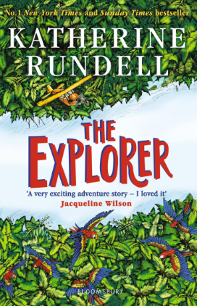
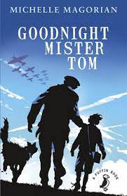
Our Core texts for this term are Goodnight Mister Tom, Roads End and The Explorer. Our English topics allow the children to immerse themselves in both history and the wider world. The children will continue to build on their current skills by creating a variety of written pieces. Example: Diary entry, narratives, instructions and newspapers.

RE
This term, we will focus on one of our big questions. Our question, ‘Why is it better to be there in person?’, where we will explore significant religious and non-religious journeys and why it is important to them.

Geography
Our topic in Geography this term is ‘Where does our energy come from?’. Throughout this topic, the children will learn to understand the importance of energy and how we can create a better future by creating new ideas on how to save energy.

History
We will be learning all about World War 2 and how the UK played a significant part in the War. Throughout the topic, we will identify the causes of World War 2 by studying the timeline and the key dates in history. The children will fully immerse themselves in the past by visiting Chislehurst Caves and taking part in an Evacuee Day. We will also look at the impact WW2 had on women’s lives and how this has helped change and shape the future as we know it today.

Art/DT
We are following the Kapow curriculum, where we will be designing and making
Playgrounds and making our voice heard through Graffiti art.

Maths
This term, we will learn about Ratios, Algebra, Decimals, Fractions, Percentages, Area/perimeter and statistics. This half term, we will continue to recap key knowledge through regular testing in the run-up to SATs to help fill any gaps.

