 | Poverest Primary Pick n Mix |  |  | Key Stage 1 | Autumn Term
 | Year 2 |  |  | Key Stage 1 | Autumn Term
Regular Homework |  | Reading: every day | Spellings: 1 new set per week (Spelling Shed) |  | Mathletics: 1 or 2 pieces set per week
In the table below, there are a variety of homework tasks to choose from. Each activity is based around what your child will be learning this term. You can complete your homework in your book or post it online in your Class Dojo portfolio. Each homework task has points, your points will be totalled at the end of the Summer Term. All regular homework must be completed in order for the points to be collected. Pick n Mix between as many tasks as you can!
Certificates will be awarded as follows: Bronze – 20 points, Silver – 60 points, Gold – 120 points
Science – Habitats and Microhabitats  Wildlife Walk  Go for a lovely walk somewhere outside (at the park, the beach, the woods, in the garden, etc.) and look out for any wildlife.  Take photos, draw pictures or make a list of the different animals, plants and minibeasts you see. Do you notice anything about the kind of habitat you are in?  15 points | Computing – What is a computer? and Algorithms and Debugging  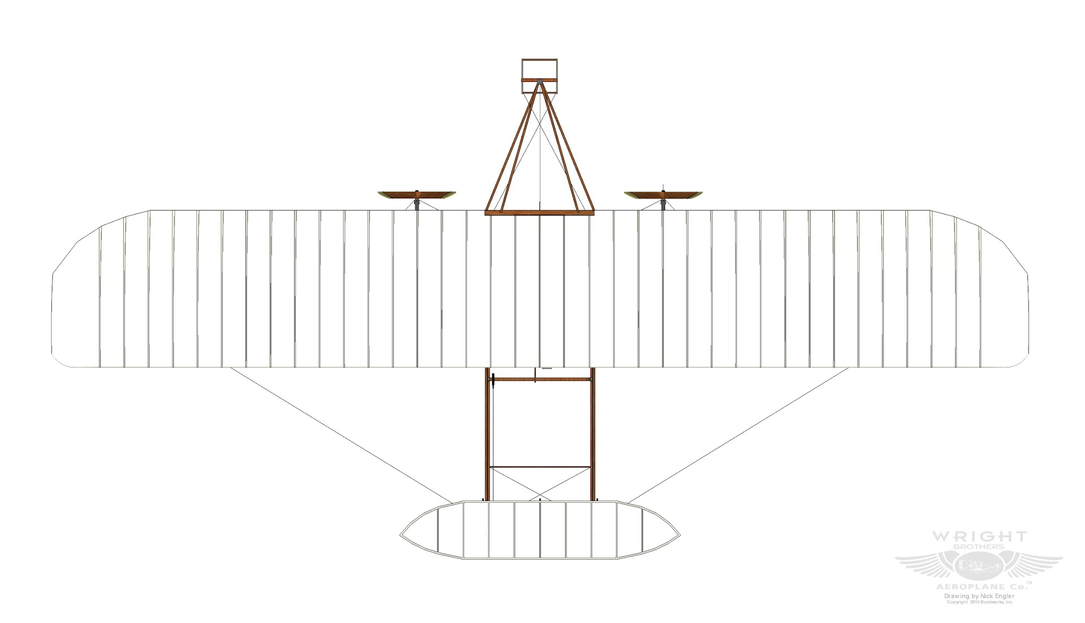  Next time you go shopping, take a look at digital equipment used by the people working in the shop. What do you think the devices do? How do they help the shop workers? How can these devices help you? (scanners, tills, phones, ipads, etc.)  This can be evidenced by answering these questions in homework books or by taking pictures whilst you are out and about.  15 points for written answers  10 points for photographs. | Geography - Would you prefer to live in a hot or cold place?  We are going to be learning about the continents and oceans of the world, before comparing hot and cold climates.  Would you prefer to live in a hot or cold climate?  Can you pretend to be a travel agent and after researching your chosen climate, can you produce a leaflet or poster persuading others to visit your chosen place?  15 points
History – Were schools different in the past?  Ask the adults you know about what school was like when they were there. Write about 3 things that have changed in schools since they were there.  15 points | RE – Why do we need to give thanks?  Create a thank you card to show thanks to someone. It could be a member of your family, a friend or a club leader. Write a message inside the card to tell them what you are thankful for.  5 points | PSHE – Families and relationships  Option 1: Tell us a little bit about your family. Create a family tree or draw a picture of the people in your family and explain how you are related to each other.  Option 2: Write about your friends (in school or outside of school). Explain how your friends make you feel and what you do to make sure your friends are happy.  10 points
Art - Map It Out  Draw a map of a journey you take. You could draw your journey to school, your journey to your swimming classes or your journey to someone’s house. Think carefully about which way you will turn and when you cross the road. Include key human and physical features which you spot along the way, like the red postbox or the pink house!  10 points | DT – Structures  Can you explore structures by designing and building a bridge and test whether it is stable or unstable? Use any materials you have available and draw/take photos of your design and write/record how your testing went!  15 points | Music – Call and response and Instruments  Find and listen to a West African call and response song such as Che, Che Kule.  Share it with your family and get them to sing along with you!  Write down the song you chose in your homework book.  5 bonus points if you share it with the class.  10 points
Wellbeing  We should see lots more rain as we enter Autumn and Winter this term. We would love to see a photo or video of you jumping in muddy puddles! Remember to wear your wellies and have lots of fun.  5 points | PE  Complete a yoga activity at home. You could use a towel for your yoga mat and follow a video to give you ideas. Or create your own yoga routine using the positions below:  5 points  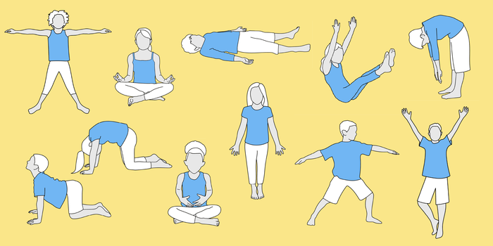 | Extra Fun - Spanish  Next year you will start learning Spanish.  Have a go at learning how to read and say the numbers to 10 in Spanish. Bonus points if you can count backwards too!  5 points

