Music
Music is taught by BYMT weekly.
In Year 6 the children will be completing a music project. This will involve composition, lyrics and the use of online music composition such as Garage Band. In addition to this there will also be singing assemblies, as well as composing and listening sessions.

Computing
In computing, we will be teaching the children to code using a variety of websites. We will also be looking at Bletchley Park and its secret coding to become computing heroes.

Science
In science we will be following the Kapow science scheme where we will be looking at Living things: Classifying big and small. In this unit the children will be looking at the scientist Carl Linnaeus and the system that he developed. Key knowledge that the children will learn are the different characteristics found in vertebrate and invertebrate groups as well as being able to describe the plant kingdom. We will also be covering the topic light and reflection where we will explore how light travels in straight lines, whilst making observations of shadows and reflection.

RE
This term we will focus on the big question ‘Why does religion look different around the world?’ and how religions show their beliefs.

Year 6 Autumn Term

PE is every Monday and alternate Fridays.
Please bring in reading books every day. Homework and reading records (with a minimum of 4 signatures) are due on Friday.

English
Our Core texts for this term are The Grimm Tales, Our Tower and Macbeth. Using these texts the children will write for a variety of different audiences and purposes, including newspaper articles, persuasive letters, narratives and diary entries. We will also have an exciting trip to The Globe Thearte.
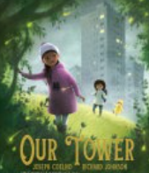
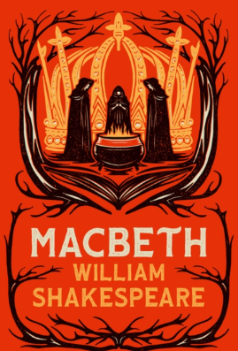
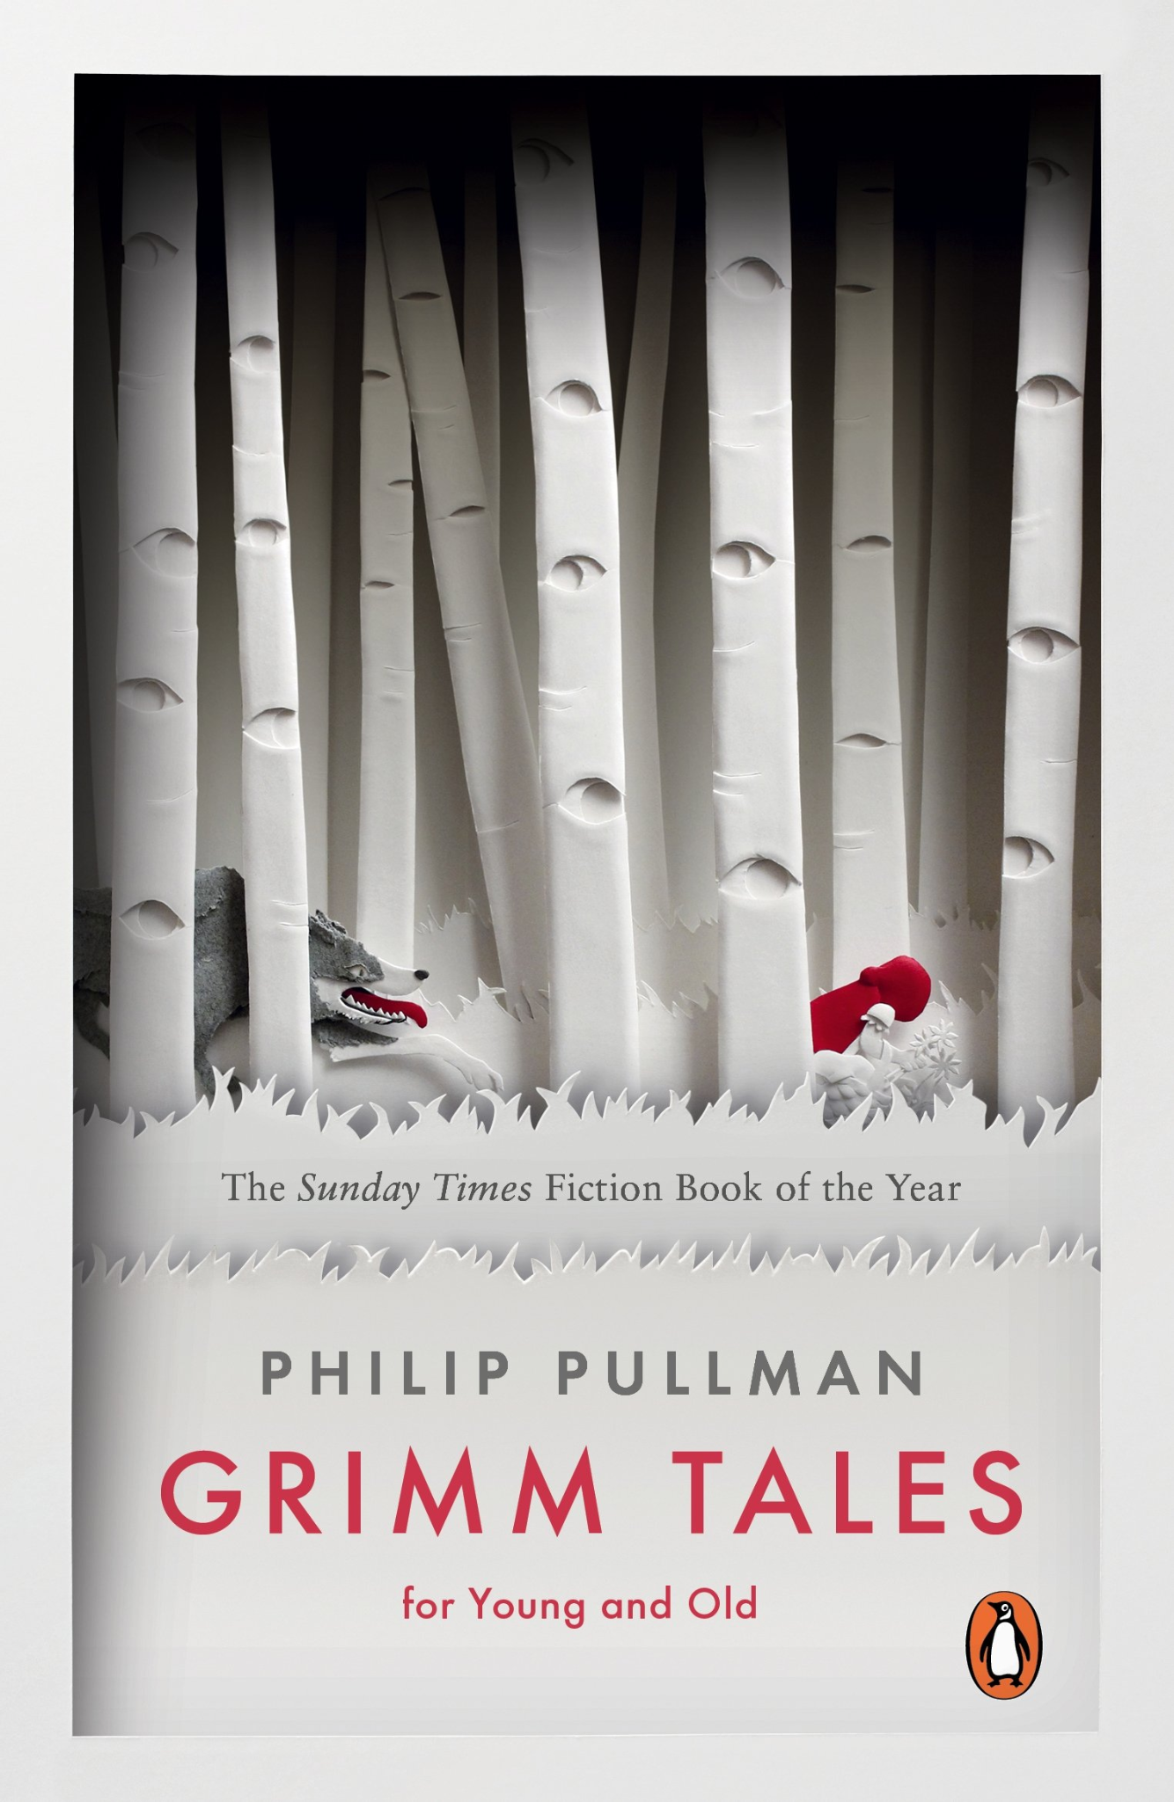

PSHE
In PSHE we will be exploring how to be respectful to everyone whilst challenging stereotypes. Also, we will discuss how we can improve our own health and wellbeing through relaxation and mindfulness.

Geography
Our topic in geography this first half term is why does population change? Throughout this unit, we will explore how the population has changed from the early 1500’s. The children will gain the knowledge to answer a variety of questions on how birth and death rates have changed the population across the world whilst discussing why people live in certain areas of the world.

History
We will be learning all about the Victorains and how they helped to shape the country that we know today. We will be looking at the census, working life for a child, school life, crime and punsihment and partaking in a local enquiry to find out who lived in our local area.

Art/DT
We are following the Kapow curriculum where we will be designing and making
waistcoats and learning various photography skills through art

Maths
This term, we will learn about Place Value, Addition, Subtraction, Multiplication, Division and Measures and Data.

