
#4 - Summer 2 2025
Top 3 Books of 2025
By Delilah
Dog Man: Brawl of the Wild
“An utter, unfettered delight.”
“Readers (of any age) will be giggling from the start
to the finish.”

Diary of a Wimpy Kid
“So funny! Laughs all the way!”
“You will be giggling from start to finish!”

Terror Swipe
“Interesting book!”
“Recommended for all ages.”

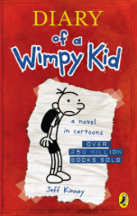
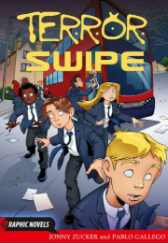

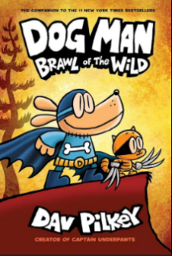

Which zodiac are you?
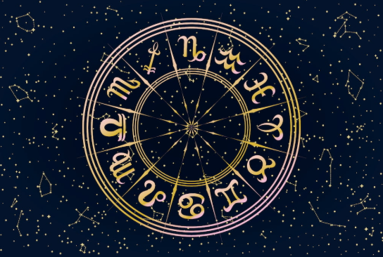
By Matilda

March 21 - April 20 = Aries! You are adventurous and ambitious.
April 21 - May 20 = Taurus! You are graceful and stubborn.
May 21 - June 21 = Gemini! You are curious and communicative.
June 22 - July 22 = Cancer! You are loyal and moody.
July 23 - August 22 = Leo! You are confident and drama-adoring.
August 23 - September 22 = Virgo! You are diligent and hardworking.

September 23 - October 23 = Libra! You are fair and charming.
October 24 - November 21 = Scorpio! You are passionate and
devoted.
November 22 – December 21 = Sagittarius! You are adventurous and
independent.
December 22 – January 19 = Capricorn! You are strong and determined.
January 20 – February 18 = Aquarius! You are creative and social.
February 19 – March 20 = Pisces! You are a dreamer and a visualist.
Places to visit in the UK
(Star rating and costs included)
By Ela and Gabriela

- The British Museum

The British Museum has a star rating of 4.7 stars and the cost is FREE! What a great way to save money! For those who want to visit, The British Museum is located at Great Russell Street, London, United Kingdom. The museum's post code is WC1B 3DG.
Fact: The British Museum is dedicated to human History, Art and Culture.

- Stonehenge

Stonehenge has a star rating of 4.5. Stonehenge is £25.90, not very cheap! For the people that are desperate to go there, here is the address: Stonehenge is located in Salisbury Plain in Wiltshire, England. Stonehenge’s post code is SP4 7DE. FUN FACT! Some stones are bigger than you think…Stonehenge’s world heritage site is humungous.

- Buckingham Palace

Buckingham Palace has a star rating of 4.5, not the best, but still better than 4.0. I’m sad to disappoint you, but I have to inform you that a ticket is £32.00! Yeah, pretty disappointing. Now if you are willing to pay that much read on the find out the address. Here is the address: London SW1A 1AA.

How much does it cost to rent a room at Buckingham Palace? We have estimated that the monthly cost to rent a room in Buckingham Palace would be between £40,258.06 and £55,354.84., which is just over £664,000 a year at the top of the scale.

- The Tate Modern

The Tate Modern has a star rating of 4.1. Now, I have amazing news on the cost. Visiting the Tate Modern is free for its permanent collection. However, special exhibitions may have an associated cost. You can book timed entry slots for exhibitions in advance on the Tate website or potentially gain entry on the day if there are available slots.

- Hyde park

I would highly recommend Hyde park!
It is free, although some activities do cost money which is a shame but it’s still not that bad. The star rating is 4.7. It is the largest of the four royal parks and stretches from Kensington to Buckingham Palace. That says a lot about its history. The beginnings of Hyde Park go back to Henry the Eighth (Henry VIII and his numerous wives), who made the area his hunting ground – already in the early 1536s.

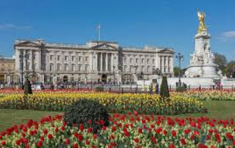
Buckingham Palace


Stonehenge


The British Museum

Summer jobs for kids!
By Matilde

Are you bored this summer? Nothing to do? Well, lend a hand and help someone do a job!! You must be over the age of 10!

Under 15:
- Lemonade stand - Can teach basic business skills!
- Selling handmade items - Can earn money and can be fun to make!
- Yard work - Mowing, cleaning weeds, planting flowers, raking leaves, etc.
- Online content creator - Earn money by having fun!
Over 15:
- Babysitting - A classic for teens, and can create a bond with little kids.
- Pet sitting or dog walking - Teaches responsibility and is great for animal lovers.
- Car washing - A nice way to earn money in the holidays.
- Camping helper - Fun and helpful! Many camps hire teens.
- Tutoring - Can be a good way to help others learn and be confident.

Tips:
- Start with your network: Talk to friends, family, and neighbours about potential opportunities.
- Utilise online platforms: Websites like Indeed and ZipRecruiter can help you find summer jobs in your area.
- Consider local businesses: Many local businesses, like cafes or shops, may be looking for summer help.
- Be realistic about age restrictions: Some jobs may have minimum age requirements.
- Prioritise safety: Ensure the job is safe and appropriate for the child's age and maturity level.

Zachary vs Robert in CHESS!!!

After 5 intense chess games, the winner is still not decided! We will continue to play matches until we have a final winner.

In this intense match, Zachary performed an incredible move on Robert’s side of the board. This struck his chances of winning!
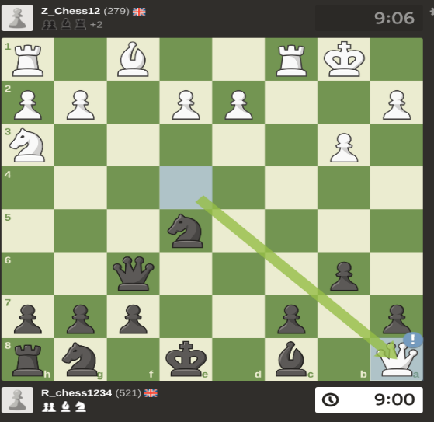

Most Popular Game on Roblox
By Teddy R

Grow a Garden has been going viral with maximum players 12.1M on its last update.
What do you do in Grow a Garden?
It’s pretty obvious by the name what you do, you Grow a Garden! You start with $20 so you can buy the starter seed twice. The starter seed is not very good, but it will start you off well.
Which fruits are there in Grow a Garden?
There are many fruits in Grow a Garden, from the events and even the shop! These include ember lily, beanstalk, cacao, mushroom, carrot, strawberry, blueberry, durian, moon blossom, lotus and many more.
Which mutations can you get on your fruits in Grow a Garden?
You can get gold, rainbow, shocked, chilled, celestial, honeyglazed, pollinated, moonlit, zombified, voidtouched, choc, molten, bloodlit and many more.

Which pets are there in Grow a Garden?
Golden lab, dog, bunny, cat, mouse, raccoon, mooncat, blood owl, night owl, owl, echo frog, frog, lion, caterpillar, cow, pig, praying mantis, crab, chicken jockey, mimic octopus and many more.

Step by step guide on how to beat your friends in Minecraft 1.8.8

- Log in and get wood.
- Immediately go to the mines once you have a pickaxe.
- Get stone and get a stone pickaxe.
- Get iron and make an iron pickaxe.
- Find diamonds.
- Make full diamond gear and tools.
- Make a base.
- Keep mining.
- Once you have got a bunch of diamonds, lure your friends into a trap and then put them in a prison in your base, then tell them to drop their loot.

- Use this over and over again, then let them go and they will know not to mess with you again!
Best levels for mining in Minecraft 1.8.8

- Diamonds: y level 13 and below
- Iron: y level 30 and below
- Lapis lazuli: level 20 and below
- Redstone: level 20 and below
- Emeralds: level 30 and below

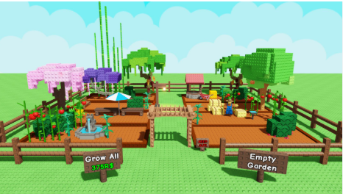


Amazing Rainbow Experiment!

By Jose

- Fold the tissue paper in half to make a nice thin rectangle.

- Choose one end of the tissue paper and colour in 1/4 of the tissue paper. Use many of your colouring pens to draw a rainbow.

- Repeat the previous step but this time on the opposite end of the tissue paper.

- So now both ends of the tissue paper should have the rainbow colours while the middle is blank with no colours (see example image on the right).

- Next add water to both cups, fill them until they are half full.

- Gently place one coloured in end of the tissue paper into one cup of water and place the other end into the other cup.


- Now leave this experiment for a few minutes and return later to see the amazing results.

TOP FIVE MOST FAMOUS PEOPLE IN THE WORLD!
By Lily
NAME: William Arthur Philip Louis
AGE: 42
WHO THEY ARE: William is the Prince of Wales. He is a member of the royal family.

NAME: Arnold Schwarzenegger
AGE: 77
WHO THEY ARE: Actor and former Governor of California.

NAME: Johnny Depp
AGE: 62
WHO THEY ARE: American actor and musician.

NAME: Leonardo DiCaprio
AGE: 50
WHO THEY ARE: American actor and film producer. He plays Jack Dawson in the Titanic.

NAME: Rowan Atkinson
AGE: 70
WHO THEY ARE: Rowan Atkinson is an actor and comedian. He plays Mr. Bean.








Benefits of running
by Zachary

Running improves cardiovascular health, gives you stronger bones and joints and helps with weight management (you only really need to lose weight when you are an adult). If you run, you should stretch after and before running or else you will injure yourself like twisting your ankle or pulling a muscle.



Parkrun and Junior Parkrun

Parkrun is a five kilometres (five K) run where you run around a park. If you have heard of Norman park, there is a parkrun called “Bromley Parkrun” there and you run around the park two and a half times before finishing. It is a flat and fast course. You also get rewards for doing a specific amount of runs. You can run from 4 years old and above.





Junior Parkrun is a 2 kilometres run that is in a park, like a parkrun, but you only run around a smaller park 2 or 3 times. If you want to run quickly, then Junior parkruns will help because they can be run from 4 years old and you have to stop at 14 years old. You get rewards for doing a specific amount of Junior parkruns, but instead of t-shirts, you get wristbands.

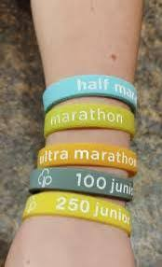

Comic by Freya



