
Music
Music is taught by BYMT weekly.
In Year 4 the children will be learning to play the ukulele. In addition to this there will also be singing assemblies, composing and listening sessions.

Computing
We will be using our Chromebooks for our computing lessons. We will be focusing on the importance of staying safe online this term, and what we can do to protect ourselves.

Science
We will learn about materials, including the states of matter, e.g. solids, liquids and gasses, and different processes such as freezing, melting, evaporation etc. We will also be learning about electricity and circuits.

Spanish
This term we will learn the names of pets and some adjectives to describe them, as well as how to count and say the days of the week and months of the year in Spanish.

RE

This term we will be learning about Jesus and why he is an important figure in the Christian faith. We will also be discussing why our own beliefs are important, and what they mean to us.

Year 4 Spring Term
PE is every Monday and Friday. Please bring in reading books every day. Homework is due on Thursdays and new homework will be given every Friday.

English
Our Core texts for this term are The Iron Man, Cinnamon, Until I Met Dudley, Odd and the Frost Giants and Jabberwocky.
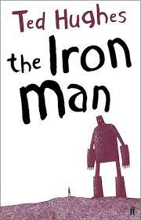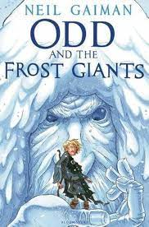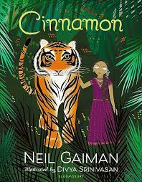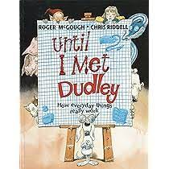

PE
This term we will be doing cross country and gymnastics.


PSHE
Our PSHE topics are Citizenship, and Safety and the Changing Body. We will talk about why diversity in the community is important, as well as how our bodies change as we grow older.

History
Our first History topic this term is titled “How hard was it to invade and settle in Britain?” We will learn about the Anglo-Saxons, the Scots and the role of King Alfred. We will also learn about how children’s lives have changed over time, with a focus on what children’s lives were like during Tudor times.

Art/DT
In Art, we are going to be exploring tints and shades using paint, and using different painting techniques to create 3D effects. In Design and Technology we will be making torches using a range of materials.

Maths
This term, we will learn about Multiplication, Division, Length and Perimeter, Fractions and Decimals.

