Music
Music is taught by BYMT weekly.
In Year 4 the children will be learning to play the ukulele. In addition to this there will also be singing assemblies, composing and listening sessions.

Computing
We will be using our Chromebooks for our computing lessons, where we will learn about systems and networks (such as using Google Docs, slides, forms etc) as well as coding.

Science
Our topic is called Digestion and Food, and this will include learning about digestion, human and animal teeth and how to care for our teeth. We will also be learning about sound and vibration.

Spanish
This term we will focus on language we can use when we visit a cafe, as well as language linked with a variety of celebrations, such as birthdays.

RE

This term we will focus on respecting different views, beliefs and religions by learning about Sikhism and the Bahai worldview among others.

Year 4 Autumn Term
PE is every Monday and Friday. Please bring in reading books every day. Homework is due on Thursday and new homework will be given every Friday.

English
Our Core texts for this term are Tuesday, Varmints, Poetry based on Remembrance Day,Viking Voyagers and Winter’s Child.
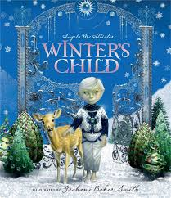
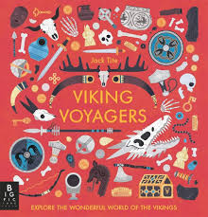
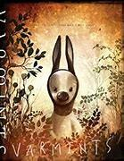

PSHE
Our PSHE topics are Families and Relationships and Health and Wellbeing.

Geography
In Geography, we will be learning about where our food comes from. We will discuss fairtrade and learn about how chocolate is made.

History
Our History topic will be the Vikings. This includes learning about how the Vikings travelled and discussing whether they were raiders or traders.

Art/DT
We will be building Viking houses and boats and learning various art and design skills throughout the year, including drawing and painting using different techniques.

Maths
This term, we will learn about Place Value, Addition, Subtraction, Multiplication, Division, Measures and Data.

