Music
Music is taught by BYMT weekly.
In Year 3 the children will be learning to play the violin. In addition to this there will also be singing assemblies every week.

Computing
We will be learning about computing systems and networks then will learn about databases.

Science
Plant reproduction then we will be reviewing our learning for the last 5 half terms and making connections.

Spanish
This term we will focus on classroom objects followed by ‘Where do we live in Spain?’

PE
PE is every Tuesday and Thursday. Please bring in reading books every day. Homework is given on Thursday and due on the following Thursday.
Reading records due on Friday with a minimum of four signatures.

English
Our Core texts for this term are The Mysteries of Harris Burdick, The Tear Thief, Ernest Shackleton fact file, The Legend of Sally Jones, The Day I Swapped My Dad for Two Goldfish, and Sparky.
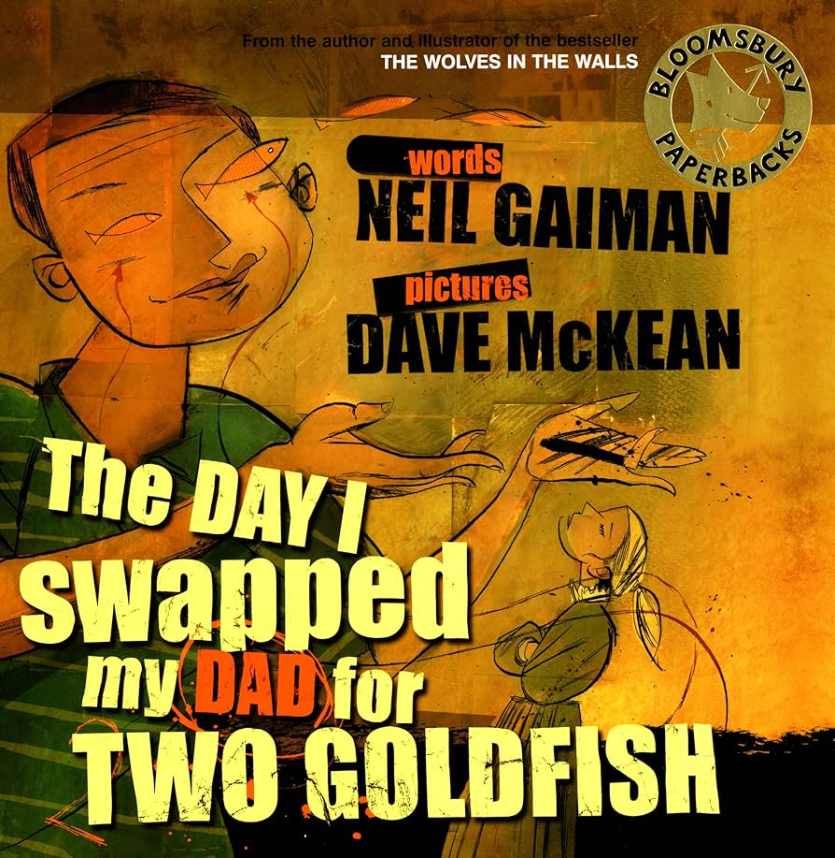

RE
This term we will focus on - Why is water symbolic and Why is fire used ceremonially?

PSHE
Our PSHE topics are - Economic Well Being.

History
Our History topic is Why did Romans settle in Britain?

Geography
Our Geography topic is Are all Settlements the Same?

Art and Design
Our Art and Design topic 3D sculpture.

Design and Technology
Our DT topic is eating Seasonally.

Maths
This term, we will learn about Shape and Space, Money, Time, Statistics.

Year 3 Summer Term

