

Music
Music is taught by BYMT weekly.
The children will be learning to play the recorder. In addition to this there will also be singing assemblies, composing and listening sessions.

Computing
We will be using our Chromebooks for our computing lessons to learn more about computational thinking and data handling.

Science
We will learn about animals and how to classify them into different groups based on a variety of characteristics. We will also learn more about their habitats and how animals adapt to survive.

Spanish
This term we will learn the names of a variety of classroom objects as well as instructions in Spanish. We will also learn more about Spanish cities.

RE

This term we will be learning about Jesus, who he really was and what he means to people from different religions. We will also be learning about the Bible and why it is the best-selling book of all time.

Year 4 Summer Term
PE is every Monday and Wednesday. Please bring in reading books every day. Homework is due on Thursdays and new homework will be given every Friday. You can also choose to do homework from the Pick n Mix Menu whenever you’d like to.

English
Our Core texts for this term are The Lion and the Unicorn, Winter’s Child, Shackleton, Pride: The Story of Harvey Milk, Weslandia and The Ever-changing Earth.
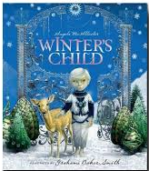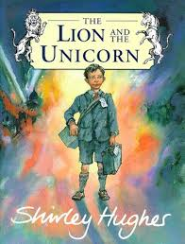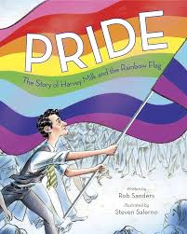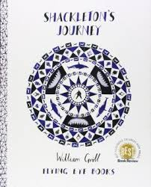

PE
This term we will be doing lacrosse and gymnastics.


PSHE
Our PSHE topic is Economic Well-being. We will learn practical ways to manage money. We are learning mindfulness through a course called Paws B, and we will also do some lessons to help with the transition into Year 5 towards the end of the term.

Geography
In Geography, we will be learning about different types of settlements. This will include learning about our local area, and then comparing this to New Delhi.

History
Our History topic is titled “How Have Children’s Lives Changed?” We will learn about life during the Victorian times, and the roles of children during this time. We will also visit the Museum of Docklands to find out more about this topic.

Art/DT
In Art, we are going to be exploring patterns through craft and design techniques, finishing by designing our own fabric. In Design and Technology we will be designing and making torches using a range of materials.

Maths
This term, we will learn about Decimals, Money, Time, Shape, Statistics, Position and Direction. The children will also complete their Times Table test in June.

