Music
Music is taught by BYMT weekly.
In Year 3 the children will be learning to play the violin. In addition to this there will also be singing assemblies every week.

Computing
We will be using our chromebooks for our computing lessons, where we will learn Systems and Networks 2- Emailing/ Journey inside a computer.

Science
We will learn about Rocks and Soils. In Spring 2 our topic will be Light and Shadows.

Spanish
This term we will focus on basic Shapes and Colours and in Spring 2 we will learn about Spanish objects.

PE
PE is every Tuesday and Thursday. Please bring in reading books every day. Homework is given on Thursday and due on the following Thursday.
Reading records due on Friday with a minimum of four signatures.

English
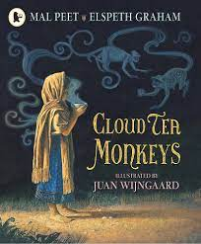
Our Core texts for this term are The Pied Piper Of Hamelin, Black Dog, The Lost Spells (poetry), Cloud Tea Monkeys, Here We Are, Dirty Beasts (Poetry) and Antarctica Fact File

RE
This term we will focus on - Why do we give thanks? Then in Spring 2- What do candles mean to people?

PSHE
Our PSHE topics are - safety and the changing body. . Then in spring 2 -Citizenship. In Year 3 we will also be learning mindfulness through a course called Paws B.

History
Our History topic is who were the ancient Egyptians and where did they live?

Geography
Our Geography topic is - who lives in Antarctica?

Art and Design
Our Art and Design topic is making Egyptians scrolls.

Design and Technology
Our DT topic is digital world wearable technology.

Maths
This term, we will learn about place value, addition, subtraction, length and height.

Year 3 Spring Term
Maple

