The Junior Cray Forum
CRAY VALLEY EAST & WEST - COMMUNITY WORKING AS ONE
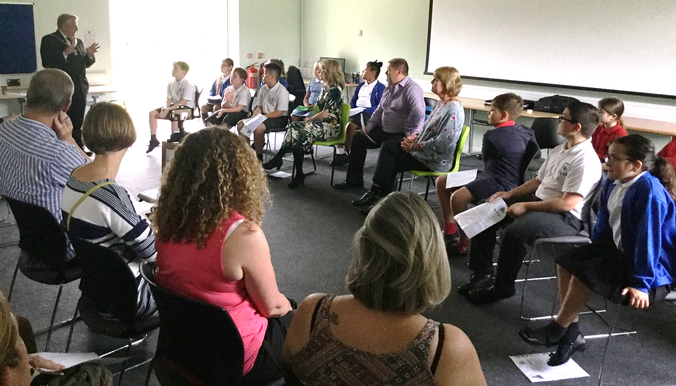
Oliver Matthews in Year 6 and Jessica Baker in Year 4 represent our school in the Junior Cray Forum. We are one of only four schools in this group who act as a youth voice about what is happening in our local area and what they would like to happen in the future. On Monday 24th June, Oliver and Jessica along with the other representatives from the Junior Cray Forum spoke to the Bromley Mayor Cllr Nicholas Bennett, representatives from local businesses, the community, the police etc about what they have already done in Brook Park with the wild flower meadow and planting the apple orchard and their plans for the future. Jessica’s idea of a litter collection walk was selected as the next community project. This will involve Poverest collecting litter whilst walking to Leesons School, Lessons School collecting litter walking to Midfield School, Midfield collecting litter walking to St Mary Cray School and St Mary Cray doing the same walking to us. The Nugent Centre have pledged to also do a litter collection on this day as well as local community groups doing the same in parks and communal areas. We are all working together to select a day and will let you know once one has been agreed if you want to get involved.

