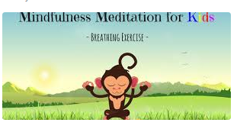
Wednesday
Today the task is “be mindful!”
We want you to have a go at this mindful activity on youtube https://www.youtube.com/watch?v=Bk_qU7l-fcU
Writing task:

Task:
Today you are going to write a prediction about where you think the boy will go in his rocket.
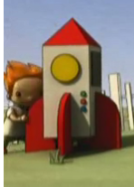
Reminder of our time conjunctions:
First
Second
Next
After that
Then
Eventually
Finally

Today we are really looking for full stops, capital letters and finger spaces! Dojo’s to be given.

Daisy challenge: to join your handwriting.

Reading / phonics task:

Task

Log on to Busy Things -> Key Stage 1 -> English -> Phonics Programme -> Phase 5 alternative letters and sounds -> alternative phonemes
Play ‘Digging for Gold’ - click the monster that is sounding out the word correctly
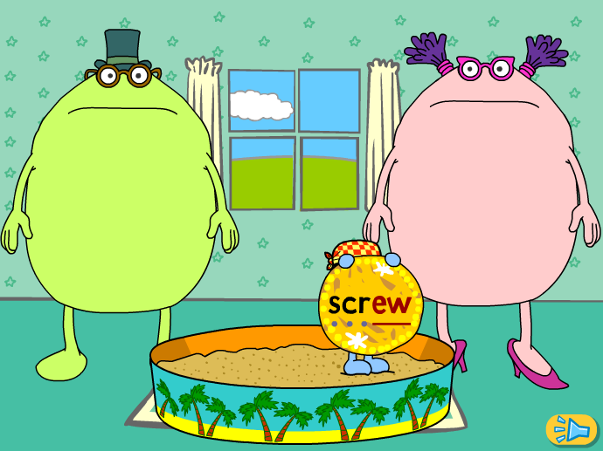
Daisy challenge:
Phase 5 alternative letters and sounds -> alternative graphemes
Play ‘Cat Splat’ - Splat all the words that have the given sound

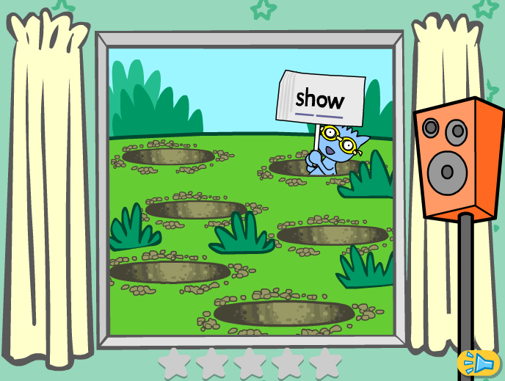

Maths task:
We are continuing to look at counting in 2s, 5s and 10s.
Task:

Play a game of Monkey Stacks.
Year 1-> Maths -> Multiplication and division -> Monkey stacks.

You can change the settings to include 2’s, 5’s and 10’s or you can select one multiplication family.
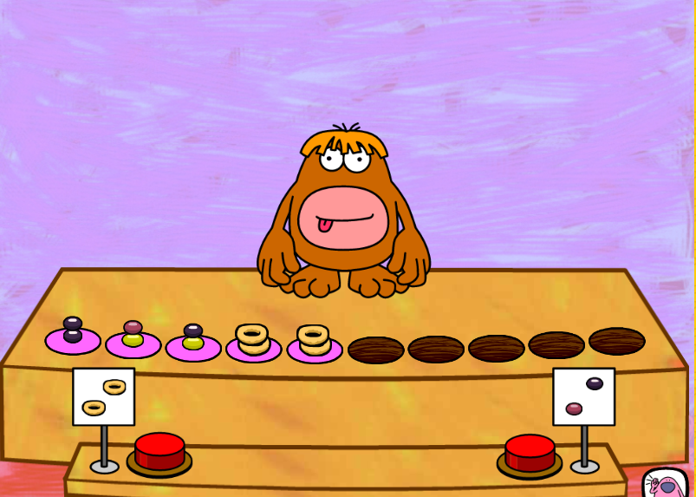

Daisy challenge: write out the multiplication sentence for each question?

Computing:
Today we are looking at creating a set of instructions for a programme to follow

Log on to PurpleMash - > Computing -> 2Go

Click on the Challenges button and work through a couple - they start of easy with simple commands and then get harder with you have to create more specific commands



