Thursday
Today the mental health task is “keep learning”
You are going to choose something you are interested in and find out 3 new things about it. You might be interested in cars, dinosaurs, football, princesses, castles, dollies, rainbows, or anything! Just enjoy learning something new about your interest. (you could use kiddle or epic to look for books based on your interest).
Writing task:

Task:
Today you can watch the whole video! Our main character meets someone very special - do you think you can describe them?
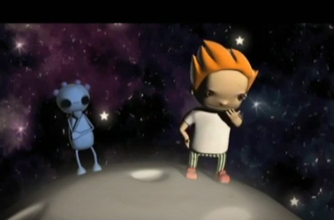
Use these questions to help you write your description:
What does the boy’s new friend look like?
Do you think they are good or bad?
What might they feel like?
What do they smell like?
What might their personality be like?
(e.g.kind, funny, smart, cheeky, nervous, rude, nasty)
Where are they from?

Today we are really looking for joined up writing, adjectives and similes! Dojo’s to be given.

Daisy challenge: Can you include a question and your suffixes in your description?

Reading / phonics task:

Task
Phonics pairs,
Write out some of the phase 5 phonics on pieces of individual paper twice. Turn them over and play pairs.

Once you have all of the pairs, write a word with that sound in.

Daisy challenge: Write a sentence using one of those words.

Maths task:
We are continuing to look at counting in 2s, 5s and 10s.
Task:
Can you answer these times tables? You can use counting in your head/on your fingers or physical objects to help you! Try and do it independently if you can
2 x 5 = 10 x 10 = 3 x 5 =

6 x 10 = 11 x 5 = 8 x 5 =

12 x 2 = 9 x 10 = 7 x 5 =

1 x 5 = 2 x 2 = 4 x 10 =

Daisy challenge: Log in to TTrockstars (same log in as your numbots account) and play in the garage - how many times correct answers can you get in the given time? You could even challenge a friend to a battle!

Music:
Complete this week’s BYMT music lesson

History:
Now you have learnt about Columbus and Armstrong, you are going to compare them.
Write all the things that were similar and all the things that were different. Rewatch these videos to remind yourself of what they did.

Neil Armstrong: https://www.bbc.co.uk/bitesize/topics/zhpchbk/articles/z4w3mfr
Christopher Columbus:
https://www.youtube.com/watch?v=Qt7IiKuYMBY

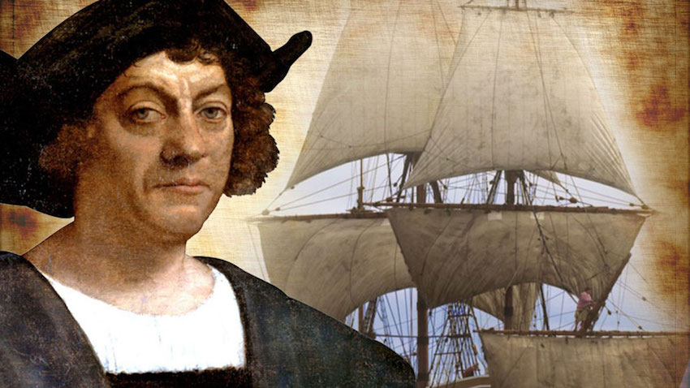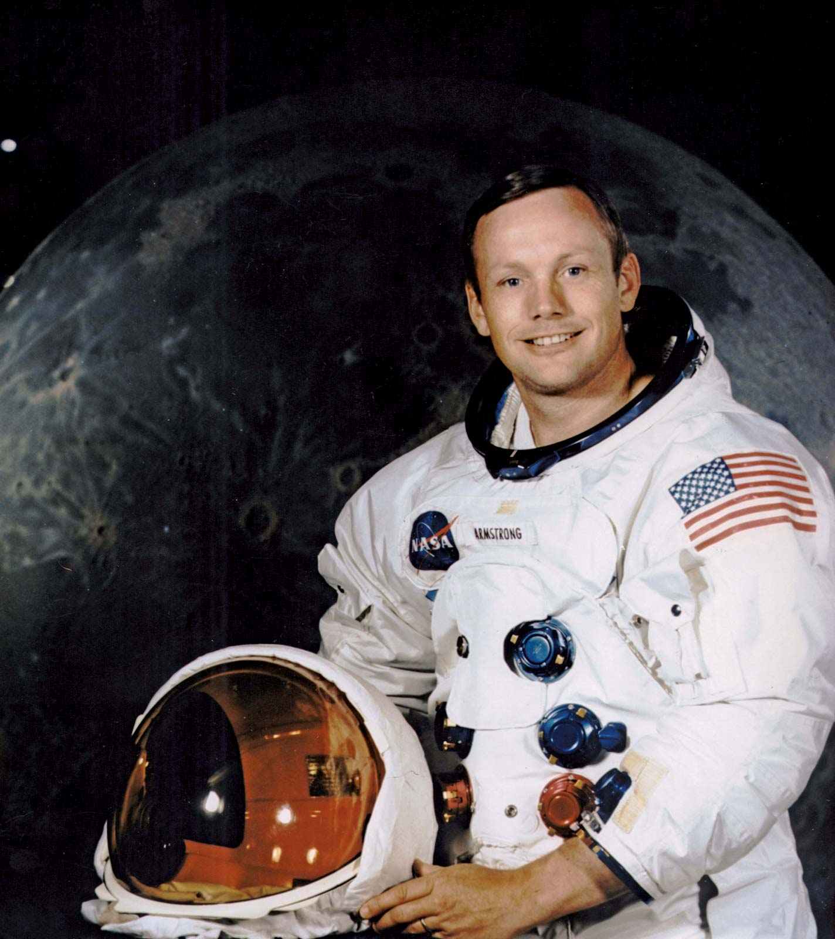
Similar | Different
They were both explorers | They explored different places

