
Monday
This week it is mental health week. Every day we are going to suggest an activity which would be good for your mental wellbeing.
Today the task is “time to talk!”
We want you to spend 10 minutes just talking to each other. You have to say at least 5 things you like about yourself and 5 things you like about the person you are talking to

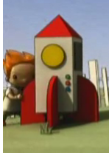
Writing task:
We are starting a new video today! Watch it on Dojo (up to 36 seconds).
The little boy has made his own rocket out of cardboard. What would you use to make your own rocket?

Task:
Make a list of what you would need to make your rocket.
Write where you might get the materials from.
How will you decorate it?
How will you fix it together?
Will the rocket have moving parts?

Daisy challenge:
To describe the different objects

Reading / phonics task:

Task
Read one of your favourite books and pick one of your favourite characters.
Draw a picture of your favourite character with a twist e.g. if they are a good character - what would they look like if they were evil?

Daisy challenge: How would the story change? Write a couple of sentences to say how

Maths task:
We are going to look at counting in 2s, 5s and 10s this week

Task:

Multiplying is all about makes groups of a certain number e.g.
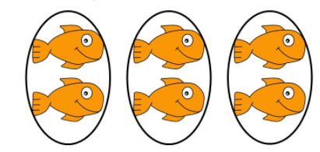
3 groups of 2
Using objects around the house how many objects are in these sets groups:
- 4 groups of 2 =
- 8 groups of 5 =
- 3 groups of 10 =
- 10 groups of 2 =
- 1 group of 10 =
- 12 groups of 5 =

Daisy challenge: can you write out the multiplication sentence for each question?

Science:
We are going to find out about the animal group amphibians today.

Task
Watch the clip
https://www.bbc.co.uk/bitesize/topics/z6882hv/articles/zc6br82

Can you design a habitat (home) suited to an amphibian?

Pe:
Linking with our Science topic of Animals including Humans in an outdoor space or inside your house can you travel like the different types of animals we have been looking at?
How would you move if you were a:
mammal
bird
reptile
amphibian

