Friday
Today the mental health task is “get inspired”
You are going to help your adult in the kitchen today. Your task is to help your adults make your breakfast, lunch or dinner.
Writing task:

Task:
Today you are going to pretend that you were the boy who went on a space adventure. You are going to write a diary entry.
Use these sentence starters to help:
Today I went on an amazing adventure to..
It was so exciting because..
I really liked it when… because …
I felt a little bit worried when… because..
I want my next adventure to be…

Today we are really looking for joined up writing. Dojo’s to be given.

Daisy challenge: To use the prefix ‘un’. Fair -> unfair

Reading / phonics task:
Task
Read either by yourself, with an adult or have the story read to you ‘Rameena’s Ramadan’ (File uploaded on dojo) and answer these questions about the story:
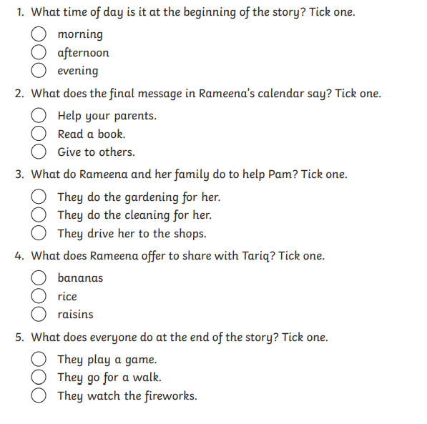

Maths task:
We are continuing to look at counting in 2s, 5s and 10s.
Task:
Write out the 2’s, 5’s and 10’s times tables (like the picture below)
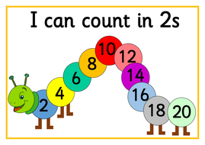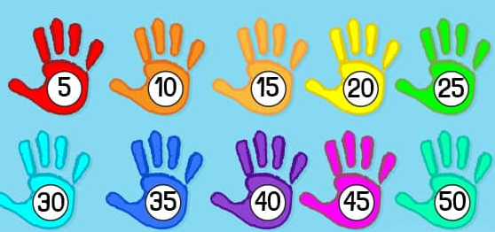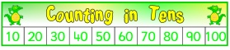

Now cut them up and put them back together (just like a puzzle). Can you see any numbers which are in all three times tables? Colour those in.

Daisy challenge: Have a go at saying the times tables without having to look at the number sequences.

RE:
Watch the video of this family prepare for their celebrations for Eid.
https://www.bbc.co.uk/cbeebies/puzzles/lets-celebrate-eid

Now have a go at the quiz on the website.

Daisy challenge Make a card for someone who would be celebrating Eid in our school. We would love to share these on our School Dojo story

