Wednesday
Writing task:
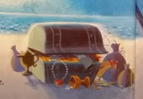
The treasure chest is very important to the Night Pirates, what do you think might be in their treasure chest?

Task:
Can you write a list of all the things you think might be in the Night Pirate’s treasure chest? Draw a picture next to each object on the list

Daisy challenge: Can you write your list in full sentences using adjectives, full stops and capital letters?

Reading / phonics task:
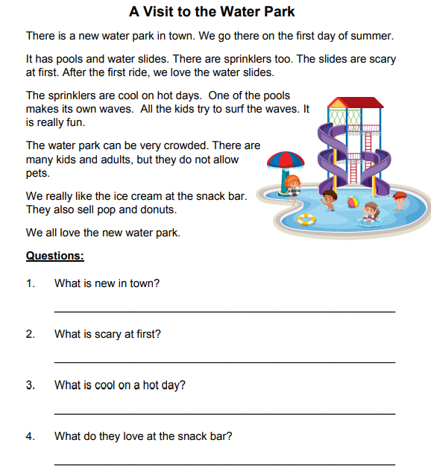

Maths task:
You have either 20p or 30p to spend in a sticker shop. Find out which sticker you will get the most change from when you buy it.
Task:
Use objects or the penny line to take away the price of each of these stickers from 10p, 20p or 30p

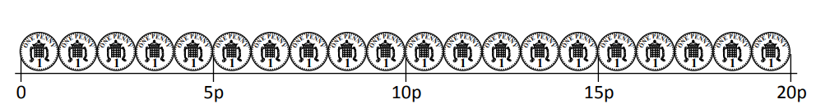
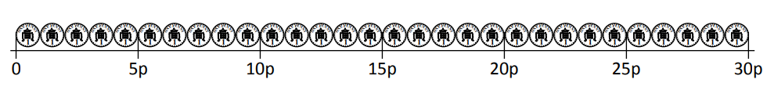
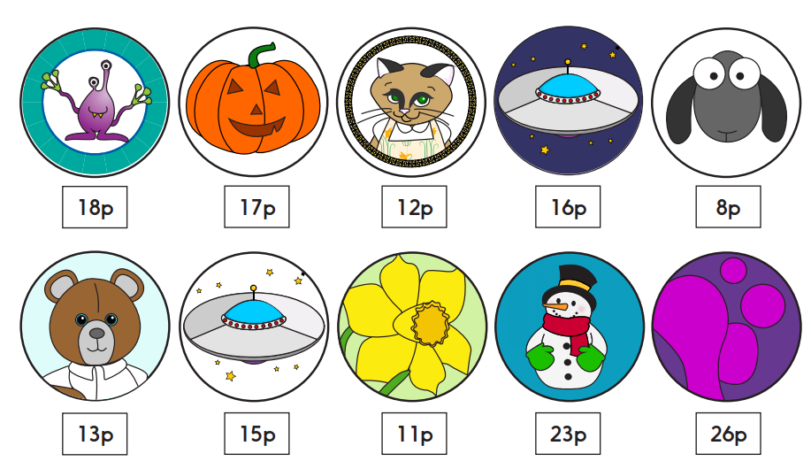

Daisy challenge: Use mixed coins to make the change (instead of 10x 1p coins, use 2x 5p coins or 1x 10p coin)
RE:
Today we are going to focus on the story of Joseph. Watch this clip about Joseph’s life:
https://www.youtube.com/watch?v=VnlqKPIZQzI

Joseph’s brothers were mean to him because they were jealous of him. Sometimes we get jealous of other people because of what they have, but that does not mean we should be mean to them. Could Joseph have done something to stop his brothers feeling jealous of him?

Joseph had a beautiful coat of many colours which many people call his dream coat. Design a patch for a coat on a piece of paper which shows your dreams - what do you want for your future? When we return to school we will stick them together and make a class dream coat!

