Tuesday
Writing task:
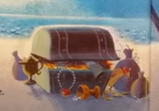
The treasure chest is very important to the Night Pirates, what is important to you?

Task:
If you had a treasure chest what important things would you keep in it? These can be anything you find important!
Why would you keep that in your treasure chest? Can you use a conjunction to say why you would keep it?

Remember:
full stops and capital letters!

Daisy challenge: Include adjectives, similes or suffixes to describe what you would put in your chest

Reading / phonics task:
https://www.phonicsplay.co.uk/member-only/ReadingRobotTest.html

Task
Have a go at the year 1 phonics screening test. Put in your sound buttons if you are unsure of reading the word.
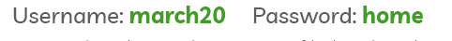
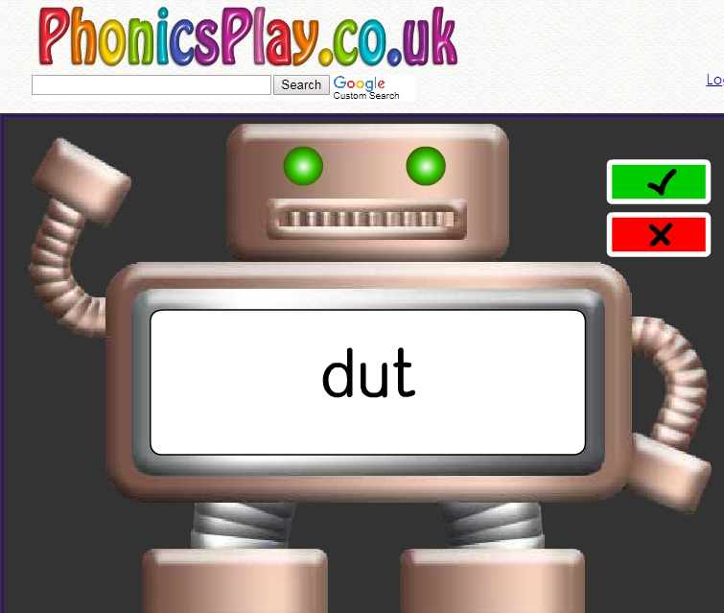

Daisy challenge:
Have a go at another game on phonics play!

Maths task:
We are going to continue looking at making change by taking away

Task:
Use objects to complete the number sentences below. Draw out the change you would be given.

10p-4p= 10p-9p= 10p-2p= 10p-6p= 10p-5p= 7p-10p=

20p-11p 20p-15p 20p-3p
20p-17p 20p-4p 20p-18p

30p-24p 30p-9p 30p-28p
30p-16p 30p-15p 30p-21p

Daisy challenge: Use mixed coins to make the change (instead of 10x 1p coins, use 2x 5p coins or 1x 10p coin)

Art:
You have all become brilliant pirates these last couple of weeks! Now it’s time to make your own pirate pet! A parrot!

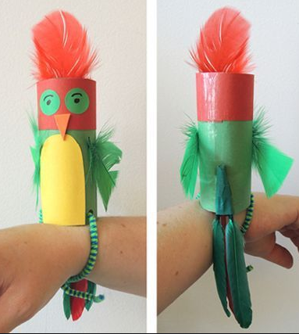
Using a toilet roll holder and craft items in your house create your own pirate parrot! Think about how you’re going to attach the decorations to your parrot and how you can get it to balance on your wrist!

Geography:

Using Google Earth you are going to research what cities or countries these landmarks are in around the world!

https://earth.google.com/web/



