Wednesday
Writing task:
We have finished the story The Night Pirates!
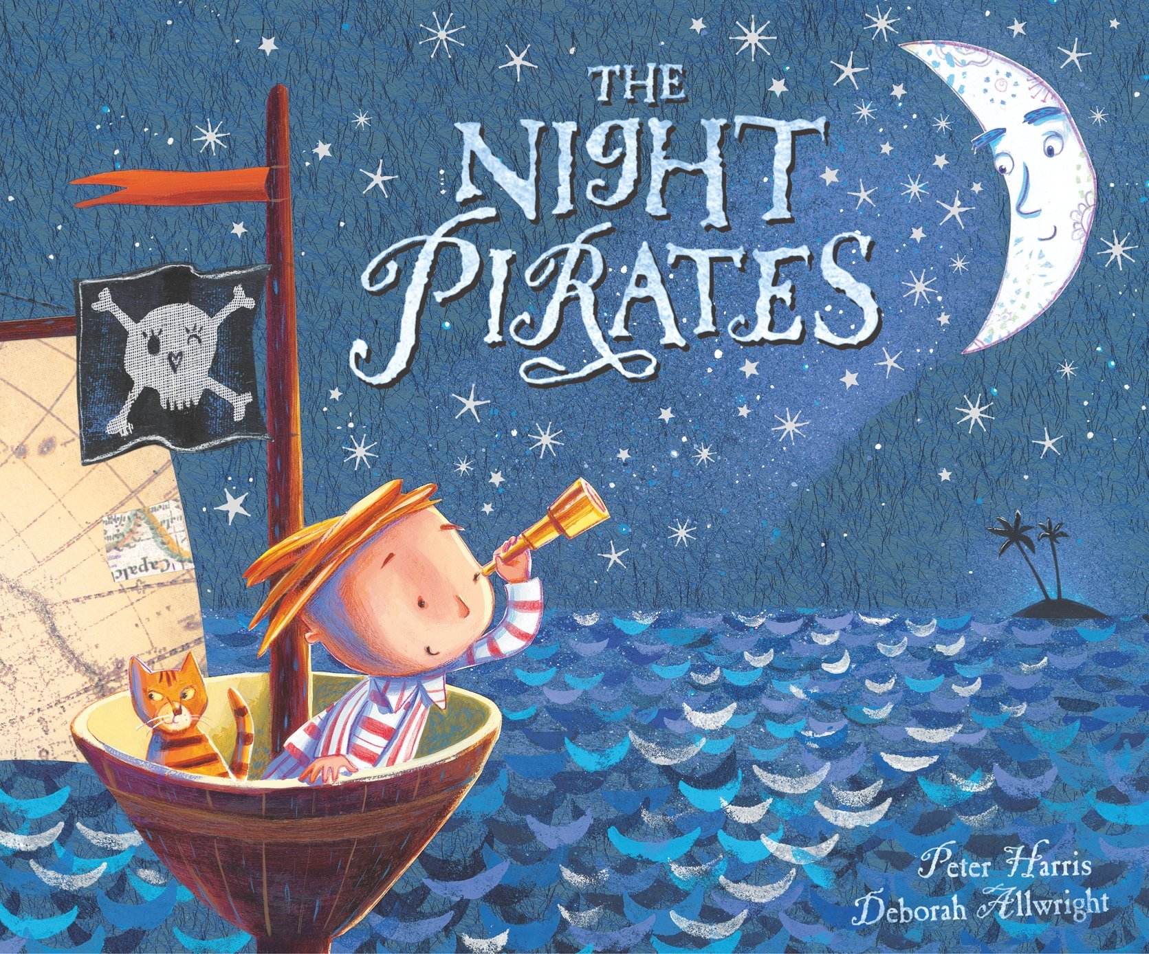

Task:
Write a book review.

Use these questions to help you write your review.
What did you like about the story?
What did you dislike about the story?
Which part was your favorite and why?
Which character did you like and why?
If you could ask the author a question about the story, what would you ask?

Daisy challenge: If you could change the ending to this story, what would it be?

Reading / phonics task:
https://www.phonicsbloom.com/uk/game/yes-no-yeti?phase=5
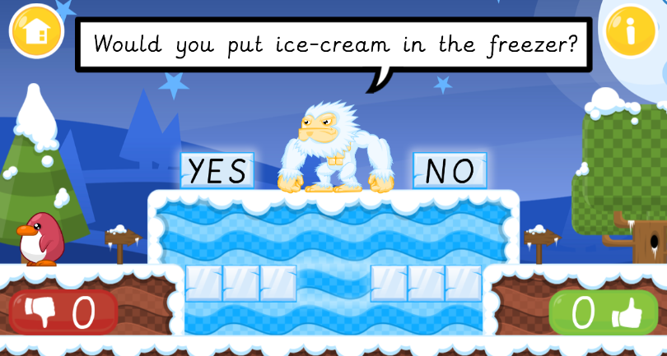

Play a game of Yes No Yetti on Phonics Bloom.

Maths task:
This is our last day of making change!

Task:
Log into purple mash and play a game of “give change”. You can choose either the 10p or 20p version, it is up to you. You might want objects and a pen and paper to help you out.

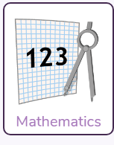 ->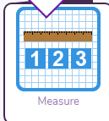->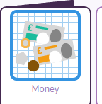->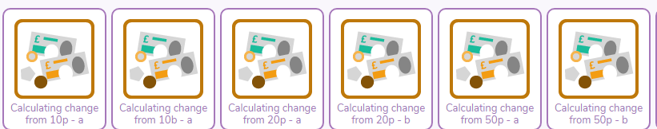

Music:
Listen to and join in with the BYMT video music lesson on the Class Story!

History:
We are going to look at another explorer today from hundreds of years ago - Christopher Columbus
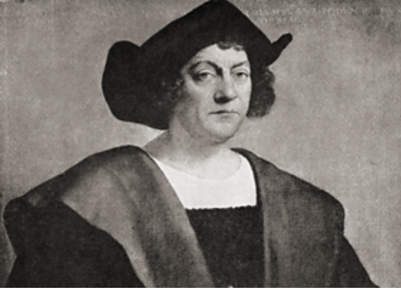
What would you ask Christopher Columbus if you could meet him today? Record your questions to Mr Columbus!

https://www.youtube.com/watch?v=Qt7IiKuYMBY

