Thursday
Writing task:

You are going to make a pirate poem using the rhyming couplets you did yesterday!

Example:
I am a pirate searching for land
I shall dig up my treasure from the golden sand!
It will be so much fun
And I will be in the sun

Reminder of rhyming words:
Map - clap, trap, slap, flap
Gold - old, fold, mould, told, sold, bold, cold
Ship - lip, trip, slip, clip, whip, flip
Parrot - carrot
Treasure - measure, pleasure, leasure

Daisy challenge: Complete your Music task!

Reading task:
Can you find all the common exception words?
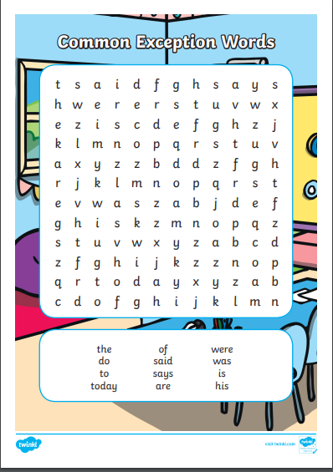

Maths task:

Today you are at a shop and everything here costs 11p or 12p! You are going to be paying with different amounts and must work out the change to make sure you get the correct amount back!

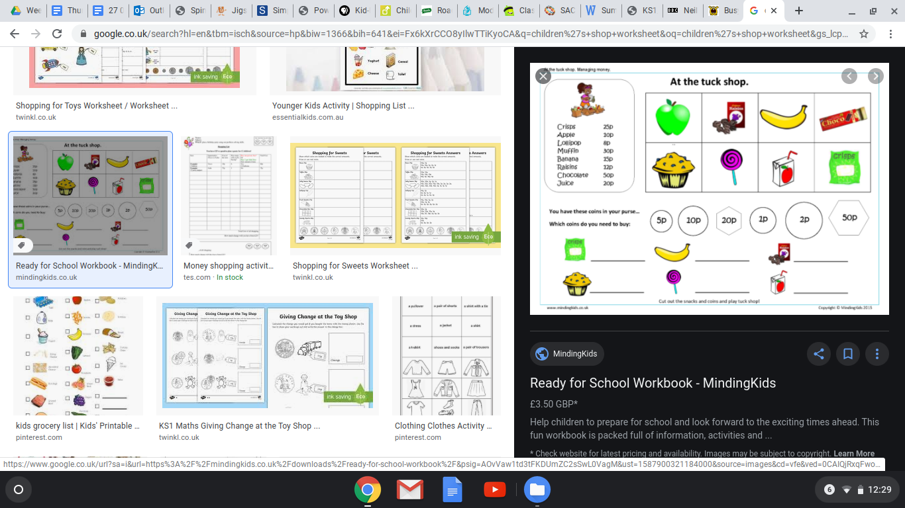
Price: 11p Price: 12p Price: 12p
Pay with: 45p Pay with: 87p Pay with: 32p

Price: 11p Price: 12p Price: 11p
Pay with: 96p Pay with: 55p Pay with: 78p

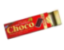
Price: 11p Price: 12p
Pay with: 96p Pay with: 27p

Remember to write out your number sentences!

Daisy challenge: All 12p prices are now down to 8p and all 11p prices are down to 9p! What will your change be now?

History:
We are going to look at a famous explorer today - Neil Armstrong! 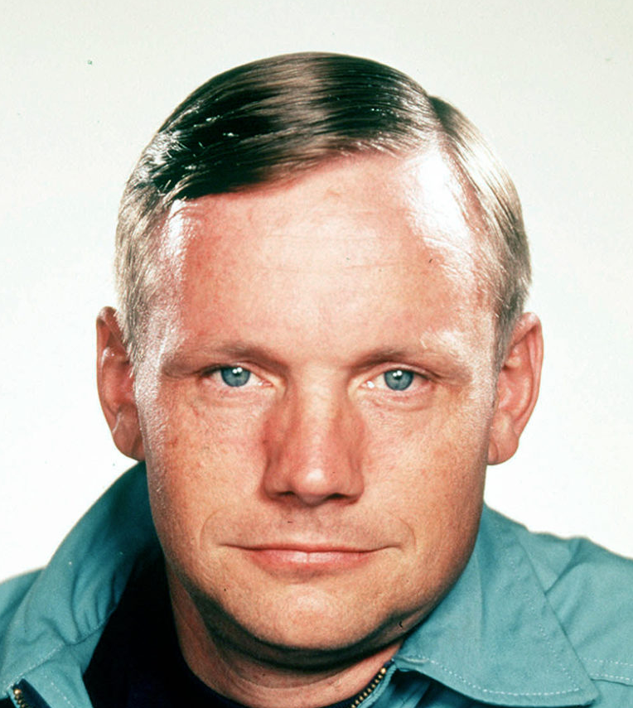

You are going to watch this clip and then take a quiz about Neil Armstrong. You will find out about his mission and why he is a famous explorer. https://www.bbc.co.uk/bitesize/topics/zjwvb82/articles/zhx4k2p

Task:
Using what you now know about Neil Armstrong, think of questions you would like to ask him.
Write them down yourself or have someone record your questions for you. You could pretend you are interviewing him!

Daisy challenge: Can you find out the answers to some of your questions?

Music:
Perform your pirate poem and include a piece of music to play in the background.

You can even try and include different actions during your performance too.


