Wednesday
Writing task:

Yesterday you came up with rhyming words for these pirate words, we have also done some which you can add to your list.

Map - clap, trap, slap, flap
Gold - old, fold, mould, told, sold, bold, cold
Ship - lip, trip, slip, clip, whip, flip
Parrot - carrot
Treasure - measure, pleasure, leasure

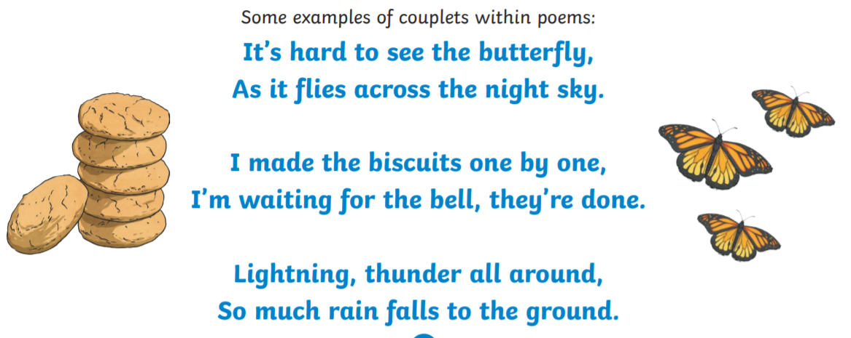
Today you are going to make up a rhyming couplet for each of your pirate words. The last word in each sentence must rhyme.

Example:
Oh wow look, I found a map
Let's be careful, it could be a trap!

Daisy challenge: have a go at using the other words in a new rhyming couplet.

Reading task:
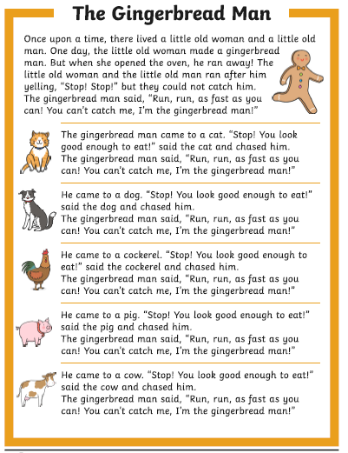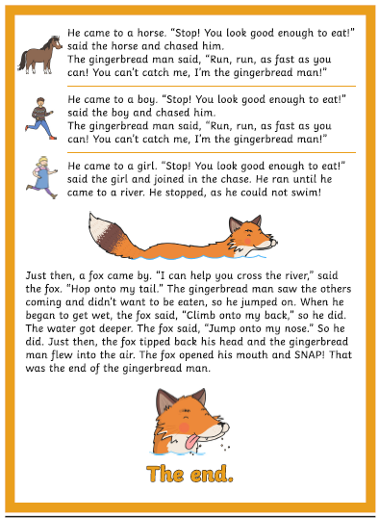
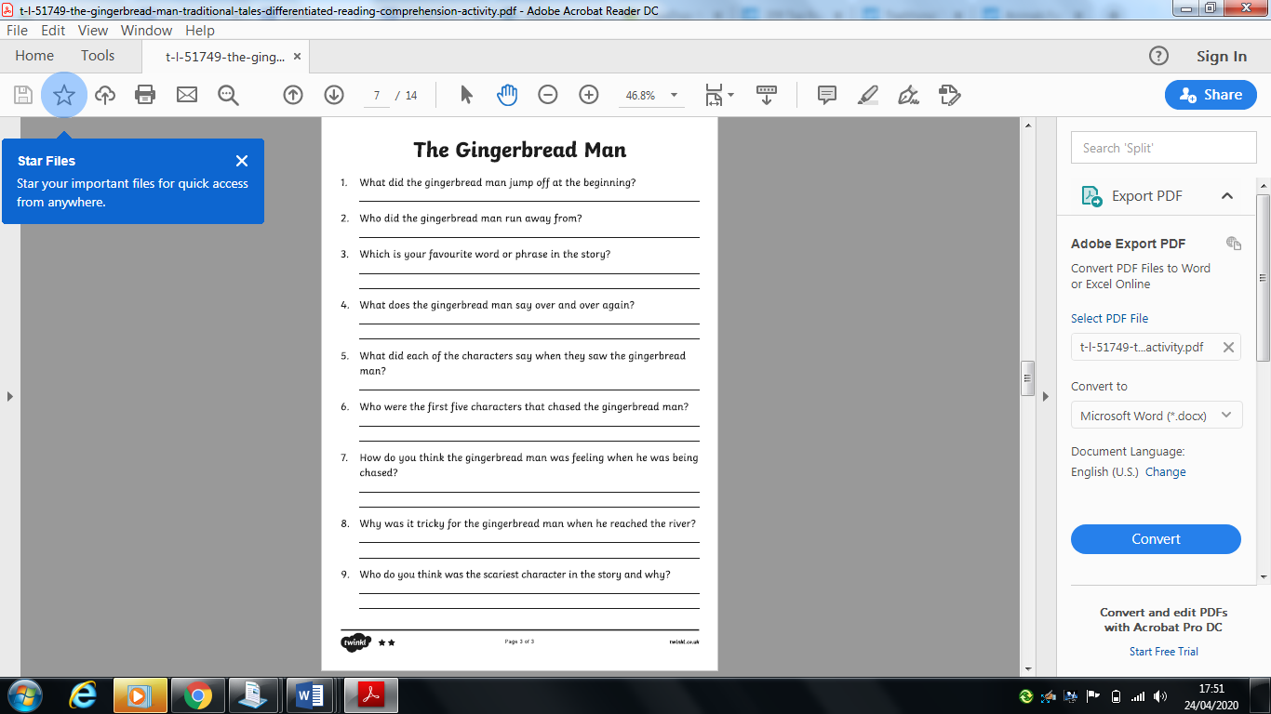

Maths task:

Task:
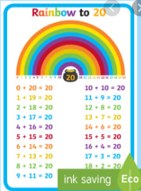
Remember we did our number bonds to 20 a couple of weeks ago? Today we are going to use those to help us with money.

You have a 20p coin when you go to the shops, you buy an item. Work out how much change you will get (what is left).

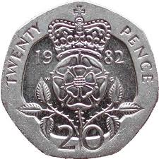 | - | 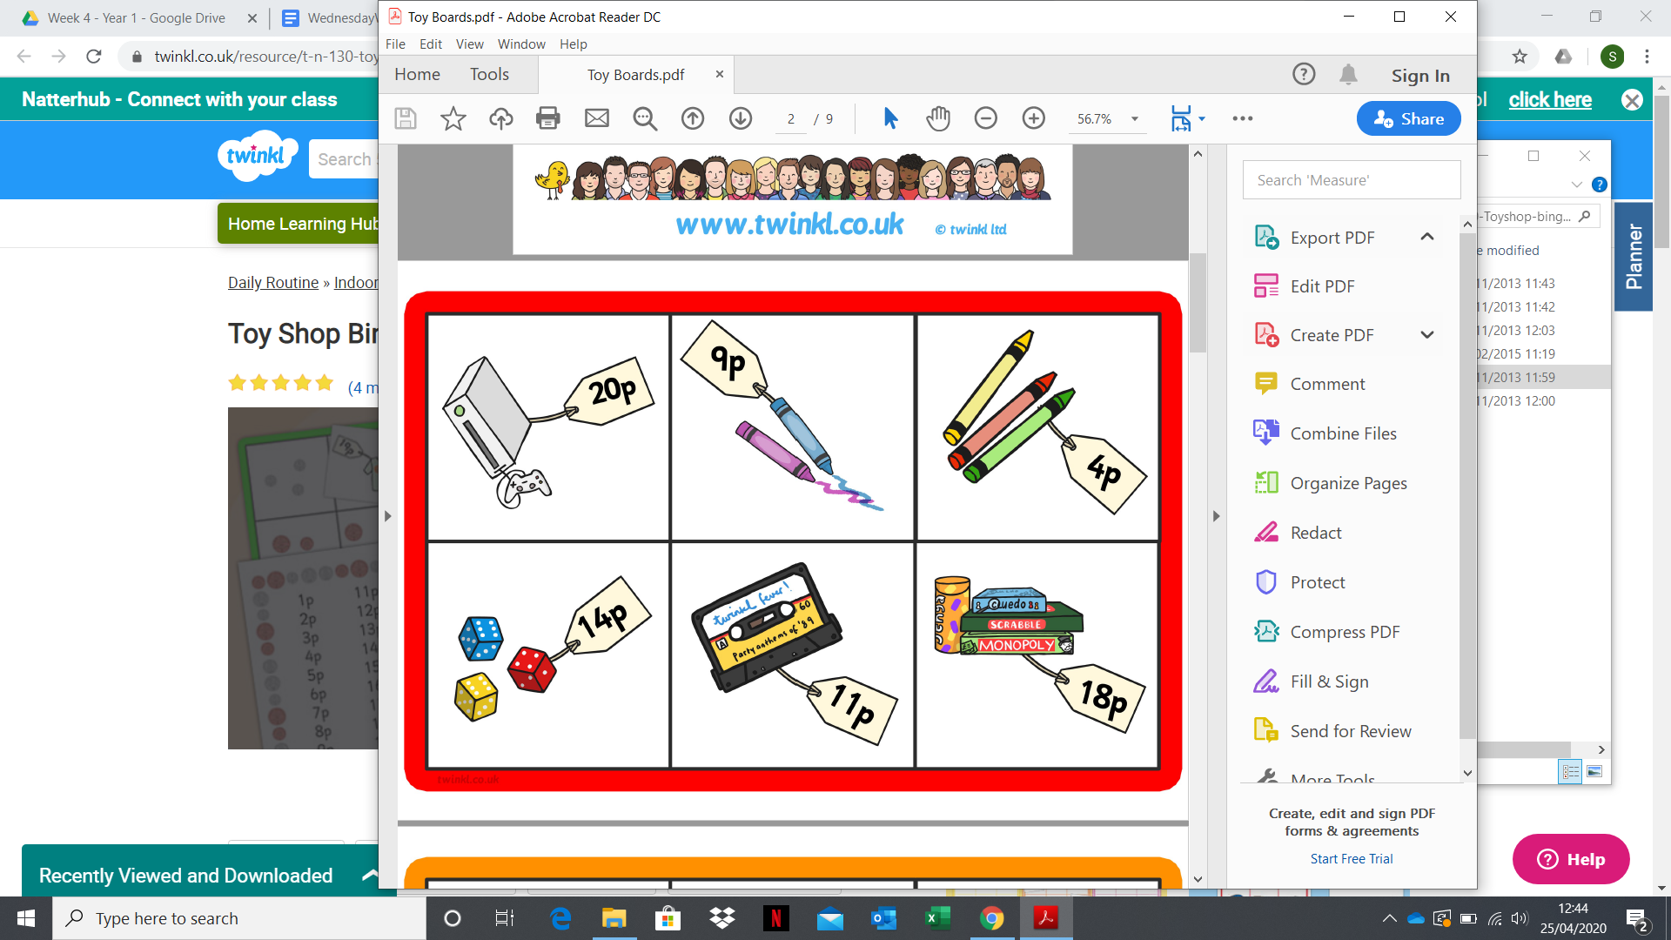
 | -
 | -
 | -
 | -
 | -
 | - | 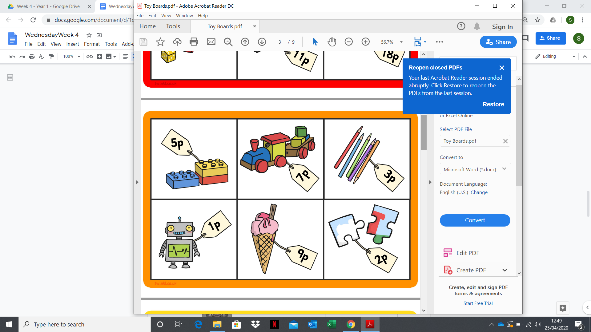
 | -
 | -

Daisy challenge: to find the change for the same items with 25p to start or a 50p coin.
RE:
In RE we have started to look at Judaism. Our last lesson was about baby Moses who was sent down the river to safety by his mother.

Task:
To find out why Moses is an important person to Jewish people. Watch the story of Moses and create a story map of what happened.
https://www.youtube.com/watch?v=RdSQT7DS1lI

When you’ve finished your story map use it to retell the story of Moses to someone in your house

Daisy challenge: Can you write short sentences under each part of your story map saying what happened in each part?

