Monday
Writing task:
Those pirates from our book have not been to school and they need your help. They have written this letter but can you help them correct it?
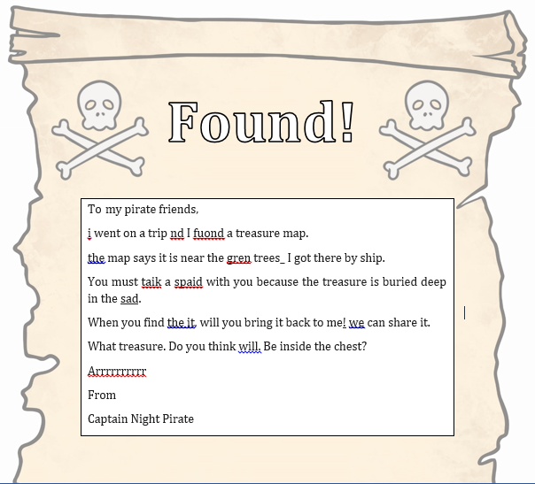
remember:
Check they have used their phonics.
Check they have used full stops and capital letters.
Daisy challenge: to write them a letter back.
Reading task:
Play a game of ‘help a hedgehog’. Have a go at trying to beat your time.
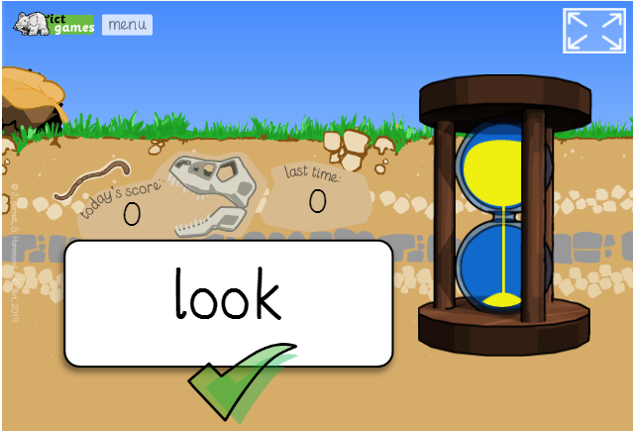
Daisy challenge: enter your own words and see how quickly you can read them (you might need to ask your adult to help you enter your own words).

Maths task:
Task:
We are looking at money again this week. Refresh your memory and write the value under each coin.
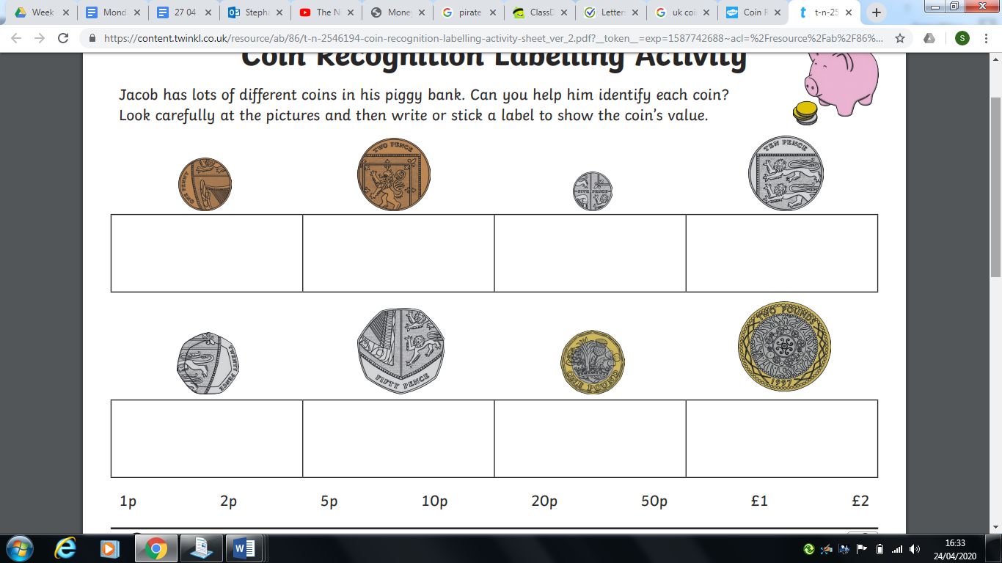
Now have a go at adding these coins together.
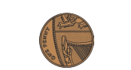 | - 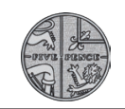
 | - 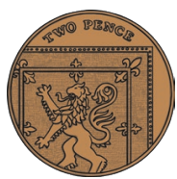
 | - 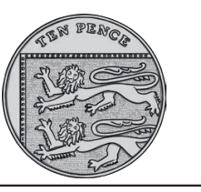
 | - 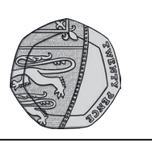
Daisy challenge: get some real coins and add them together. See if you can add 3 or more coins together. You could even write a number sentence for them!

Science:
Our Topic for Science is ‘Animals Including Humans’. Each week we are going to focus on a different animal group. This week it’s mammals!
Watch this video clip on what mammals are and create your own poster including facts about mammals - there’s a little game at the bottom of the page to test you knowledge on mammals!

https://www.bbc.co.uk/bitesize/topics/z6882hv/articles/zp92xnb

Daisy challenge: Use kiddle with your adult’s permission to find out what animals (other than the ones in the video) are mammals

PE:

Enjoy some mindfulness with the Cosmic Kids Yoga stories!

https://www.youtube.com/watch?v=LhYtcadR9nw



