Friday
Writing task:
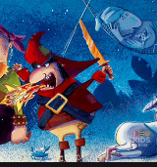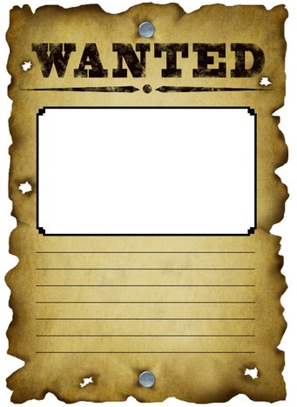
Listen to a bit more of the story.
We have been introduced to the grown up pirate Captain Patch!

Task:
Create a wanted poster for Captain Patch. He has taken the pirate treasure!

What to include in your wanted poster?
A picture.
Description of what he looks like.
Description of what he's done.
The reward if he is caught.

Remember:
full stops, capital letters, adjectives and similes!

Daisy challenge: Use question marks and exclamation marks correctly.

Reading / phonics task:

Task
Play forest phonics on ICTgames
https://www.ictgames.com/mobilePage/forestPhonics/index.html
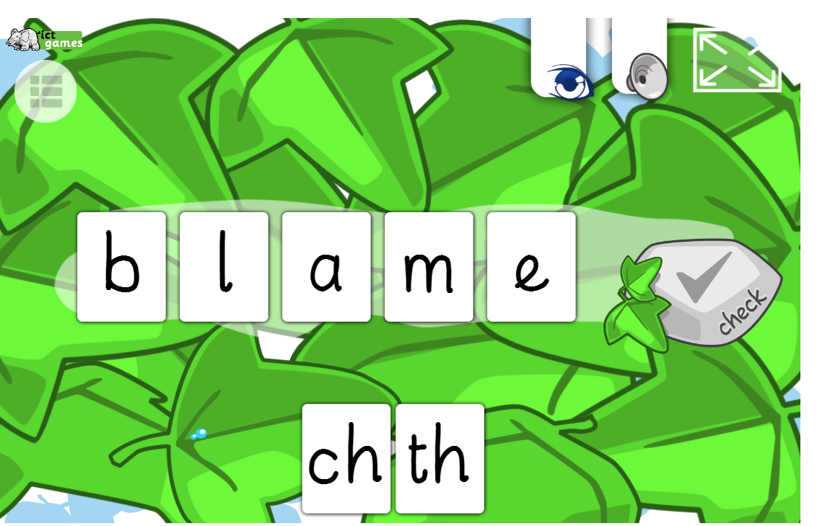

Daisy challenge: log onto Oxford owl or Epic and download an ebook to read.
Enjoy as many books as you can over the weekend.

Maths task:
Play the toy shop money game https://www.topmarks.co.uk/money/toy-shop-money

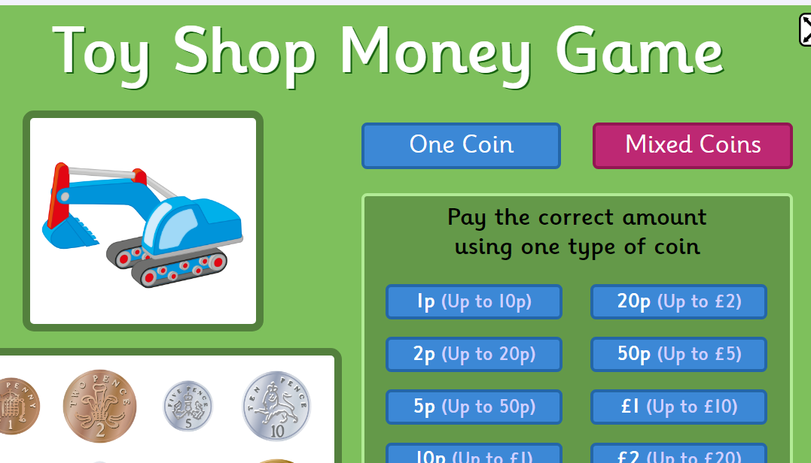 click on ‘mixed coins’
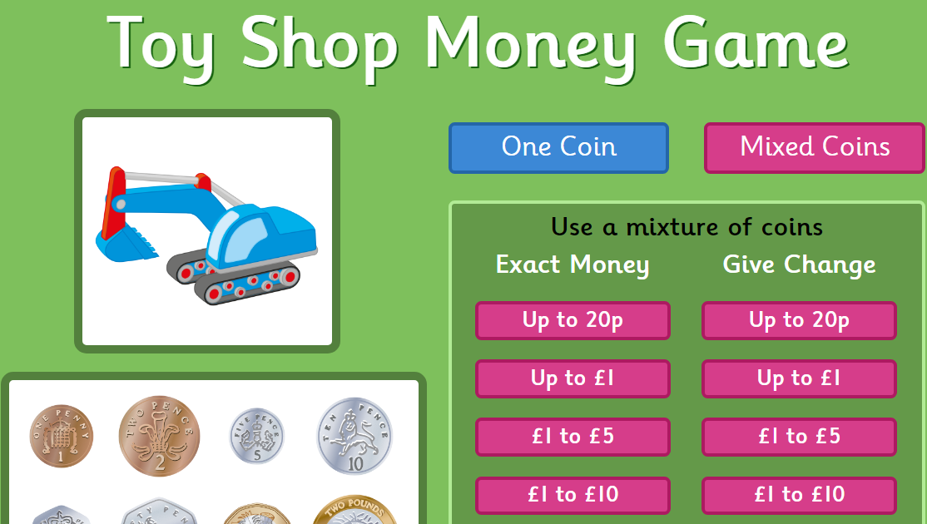select from the ‘give change’ section
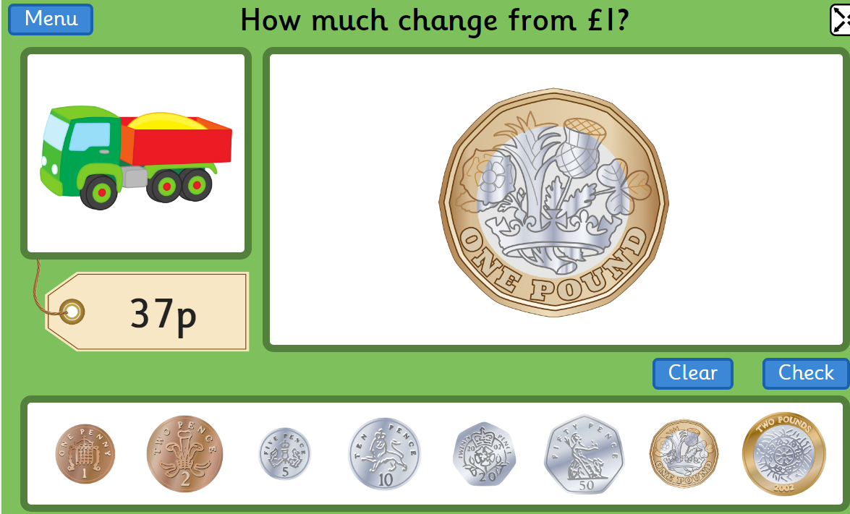 you can use the 100 square or your number bonds to 20 to help.

Daisy challenge: set up your own shop at home and role play using real coins! Take a photo and send it on Dojo.

Art:
The Jolly Roger has been the flag of pirates for many years, it's time for an update! Now that you are a fully fledged Night Pirate can you design a new flag for your pirate crew? You can use pencils, pens, paints, anything you like! Let your imagination run free!

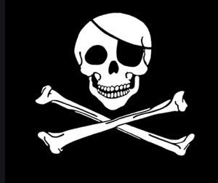

Computing:
Log onto Busy things > Key Stage 1 > Year 1 > Computing > Computer Literacy
Practise typing on Tree Keys

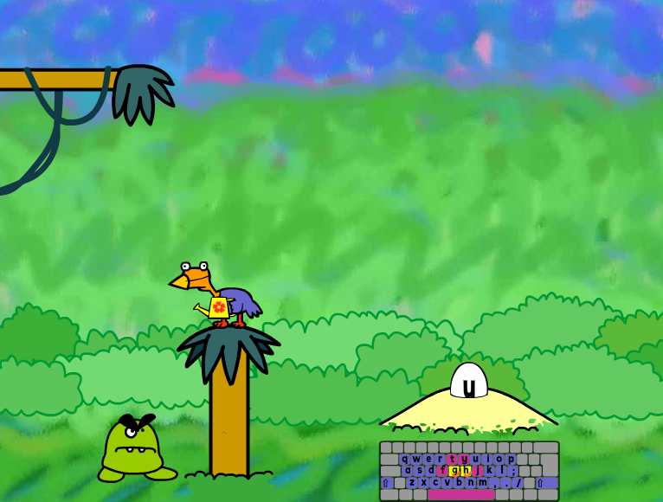

Daisy challenge: Challenge yourself to type words in Bird Words!



