Thursday
Writing task:
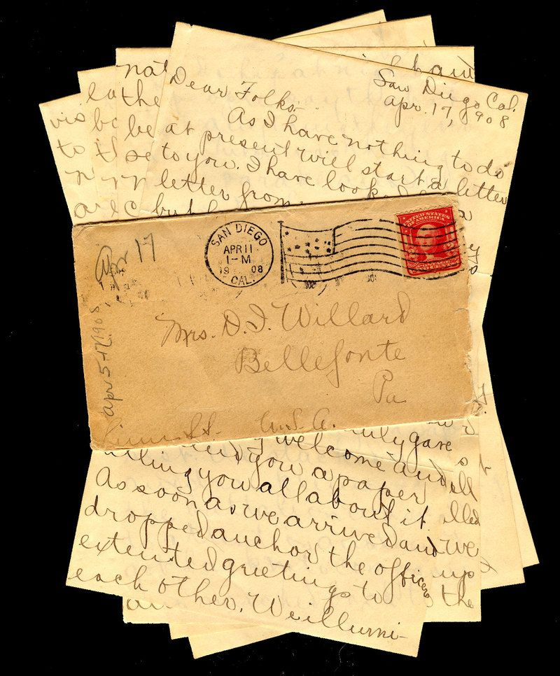
Yesterday you designed yourself as a pirate! Now you are going to write a letter to the Night Pirates and tell them why you should be a pirate on their ship.
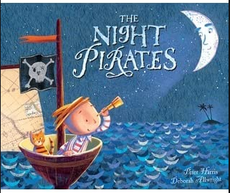

Dear The Night Pirates,

My name is …
I am a … pirate and I have a …
I look like…
I think I would be good on your ship because I can…

Daisy challenge: use your suffixes in your writing (-er, -est, -ing & -ed)

Reading task:

Today you are going on a sound hunt around your home/area
How many things in your house can you find that have the oa (oe, o_e),
igh (ie, i_e) and ee (ey, e_e) sounds in? Write down all the objects you find!
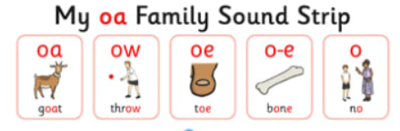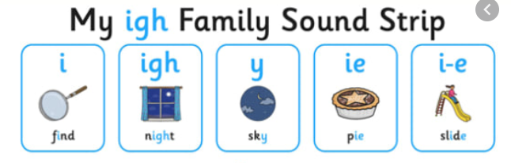
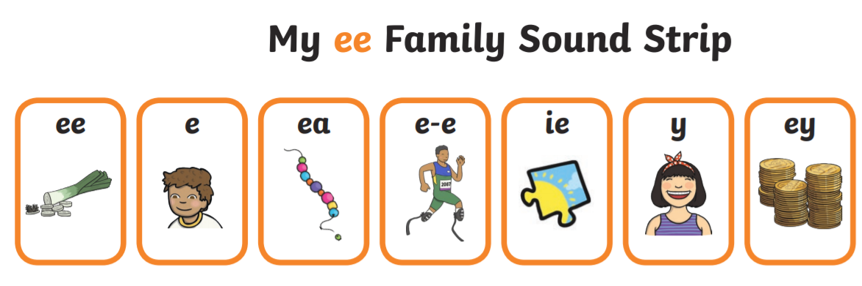

Daisy challenge: Can you write a sentence for some of your words?

Maths task:
Today we are going to look at subtracting 11p from a number.
You need to look up and to the right to find the answer.
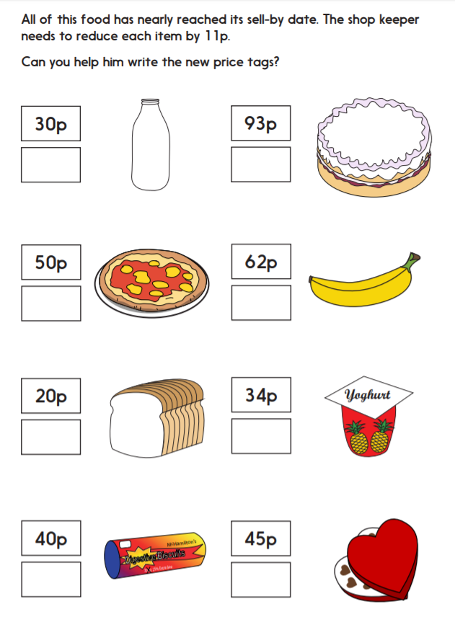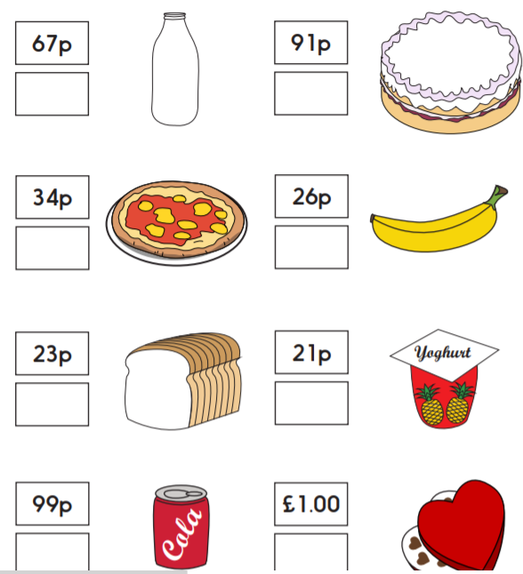

Daisy challenge: play this game and take it in turns to get points. First person to get 5 points is the winner. I’m thinking of a number on this 100 square. I take away 11 and end up here. Point to number. Where did I start?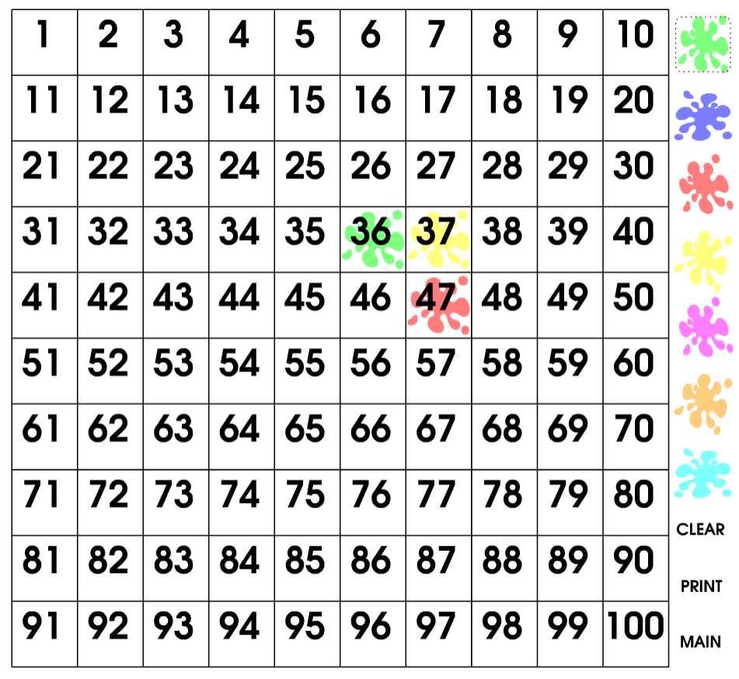
Science:
We have found a new alien planet! NASA wants us to help them to create alien animals to put on the planet. To design our animals we need to create and record some data. Create a table that has 3 different body parts at the top. Roll the dice - whatever number it lands on write it under your first body part then continue until there is a number under each body part - that’s how many of each body part your alien animal will have! Once you’re ready, draw your alien animal and give it a name!

 | tentacles | eyes | mouth
Alien 1 | 7 | 1 | 1
Alien 2 | 0 | 3 | 1

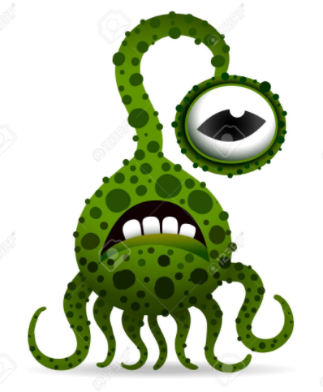

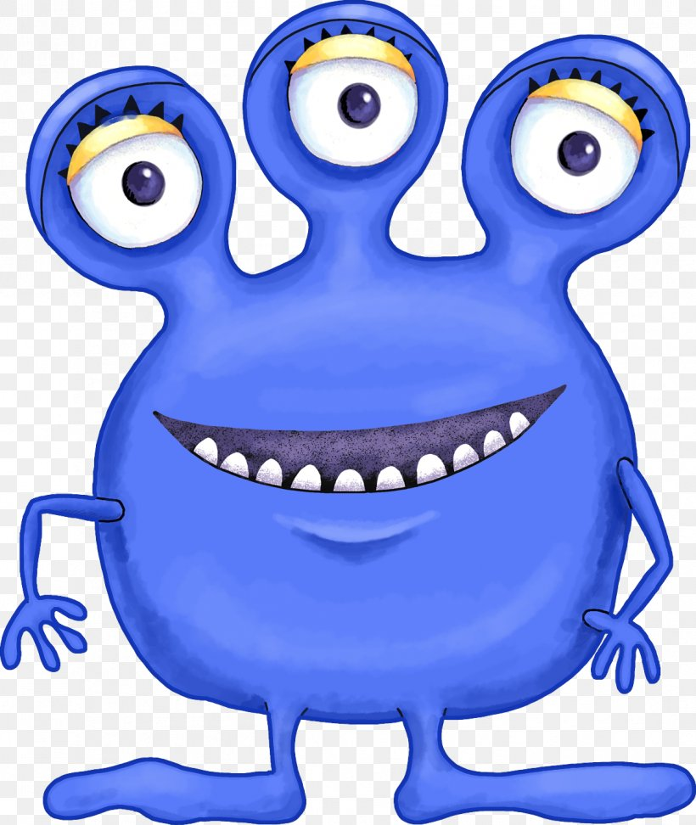
Daisy challenge: Write a fact file about your alien. What is their name? What do they eat? Where do they live? (swamp.desert, forest, etc.) Do they do anything special?

