Wednesday
Writing task:
Having listened to/read part of our story we know it is all about pirates! Our book is called ‘The Night Pirates’. If you were a pirate how would you look? Design your own pirate outfit and new pirate name and describe it using your adjectives and similes
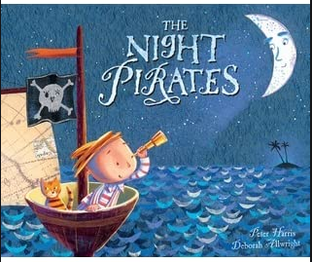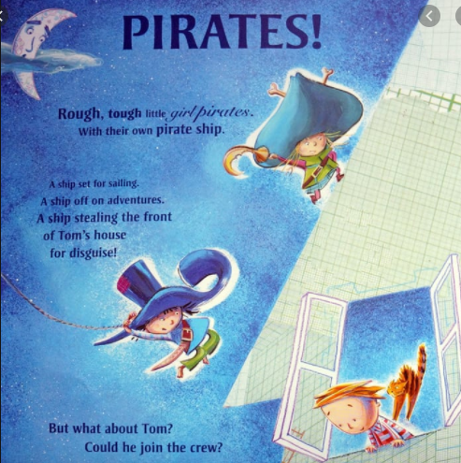

Daisy challenge: use your suffixes in your writing (-er & -est)

Reading task:
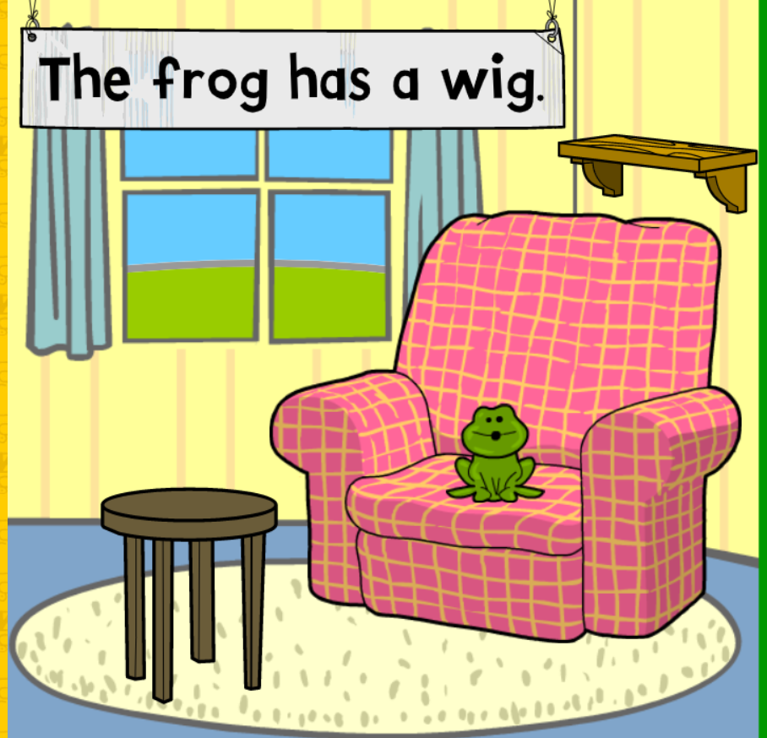
Have a go at playing ‘read the caption’.
To find the game click on:

Year 1 -> English -> phonics programme -> phase 2,3 and 4 -> further activities -> read the caption

Daisy challenge: have a go at the phase 5 alternative sounds activities!

Year 1 -> English -> phonics programme -> phase 5 and alternative sounds.

Maths task:

Today we are going to look at subtracting 10s from numbers using our take away sign -
Pick a number from 50-100 this time and roll your dice to find out how many 10s you are taking away now.
When we were adding we would move down the 100 square, when we take 10s away we move up. Have a go at writing the number sentences
57-20 = 37
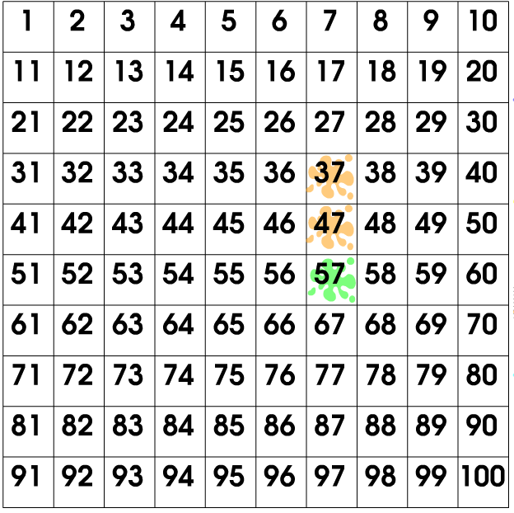
Daisy challenge:
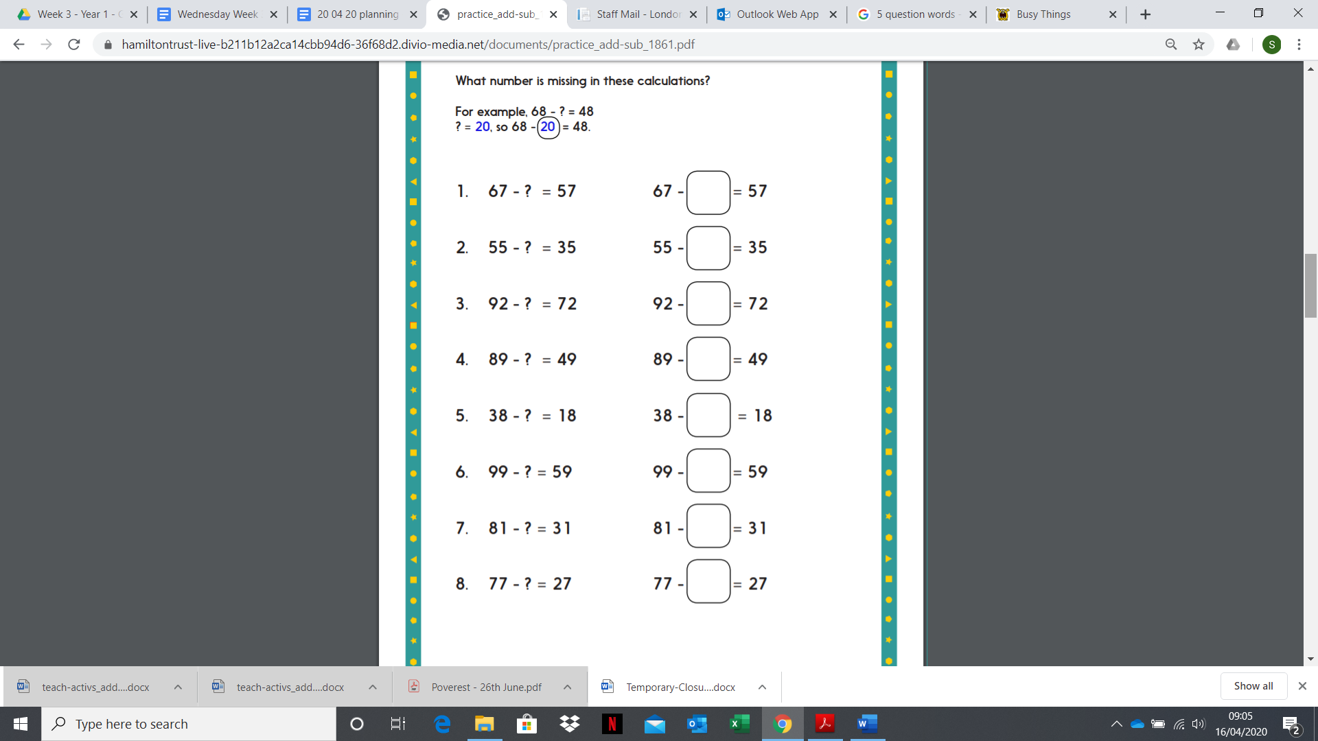

Geography:
You are now an expert in the history of your landmark! Can you now become an architect now create your landmark out of your construction toys or paper?
Daisy challenge: can you make a poster of your landmark to persuade people to visit? You can use a picture of your creation or draw it out and add your information in a creative and colourful way!
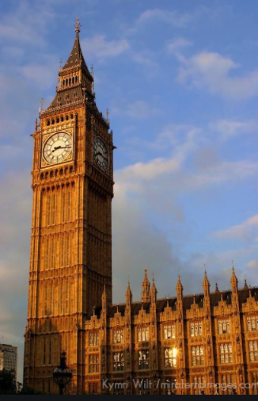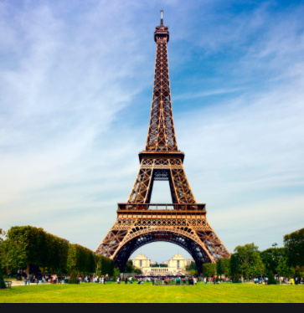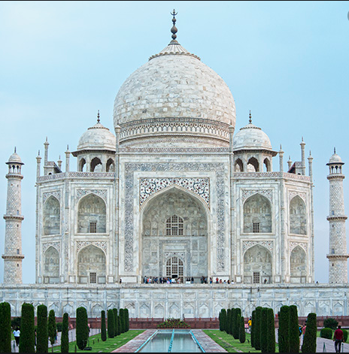
Big Ben, UK The Eiffel Tower, France The Taj Mahal, India

Art
Draw a picture of your pirate!

