Thursday
Writing task:
Now you have tables with words using all your year 1 suffixes (-er, -est, -ing & -ed) can make a poster on how to make the world a better place according to the dinosaurs? Make sure it’s bright, colourful and has lots of words with suffixes added!

Root word | - -ing | - -ed
drop | dropping | dropped
pick | picking | picked
stamp | stamping | stamped
clean | cleaning | cleaned
tidy | tidying | tidied
wipe | wiping | wiped
plant | planting | planted
grow | growing
*to say something was grown in the past you write grew

Reading task:
Read this short story and highlight/write out all the words with digraphs in. After answer the questions about the story
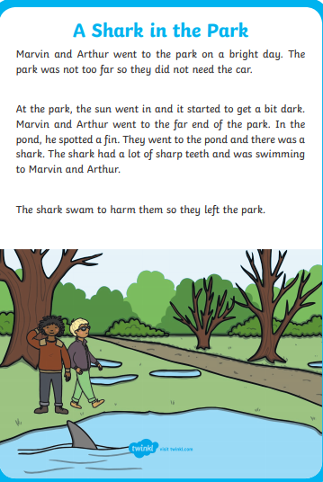

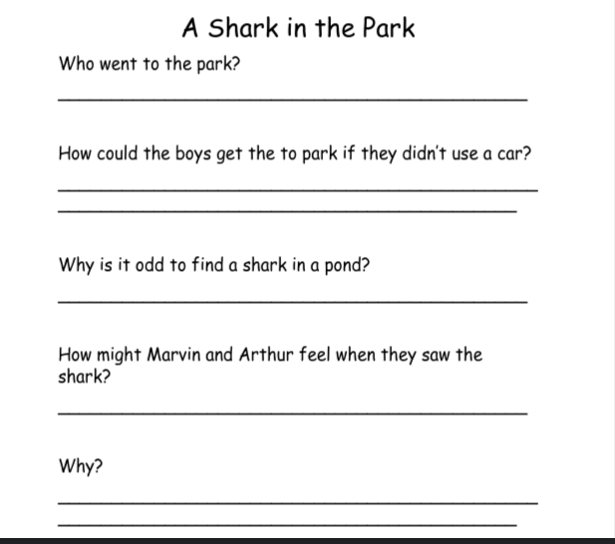

Maths task:
Today you are going to play clock master.

You need to keep an eye on the time and complete the list of challenges below at the correct time:

time | Activity
8:30am | 10 star jumps
9:00am | 20 squats
10:30am | Push ups for 30 seconds
11:30am | Pretend to be a sleeping lion for 1 minute
1:00pm | Elbow bump all of the people in your house
2:30pm | Spin in a circle
3:00pm | 12 big jumps to touch the sky
3:30pm | Make a drink for your adult!

Daisy challenge: make up your own clock master challenges!

Science task:
Pick 2 flowers from your garden or local area, you are going to conduct a little experiment. Put one flower in some water and keep it in a sunny area in your home. The other flower must also be in water but put it in a dark space. Keep an eye on your plants and record what happens after 3 days

