Monday
Writing task:
Listen to/ read the story on Dojo, the dinosaurs have come back to help clean up the man’s mess!
As a dinosaur, can you write some instructions on how to clean up the world and make it a nicer place?
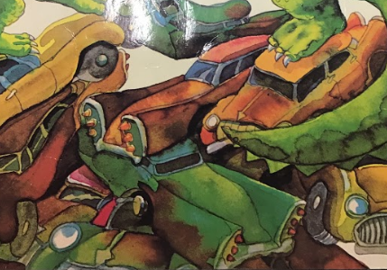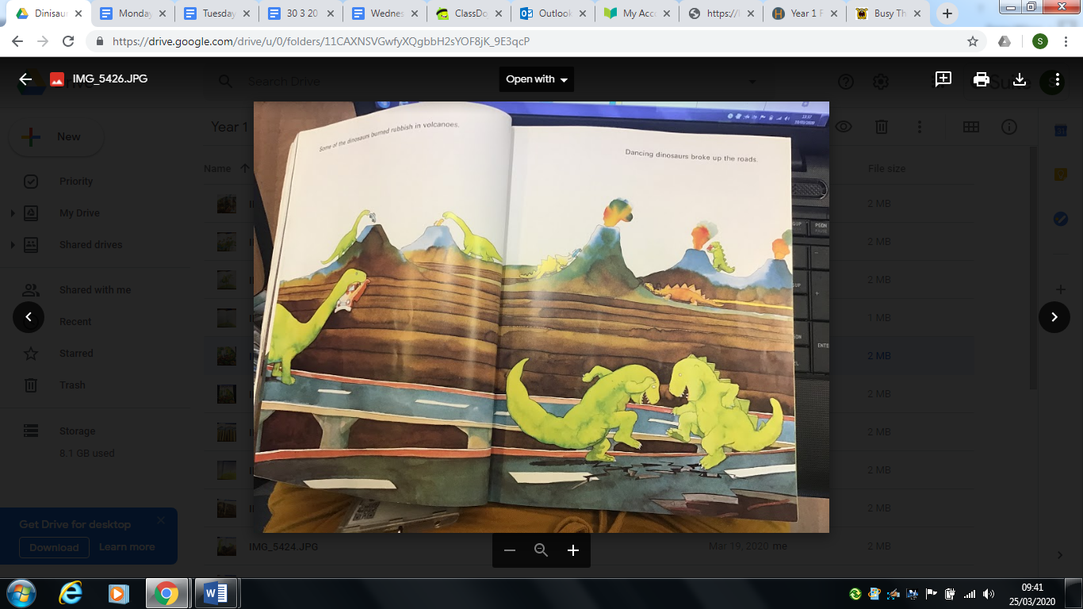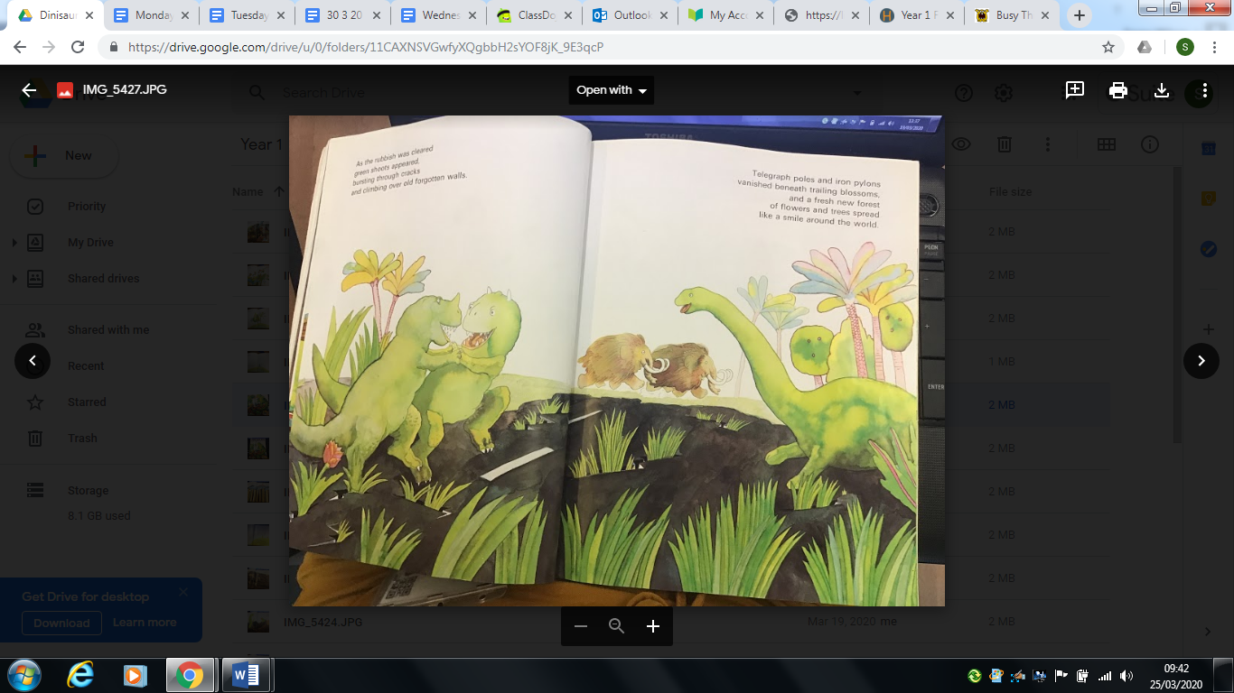
Use these time conjunctions to order your writing:
First
Second
Next
Then
After
Finally/ last

Daisy challenge: use adjectives to describe.

Reading task:
Pairs game.
Have a go at this pairs game on phonics bloom.
https://www.phonicsbloom.com/uk/game/word-pairs?phase=4

Alternatively, make your own pairs game using the year 1 common exception words which are on Class Dojo.
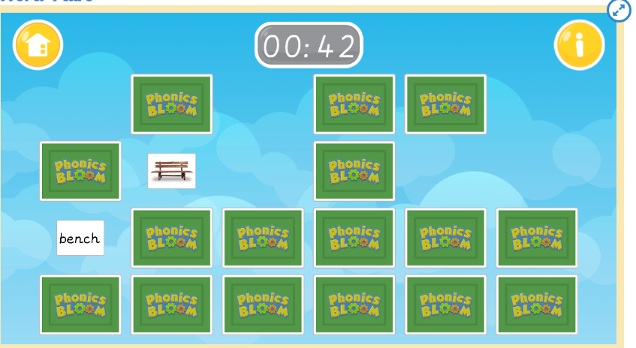

Maths task:
Time
We have learnt how to tell the time to o’clock - knowing that the long (minute) hand points at the 12 and the hour hand points to what hour it is!

Now we are looking at times which are called ‘half past’. This is when the minute hand has travelled halfway round the clock pointing at the six. The short hour hand moves between the hours, so if it was 3 o’clock the hour hand will be between the 3 and the 4!

Task:
Use an old clock or log onto busy things (go to maths> measures> ‘The clock’) and have a go at making these times, what might you be doing at these times? (Busy things will help you think about that!)

9:00am 9:30am
11:00am 11:30am
1:30pm 3:30pm 12:30pm
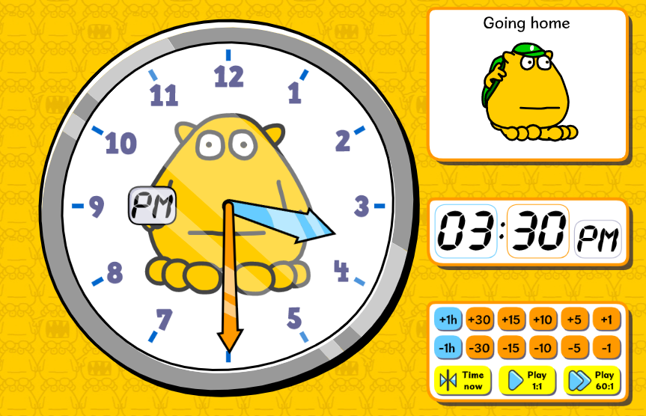
Daisy challenge: draw out the clocks and their hands.

PE:
https://www.youtube.com/watch?v=gCzgc_RelBA

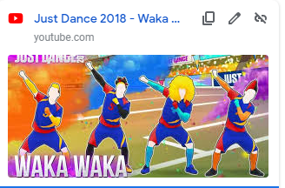
For PE we would like you to have a go at a Just Dance. It is so much fun especially when everyone gets involved…

Music:
Sing the song ‘Row Row Row your boat’ and play along with your instrument! Can you change the words to make it about a different mode of transport?

E.g. scoot, scoot, scoot your scooter
Quickly down the path
If you see a muddy dog
Please give it a bath!

