Friday
Writing task:
Make a list of rules which both the man and dinosaurs will have to come up with to make sure they keep their world nice. See if you can link these with any of the rules we have in our classroom or at home.

Daisy challenge: use a question mark/ exclamation mark in your writing.

Reading task:
Play a game of Obb and Bob on Phonics Bloom.
https://www.phonicsbloom.com/uk/game/odd-and-bob?phase=4

Please click on “revise all” to get a good range of sounds.
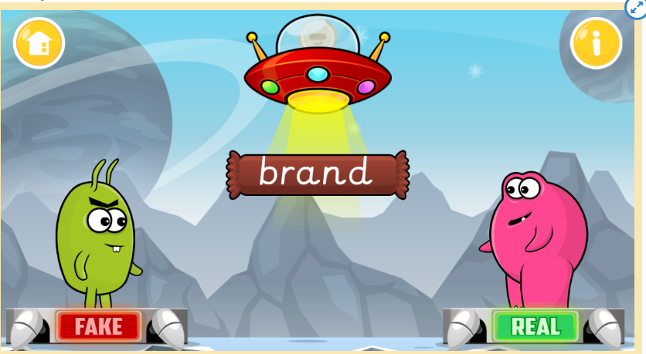

Maths task:
Draw a timeline of your day making sure to write down the times you do things. Here’s a little example:
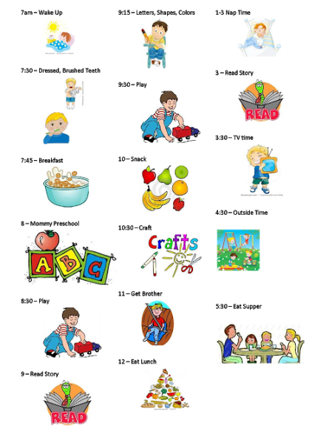

Daisy Challenge: can you draw the clocks next to each of your activities?

Art task:
It is almost Easter time!
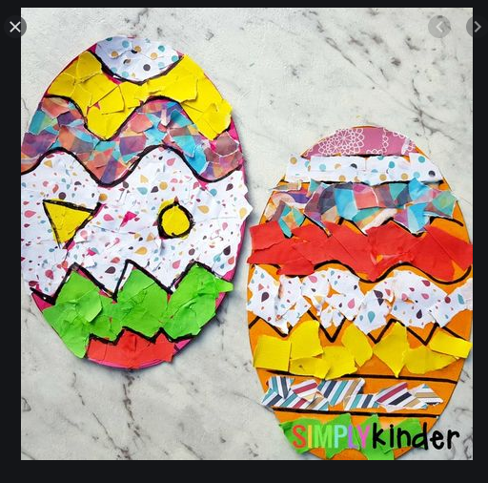
Decorate an egg - be as creative as you like. It could be 3d, 2d, paper mache, paint, collage, paper… the list is endless!

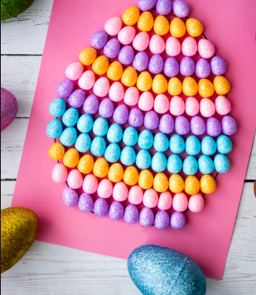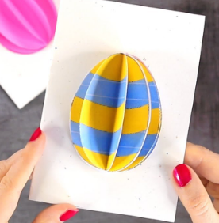

Computing task:
Log into your PurpleMash and continue to practise touch typing on the 2Type programme. Once you’ve done that, go to the games section of PurpleMash and play a bit of ‘Bond Bubbles’. Pop the bubbles by making number bonds!

