Wednesday
Writing task:
Today you are going to add ‘ing’ and ‘ed’ to words. Tomorrow you are going to use these in sentences for a very important job!

Root word | - -ing | - -ed
drop
pick
stamp
clean
tidy
wipe
plant
grow

Reading task:
Play ‘Make a Caption’ on Busy Things.
Year 1 > English > phonics programme > phase 2,3,4 > further activities

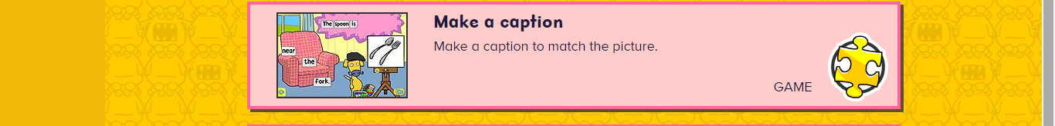
Maths task:
Look at the times in the table below. Write out the times +1 hour and -1 hour?
+1 hour- the minute hand goes round the clock once until it gets back to where it began.
-1 hour- the minute hand must move backwards round the clock.
Use the clock on Busy Things to help you.

-1 hour | time | +1 hour
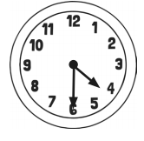
Half past four
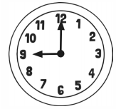
Nine o’clock
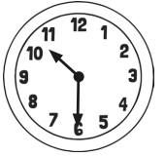
Half past ten
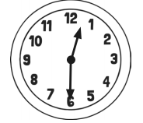
Half past twelve

Daisy challenge: make up your own times and add 1 hour/ take away 1 hour.
Can you add 2 hours? Take away 2 hours?

Geography task:
Take a short walk around your local area, talk to your adult about what you can see and where things are. Once you get home draw a map of your area.

daisy challenge create a key for your map!

