Tuesday
Writing task:
Read back through the parts of the story you have seen so far. The dinosaurs have spent a long time clearing the mess that the man made.
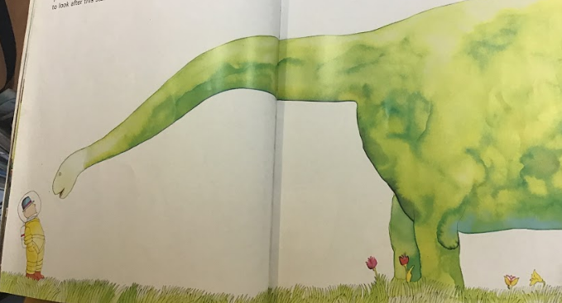

Your task is to write what you think the dinosaur would say to the man when he comes back to earth.
Use these sentences starters to help if you need them
I feel… because…
You need to…
We have …
If you come back to earth you should…
When you left the earth was… now the earth is…

Daisy challenge: to use the endings est/er/ing/ed in your writing.

Reading task:
Yesterday you did some beautiful writing. Now have a go at finding the phase 5 digraphs (from the sound mat on Dojo).

If you can’t find any in your writing, can you add any in? Make a word with the phase 5 digraphs and put them into a sentence.
Try and remember your rules for using the digraphs (e.g. ‘ai’ comes in the middle of a word but ‘ay’ will come at the end)

Maths:
Look at the times given below, can you label them with the correct time? Remember, the minute hand points to the 12 when it’s o’clock but will point to the 6 when it is half past

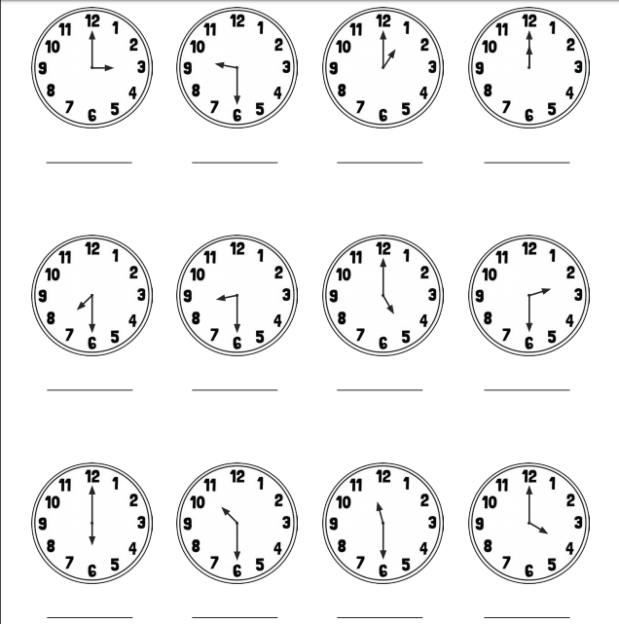
History:
We have been looking at the differences between schools in the past and schools now. We are going to now look at the changes in our local area (Orpington!) Have a look at these pictures - can you match the picture from the past to the picture of that area today? How do you know it’s the same area? What’s changed? What’s stayed the same?


