Wednesday
Writing task:
Using the table we filled in yesterday, can you write a description comparing these two pictures from our new class book.
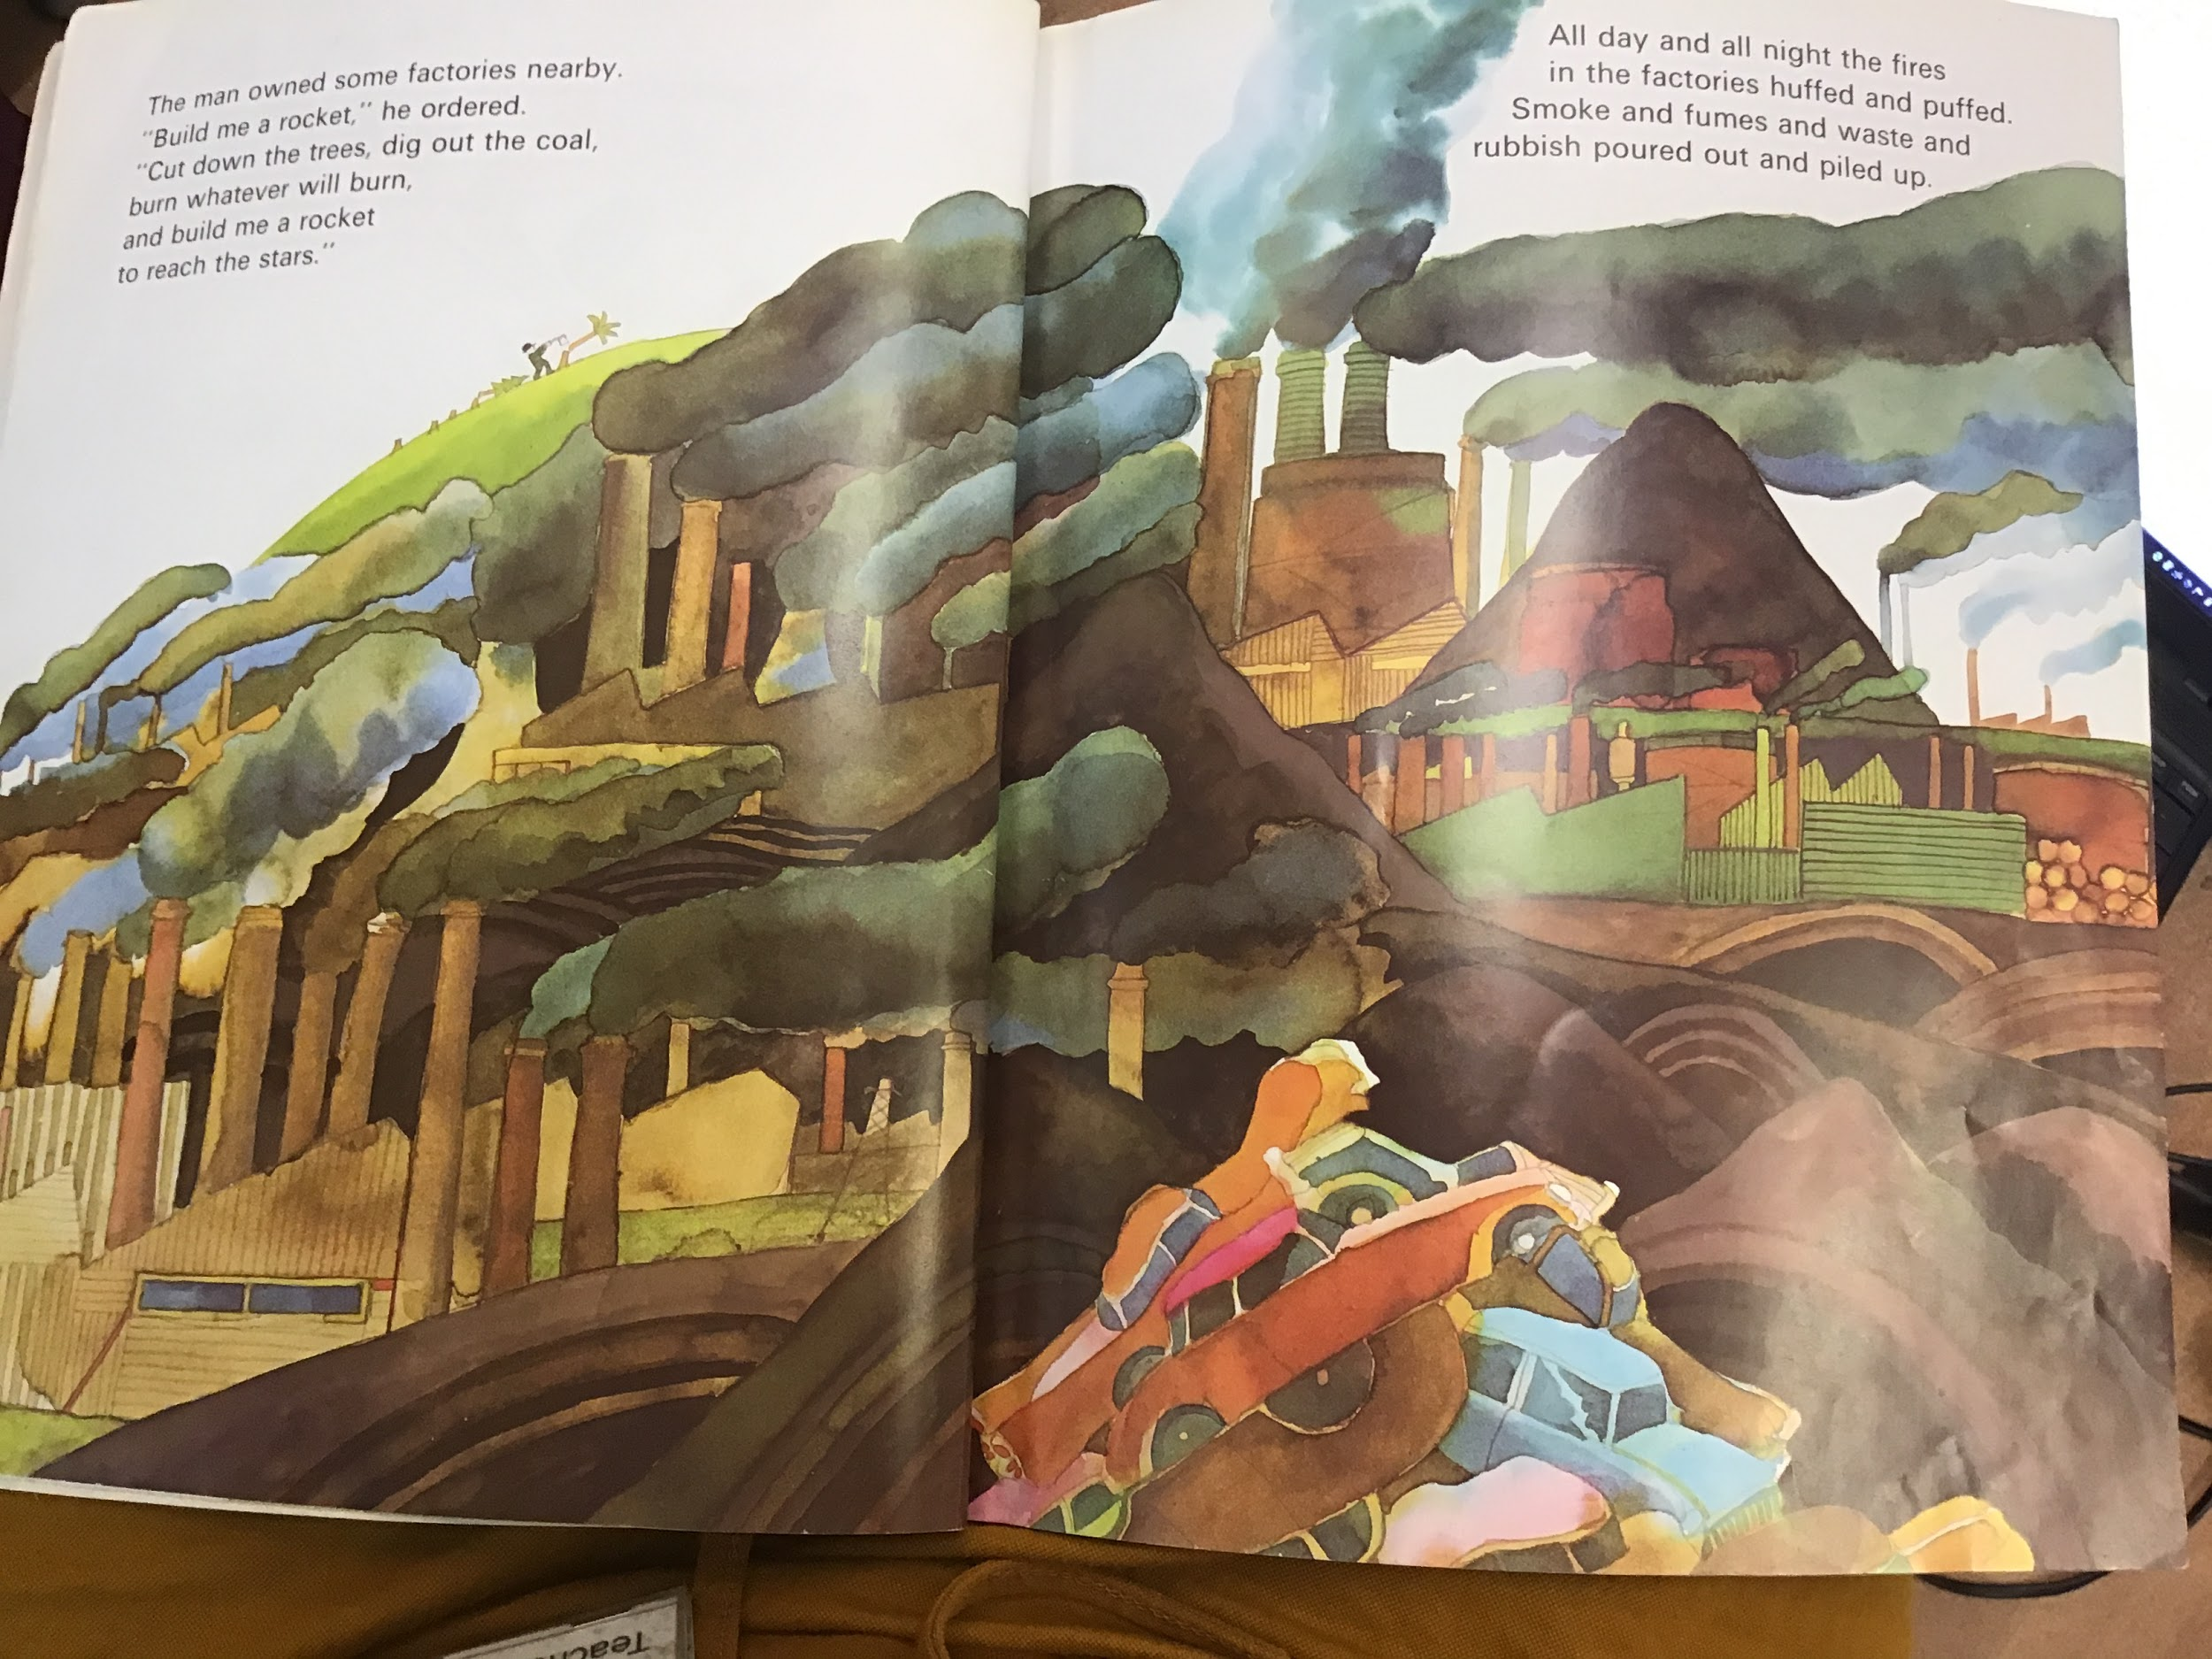
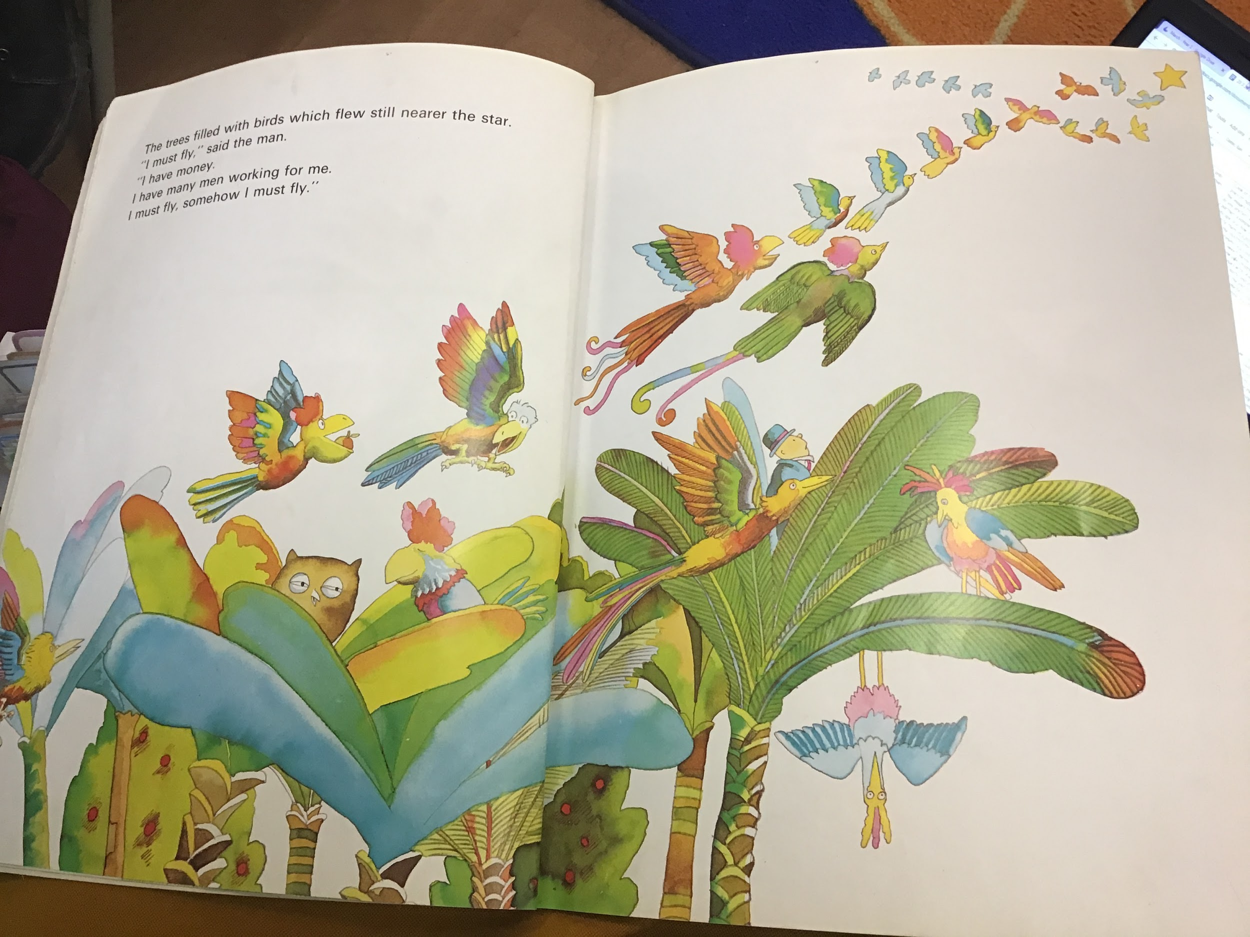

Root word | - -er | - -est
bright | brighter | brightest
green | greener | brightest
long | longer | longest
big | bigger | biggest
small | smaller | smallest
dark | darker | darkest
cold | colder | coldest
warm | warmer | warmest
soft | softer | softest
sweet | sweeter | sweetest

Maths task:
Today we are going to make a number bonds pairs game - can you make cards from 0 - 20? You can use paper, card, cereal boxes?

Example:

1 | 2 | 3 | 4 | 5 | 6 | 7 | 8 | 9 | 10
11 | 12 | 13 | 14 | 15 | 16 | 17 | 18 | 19 | 20

Use your pairs cards to play number bonds pairs! Can you find them all? Why don’t you play against someone in your family and see who can get the most pairs?

Science task:
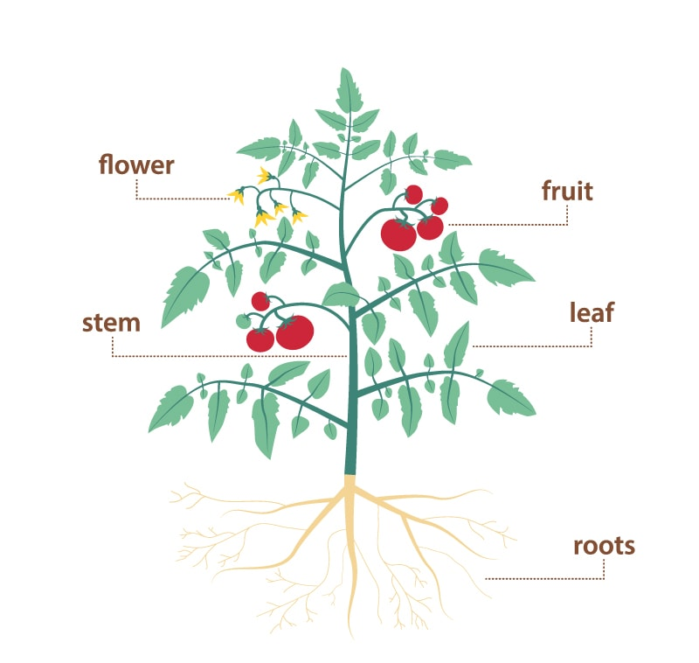
Here is a labelled picture of a plant. Use the Kiddle website (a child-friendly search engine) to research one part of the plant and write down what it does. Are there different types of that specific plant part? Can you draw them or name them?

