Tuesday
Writing task:
We are starting a new class book called ‘Dinosaurs and All That Rubbish!’
Add the -er and -est suffix to these adjectives!
When you add -er to an adjective you are comparing two objects (The rabbit is faster than the tortoise.)
When you add -est to an adjective you are saying that is the best suited to that adjective! (The rabbit is the fastest!)

Root word | - -er | - -est
bright
green
long
big
small
dark
cold
warm
soft
sweet

Maths task:
Yesterday you looked at number bonds to 20.
Today you are going to make the number bonds with objects.

Get out 20 objects (you could use pieces of cereal, small toys, cutlery)
Now make the number bonds to 20 using the objects. For example:
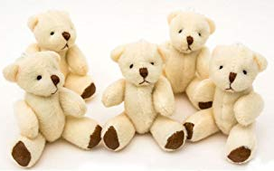 +
10 + 10 = 20

You could take photos and send them.

For your daisy challenge can you write out the number sentences to match?

Reading task:
Grab any old newspapers and magazines - colour in the digraphs and trigraphs you see! If you don’t have any newspapers at home grab some of your books and write down the words with digraphs and trigraphs you see- can you put in your sound buttons?

DT/Art task:
Now it’s time to get creating! Start making your musical instrument! Think about how you will need to attach parts to it and how would you decorate your instrument?

