Thursday
Writing
Read the class pages on Dojo.
Today we are going to pretend to be the man who wants to visit the star. We are going to write a diary about what happens to us as we go on our journey. Where do we start our journey? What does the earth look like - remember to use the -er and -est suffix!

Here is a little story map of our day:
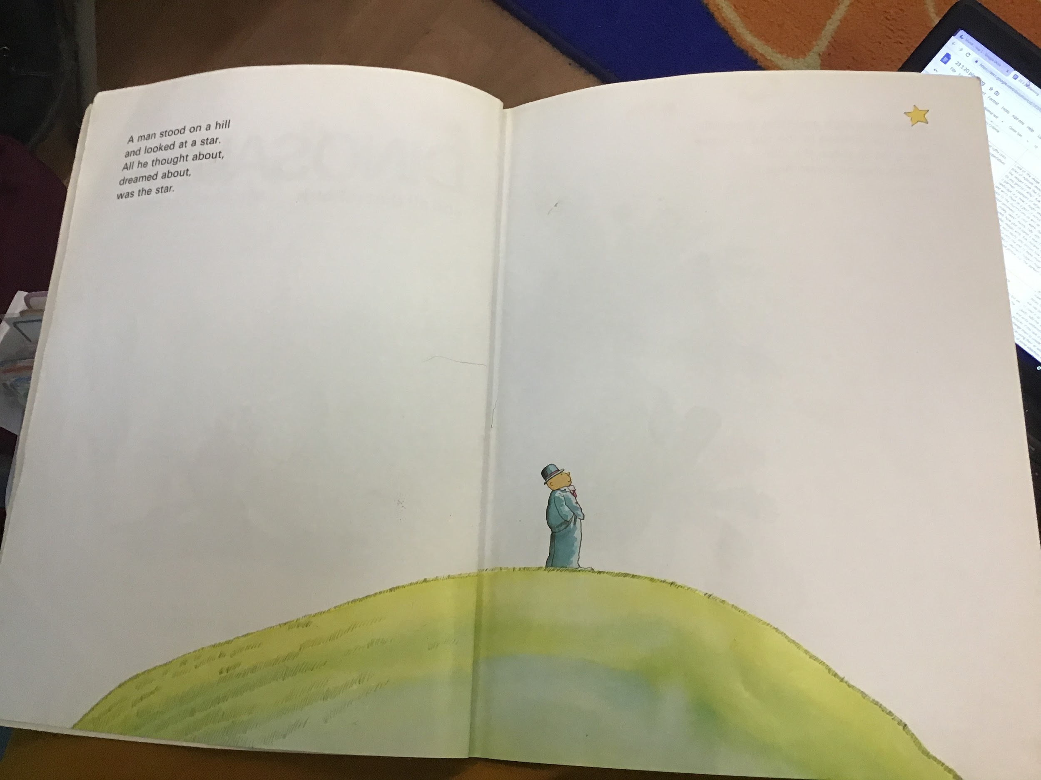

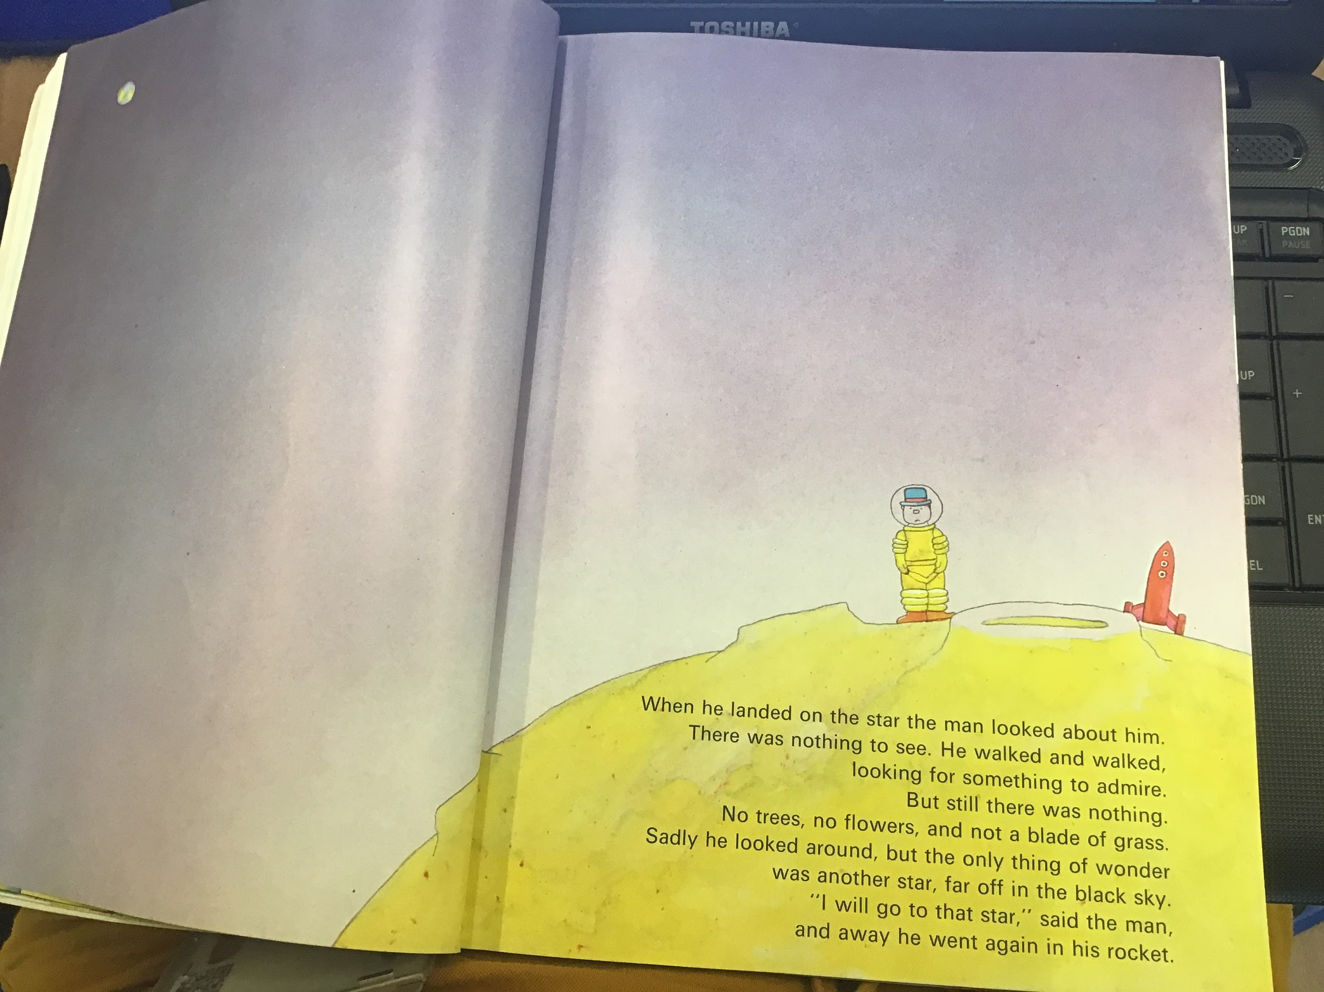
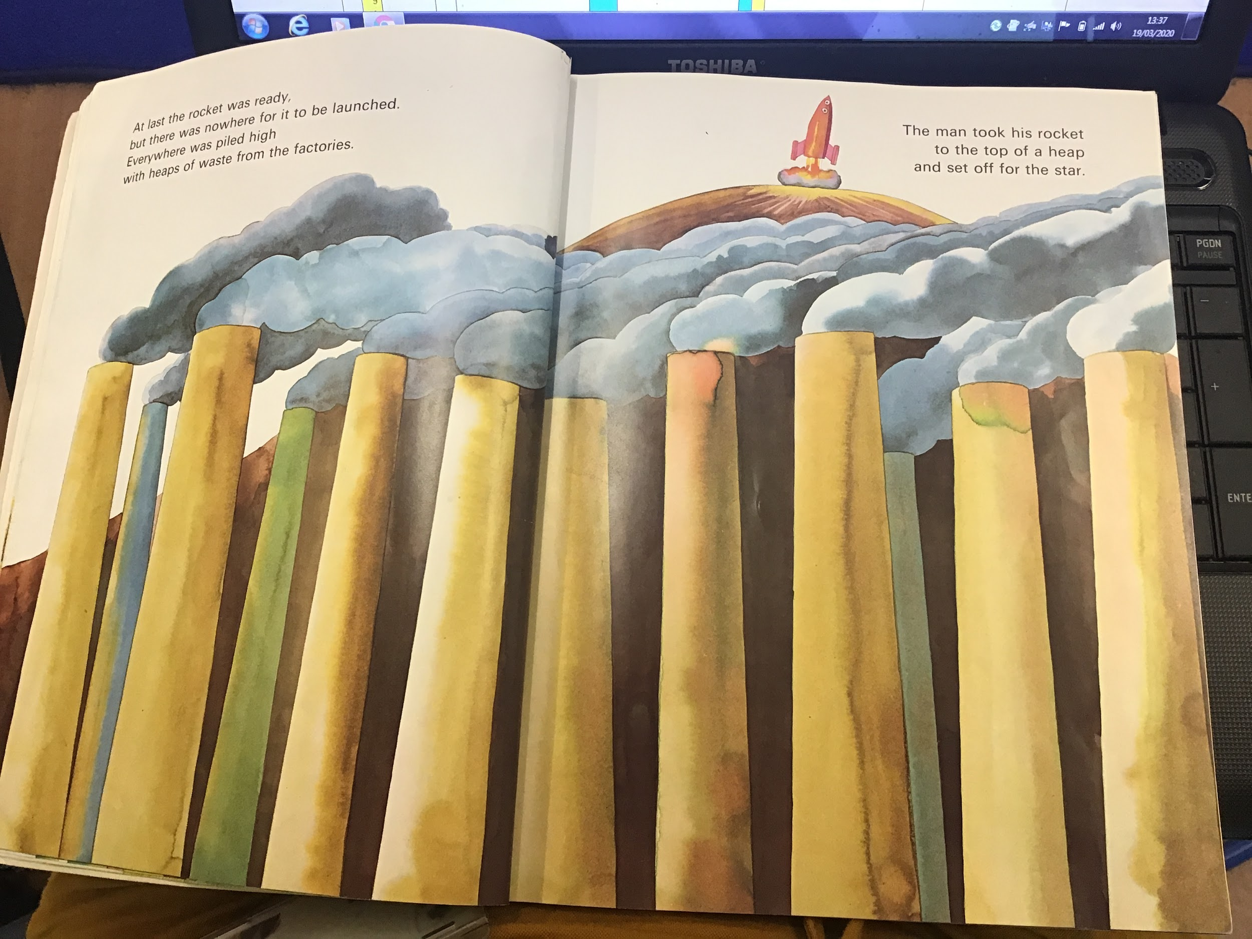

Reading task:
Today you are going to play the ‘read a caption’ game on Busy Things.

https://www.busythings.co.uk/play/

Maths task:
Use the splat square or the 100 square below. https://www.primarygames.co.uk/pg2/splat/splatsq100.html

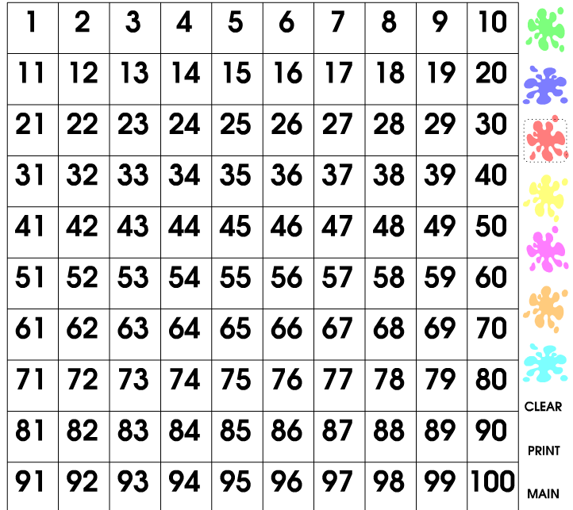
splat/ mark one number. Now splat/mark another number. How many jumps does it take to get to the second number. Write this as a number sentence.

Start with 0-20! It will look something like this:
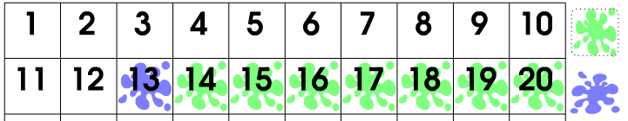
13 + 7 = 20

Computing task:
Log into PurpleMash www.purplemash.com/poverest
Click on the computing icon 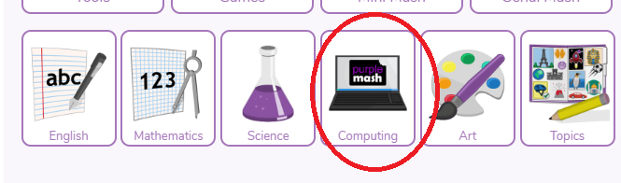
Click on the 2Type programme
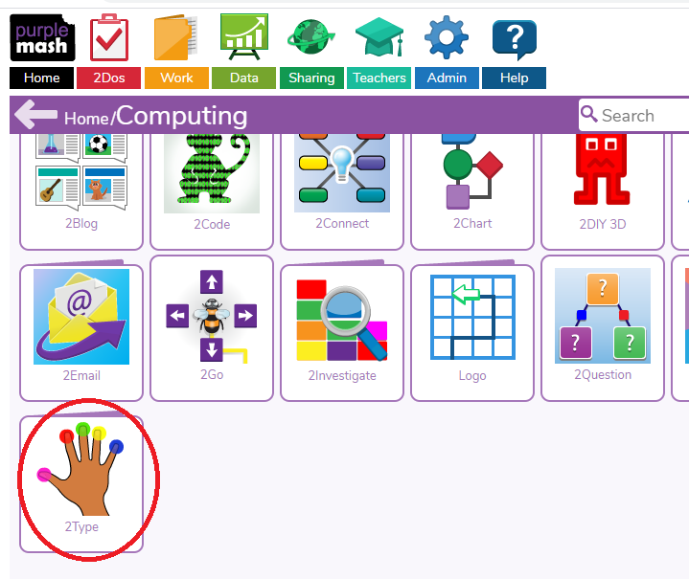

Start on first steps and practise touch typing! 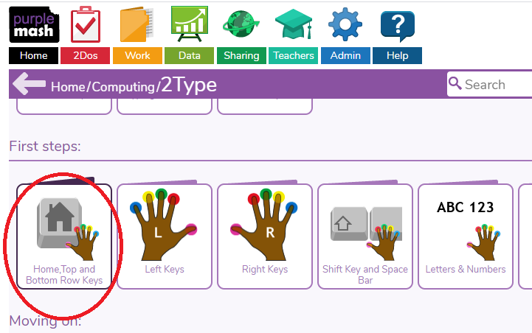

Geography
Make a map of your house. Remember to use a birds eye view and have a go at creating a key.

