Friday
Writing task:
Listen to this piece of music:

https://www.youtube.com/watch?v=l-dYNttdgl0
It’s called ‘Spring’ by a composer called Vivaldi
Write about how this piece of music makes you feel. What does it remind you of? How do you think the man in our story would feel listening to this?

Maths task:
I bet you are number bonds geniuses by now! Why not use the Numbots app to have a practice? Your log in is the same as your TTRockstars log in.

Reading task:
Have a go at reading the fact sheet about bats. Once you have done that, answer the questions below by writing the answers or telling an adult.
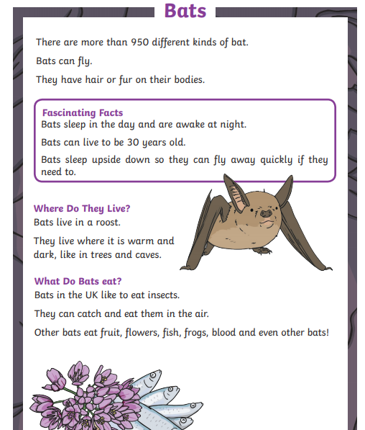
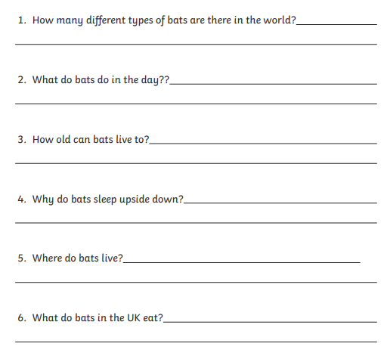
Creative task:
Finish off your instruments if you need to and play them! Can you play along with the song from our writing task? Why not share a video on the dojo portfolio!
PE task:
Get your maths brains and your bodies going with this Digit Dance from Supermovers!
https://www.bbc.co.uk/teach/supermovers/ks1-maths-digits-&-numbers-with-marlon-wallen/zfyjbdm

Bedtime story:
Here’s a link to Oliver Jeffer’s reading stories for a bedtime treat!
https://www.oliverjeffers.com/books#/abookaday/

Sweet dreams year 1

