Monday
Writing task:
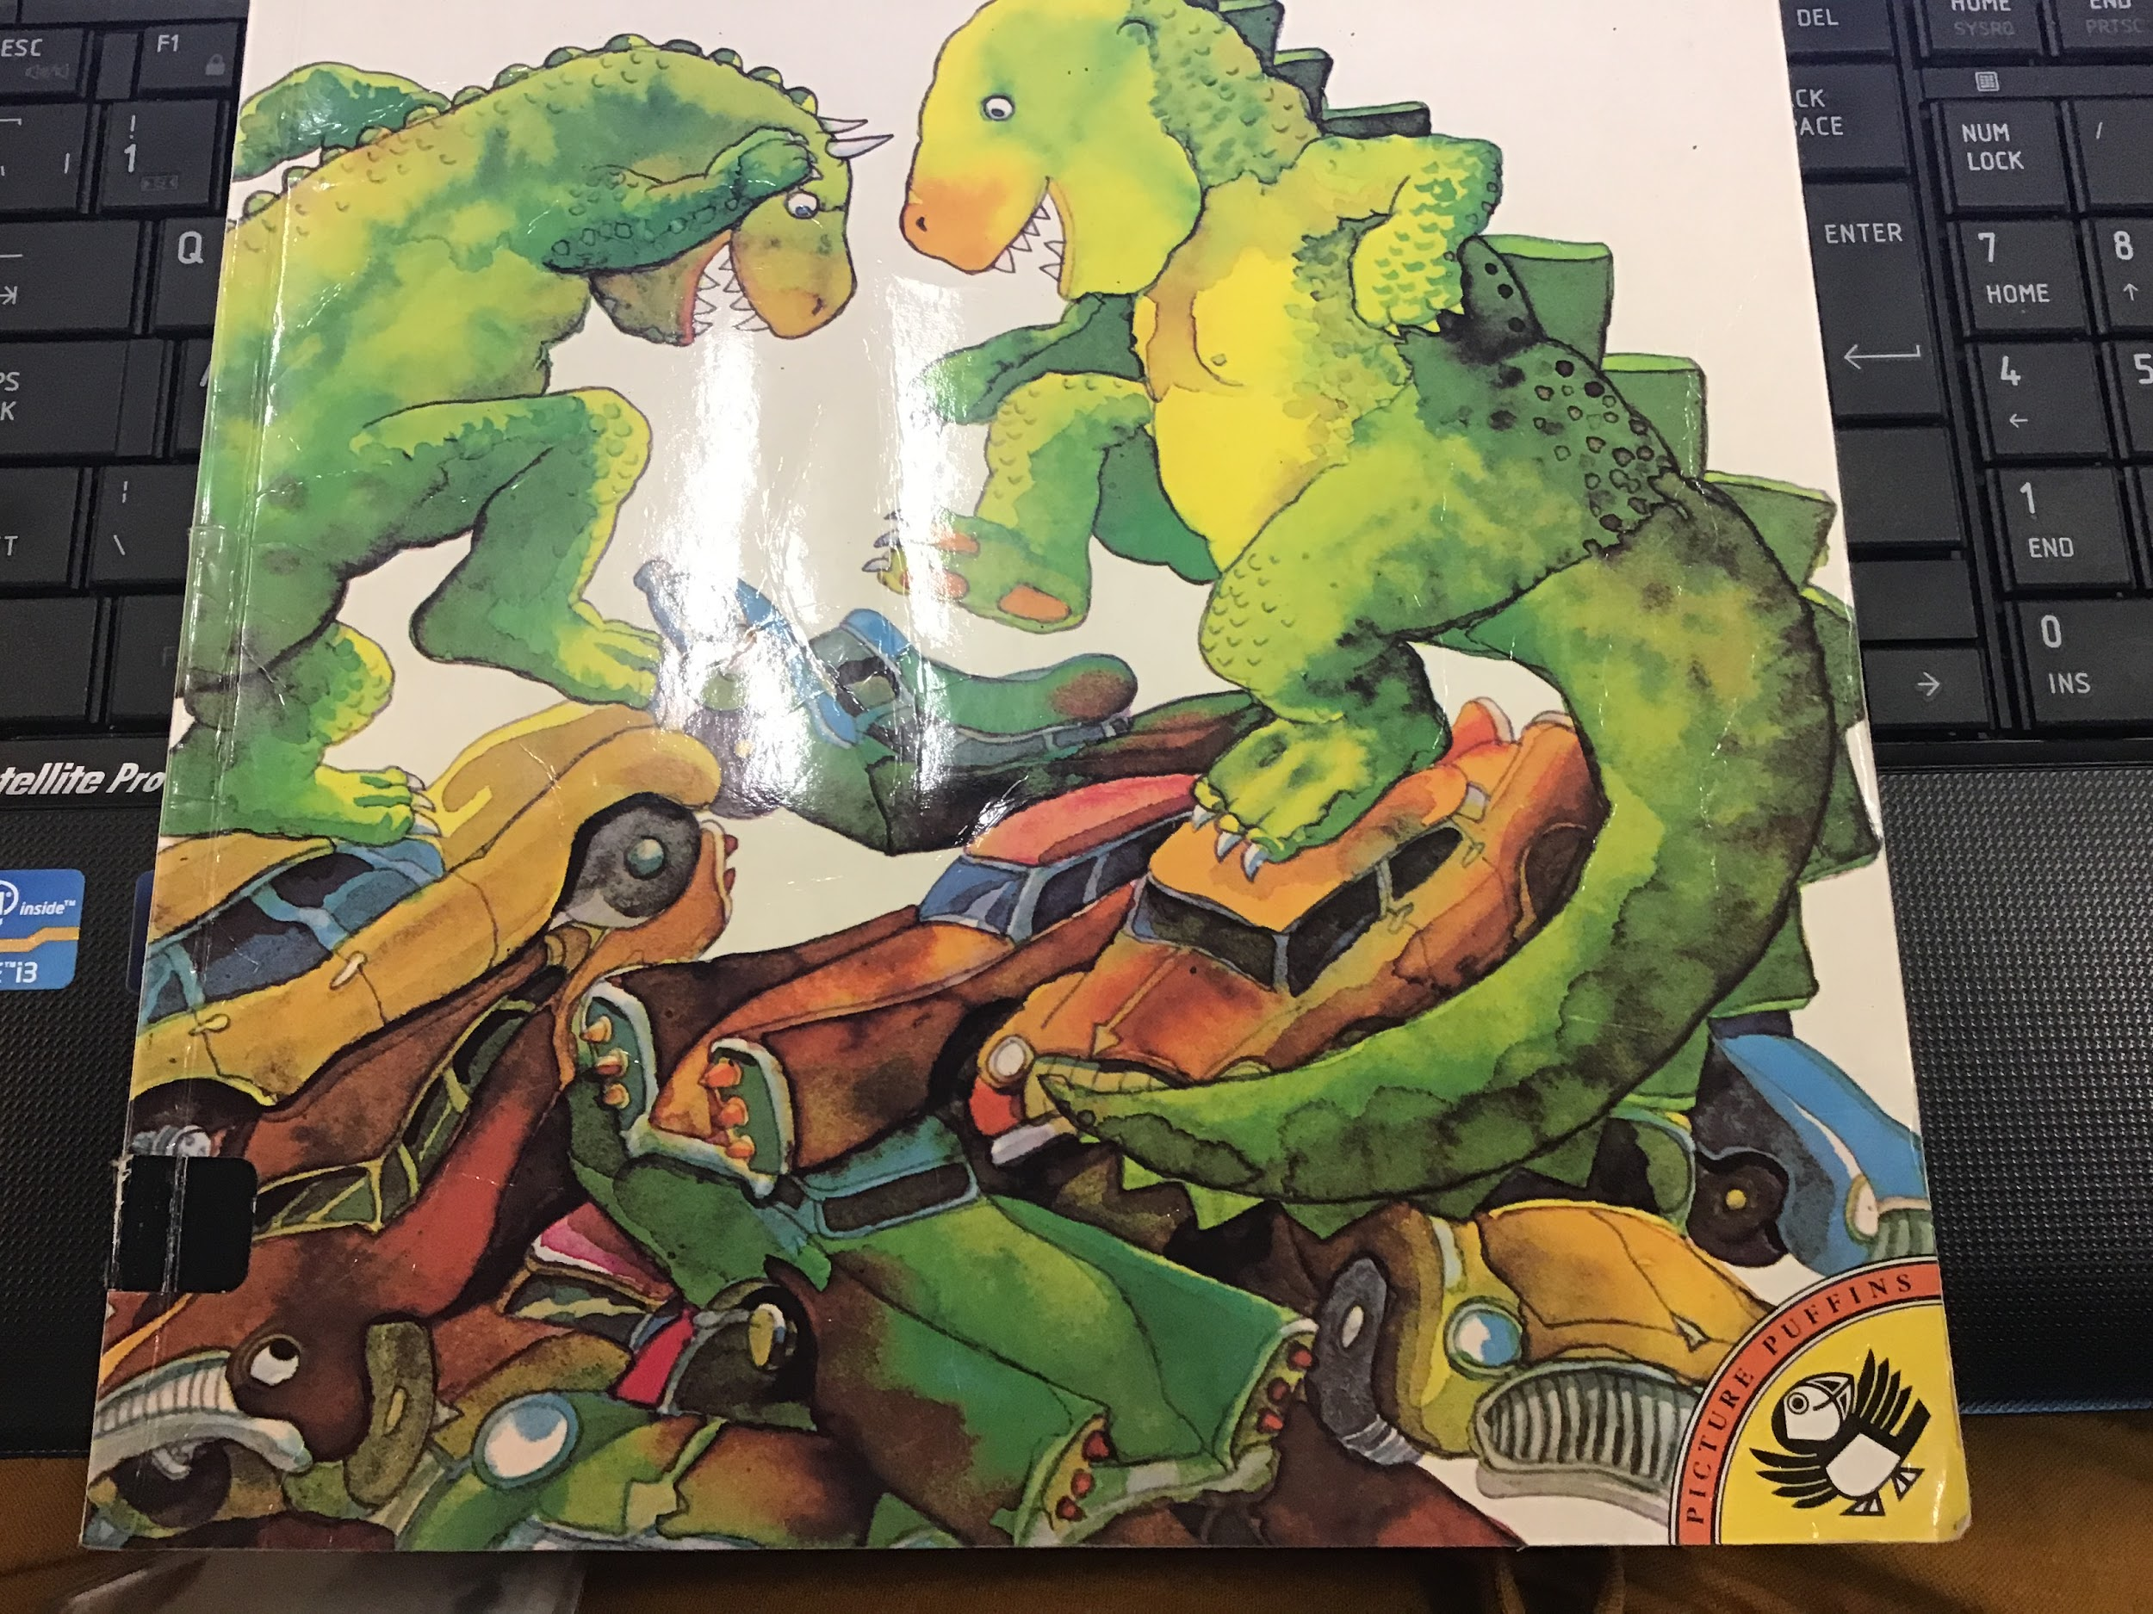
This is a picture of the front cover of our new class book! Can you write a prediction of what you think it might be about?
Here are some questions that might help you:
What are the dinosaurs doing?
Why are they doing it?
How do you think they feel? Why?
Where are they?

Remember to include some nice adjectives!
Your daisy challenge is to try and include some similes!
Reading task:
Today you are going to complete a “Busy Things” activity. Log on to Busy Things with your LGFL username and password. Go to the Key Stage 1, Year 1 area. Once you are there click on English and then the ‘Phonics Programme’

Maths task:
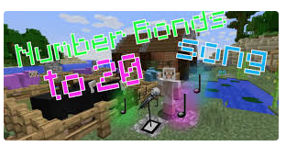
Listen to this Minecraft number bonds song. https://www.youtube.com/watch?v=-_NACf1BtE8
Have a go at making your own number bonds picture. You could make a rainbow just like the one below.
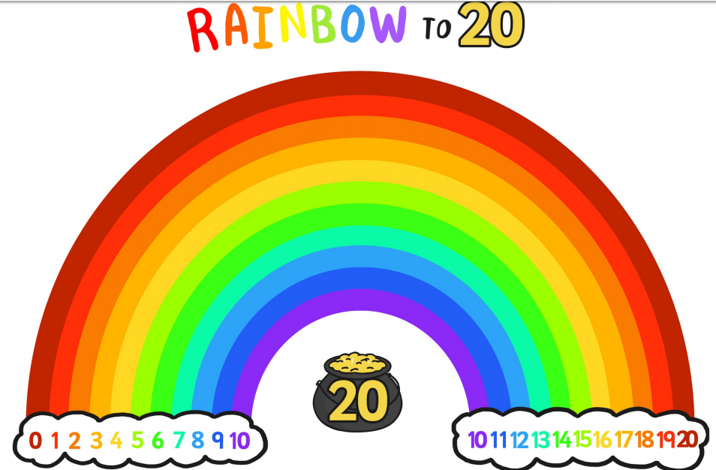

DT/Art task:
We are going to make our own musical instruments out of the recycling we have in our homes! Your task for today is to design your musical instrument! What materials do you need to collect to make it? Start collecting your materials to create the instrument!
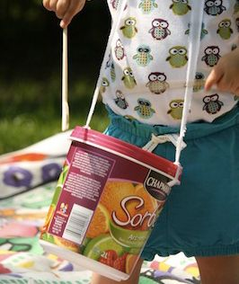
Here are some examples:
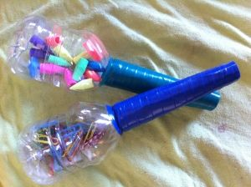
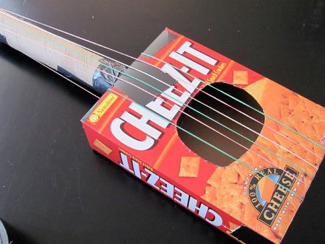

PE task:
Complete this Joe Wicks workout! Can you complete the full 16 minutes? Get your family to join in and add your photos/videos to the Dojo portfolio!

https://www.youtube.com/watch?v=mhHY8mOQ5eo

