Wednesday
Writing task:
Today you are going to continue with your plan for your pirate adventure story.
Task:
Create a plan to help you write your story.
Will you make your story into a book? A zigzag book? A story in a bottle?

beginning | next | middle | end
What will happen at the start of your story? | What will happen next? How will they travel to the next setting? | What will your character do? Make sure this is exciting!! | How will the story end? Will your character go back home?

Daisy challenge: Draw pictures to represent each box

Reading / phonics task:

Task
This week in our spellings we are looking at the soft c and g sounds. When next to i, e, y or in the middle of a split digraph c makes a ‘s’ sound and g makes a ‘j’ sound.

Fill in the blanks of these words with either c or g and blend them. Can you draw a picture of what the word is?
soft g | soft c
_em | ra_e
ma_ic | i_e
ca_e | _ircus
_iraffe | prin_ess
_iant | pen_il

Daisy challenge: pick 2 words from each side and write sentences using them

Maths task:
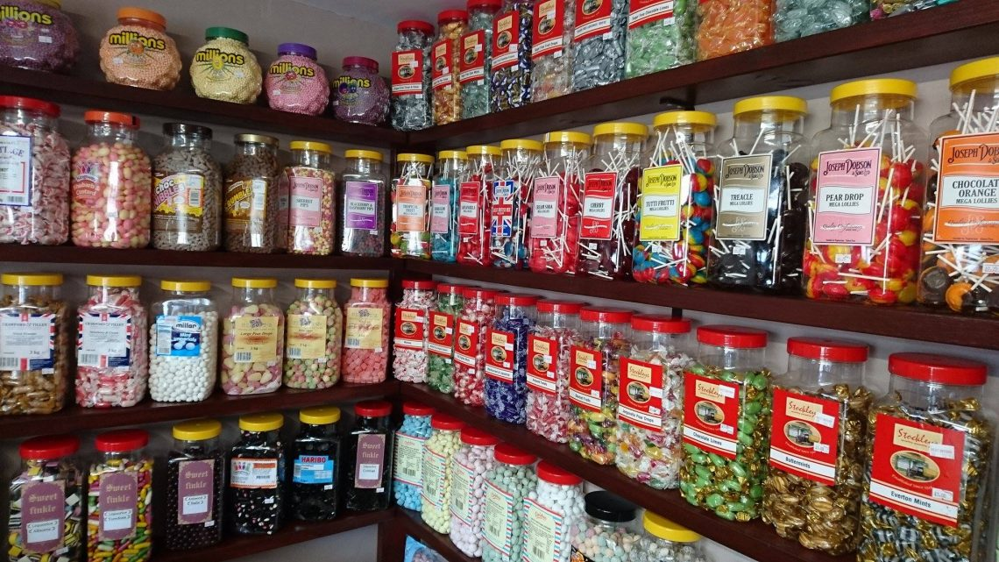
Welcome to the 5p sweet shop! Every sweet in the shop costs 5p.

Task:
Each child wants to know how much their bag of sweets will cost. Use objects or a 100 square to work out how much each bag will cost.
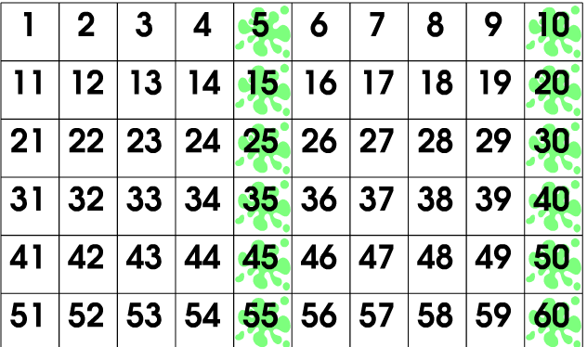
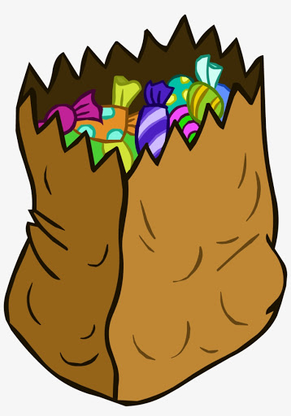How much will 4 sweets cost in total?2 sweets?
5 sweets? 7 sweets?
9 sweets? 11 sweets?
Daisy challenge: now make up your own bag of sweets and get someone else to work out the answer. Check to see if they are correct.
RE:

Today we are going to look at the special building Jewish people pray in. We learnt that Christians go to a special place called church to pray, Jewish people to a special building called a synagogue
Watch this video showing you all the important parts of a synagogue:

https://www.bbc.co.uk/bitesize/clips/z4mxfg8

Using the construction at home can you make a synagogue or a special part of one?

