Tuesday
Writing task:
Today you are going to continue with your plan for your pirate adventure story.
Task:
To create the settings your character will be in your story

Step 1: decide where your character will start.
Step 2: decide what will your character travel in/on.
Step 3: decide where your character will go.
Step 4: draw and write about the settings
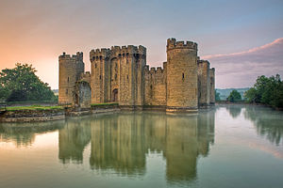
example: my character will live in a beautiful, ancient castle and this is where the night pirates will find him.

Remember:
full stops and capital letters.

Daisy challenge: Use adjectives

Reading / phonics task:

Task
https://www.busythings.co.uk/play/

Play a game of common word makeover. Choose the correct spelling for the word the robot asks for
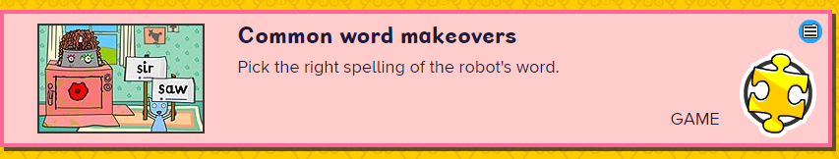
English -> phonics activities -> phase 5 -> further activities -> common word makeovers

Daisy challenge: choose 3 of the words you have heard today and use them in a sentence.

Maths task:
Jog your memory of the 5 times table with our song

https://www.youtube.com/watch?v=uDSWMjtMff4

Task:
Today you are going to be decorating cookies! (not real ones unfortunately)

Each cookie needs to be decorated with 5 sweets - can you work out how many sweets you will need altogether if you were to decorate:

2 cookies 7 cookies 11 cookies

5 cookies 9 cookies 6 cookies
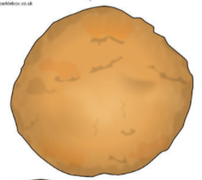

Draw out the amount of cookies you need and either use objects as pretend sweets or draw on your sweets to the cookies to help you

Daisy challenge: Looking at the numbers in the 5 times table, can you find the pattern?

Geography:
Today you are going to have some fun on Google Earth

Task
https://www.google.co.uk/intl/en_uk/earth/
Go onto google earth and choose a landmark which you like the look of most.
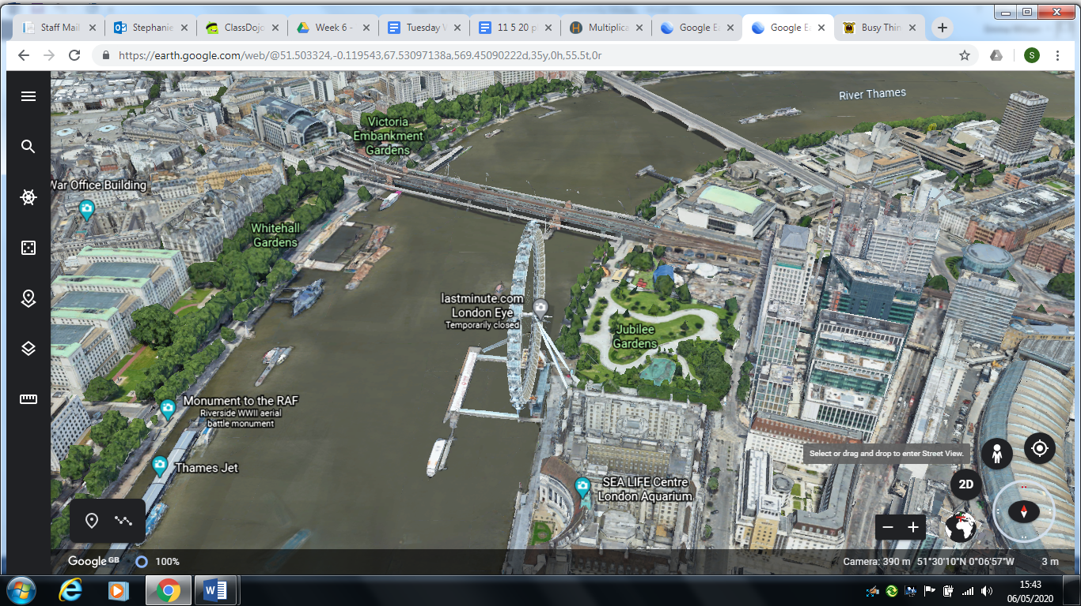
Type it in the search bar.

Once you are at your landmark, pick up the little man on the right hand side of the screen.

Put the man somewhere away from the landmark.
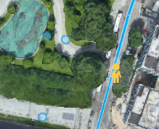
Now help him find his way back to the landmark

Finally write the directions you took to get him back to the landmark go straight
Turn left…

Daisy challenge: Use the compass in the corner to write your directions (go north, south, east, west).

Art:
You are now a fully fledged Night Pirate! Every pirate needs their own treasure chest! Make your own treasure chest to keep all your valuable treasures in. Decorate it with the craft materials available to you and make sure no one but you can get into it!


