Thursday
Writing task:

Task:
It is time to start writing your pirate story! Only write the beginning and some of the middle of the story. Really focus on making the story exciting.

Remember:
Full stops and capital letters.
Adjectives and similes.
Question marks and exclamation marks.
est, er, ed, ing suffixes

Daisy challenge: join your handwriting up.

Reading / phonics task:

Task
Read a book (or two or three) in an unusual place. Take a photo and send it to your teacher.

Maths task:
Have a go at these word problems:
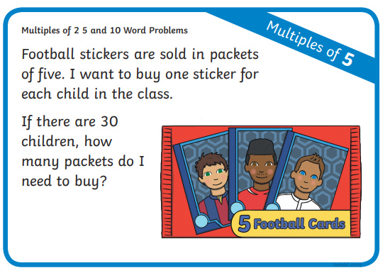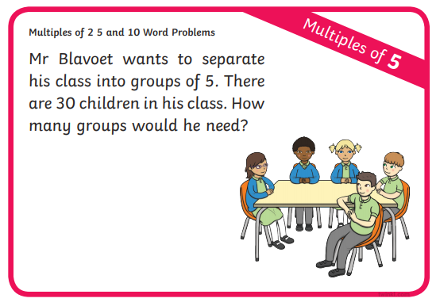
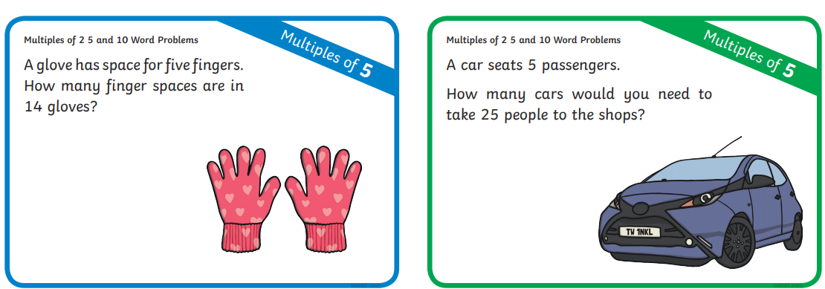
Now write your own word problems!

Daisy challenge: write out the number sentence for your word problems.

History:
Today we are looking at Neil Armstrong and Christopher Columbus
Task
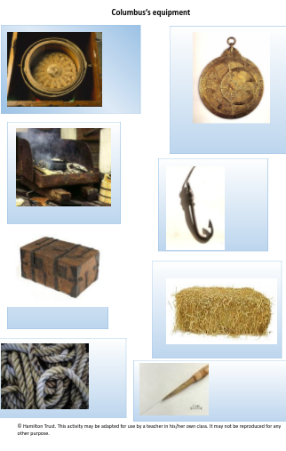
These are the pieces of equipment Neil Armstrong and Christopher Columbus packed on their expeditions:
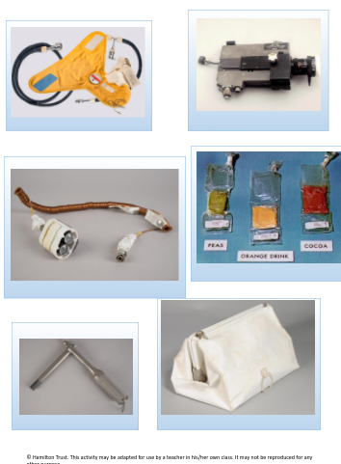
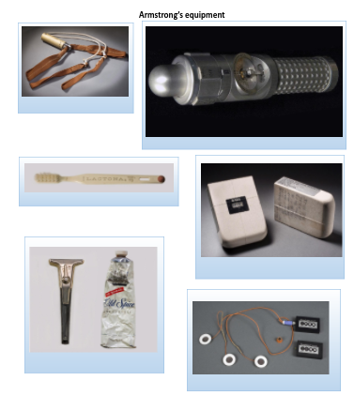
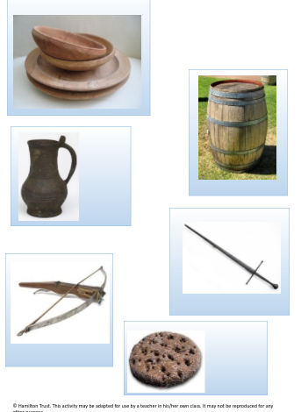

What is different between the 2 packs of equipment and what’s the same?
Think about:
What are the items made of?
Why would they need/not need them?
What are some differences in their expeditions that means they need different equipment?
Which set of equipment is the oldest?

Daisy challenge: Pick an object that you don’t know. What do you think it might be why? Write down your explanation

