Friday
Writing task:

Task:
Today you are going to finish and edit your pirate stories. Don't forget illustrations and check for any writing mistakes.

Remember:
Full stops and capital letters.
Adjectives and similes.
Question marks and exclamation marks.
est, er, ed, ing suffixes

Daisy challenge: join your handwriting up.

Reading / phonics task: Complete today’s reading comprehension
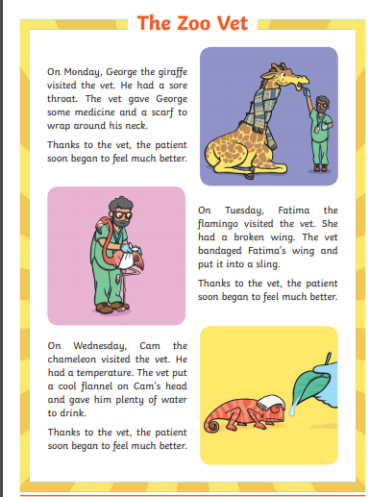
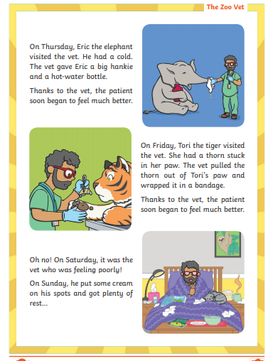

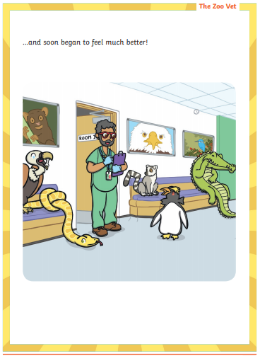
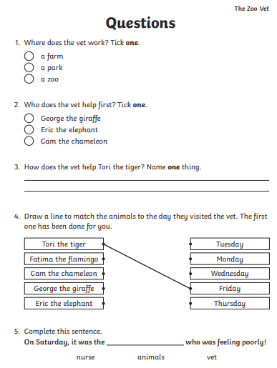

Maths task:
Have a go at these reasoning questions:
These questions will be a little tricky so take your time, use your 100 square, 5 times table and any objects you need to help you work out your answers

Fill in the missing numbers:

0, ? , 10, 15, ?, ?, 30, 35, ?

True or false?
Looking at the number sequence above - I know the next number (after the last question mark) will be 44.

If I carry on the blue sequence, I will say the number 65. Am I right? Explain your answer.

True or False?
If I count in 5s I will say the number 22.

I know the number 15 is in the 5 times tables, so I know it is also in the 10 times table. Am I right? Why/why not?

Daisy challenge: Can you think of your own reasoning question for the class? Send your questions to be shared on the class story!

Computing:
You are going to work on problem solving today.
Task:
Log onto Busy Things-> Computing-> Early Coding and play Puzzling Paths.
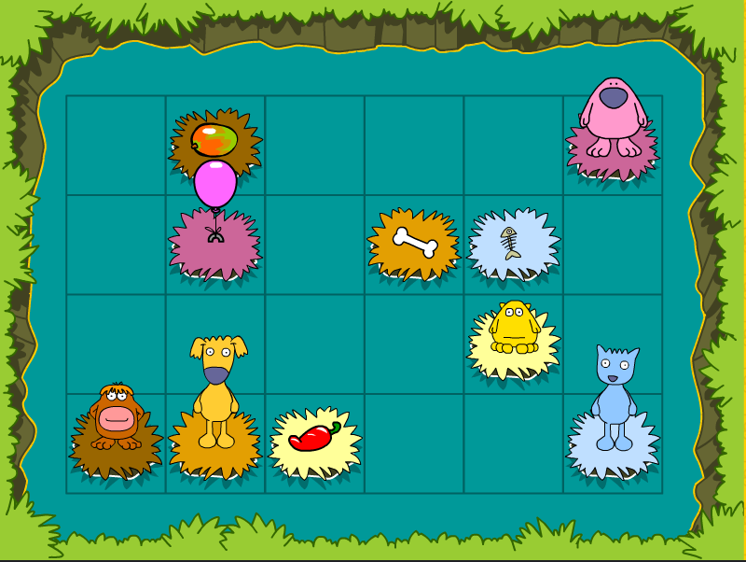
Help each animal find a way to their special object without touching another animal’s path

Daisy challenge: Try Path Peril - help the chicken collect the shapes in order



