Tuesday
Writing task:
The shadows seem to be friendly, we can ask them some questions!
Today you are going to ask some questions to the shadows to find out a little more about them.
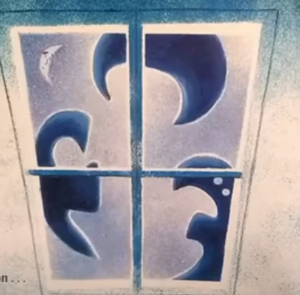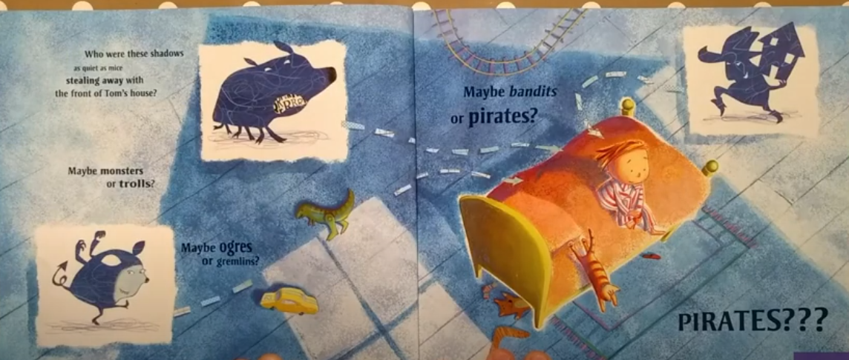

Use these question openers to help:
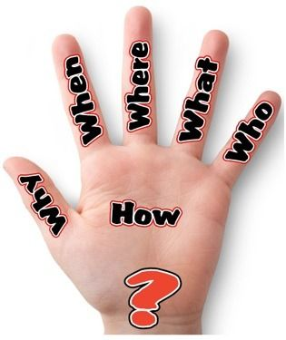

Daisy challenge: use adjectives to make your questions more interesting.

Reading task:
Can you spot the words with digraphs in books, newspapers or any other reading material you have? Colour in the digraphs/write them down and add in sound buttons.

Daisy challenge: Are there any words you don’t know? With an adult's permission why not look up what they mean? Can you write a sentence with this word in?

Maths task:

Today you are going to be adding 11 to numbers.
This time as you add 10, move one square to the left so you add 11. What is the new total?
Have a go at adding 11p to the cakes below. Can you write the number sentence?

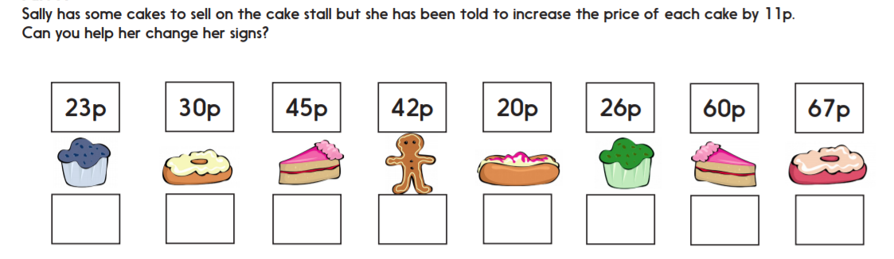

Task:
Daisy challenge: play this game and take it in turns to get points. First person to get 5 points is the winner.

I’m thinking of a number on this 100 square. I add 11 and end up here. Point to number. Where did I start?
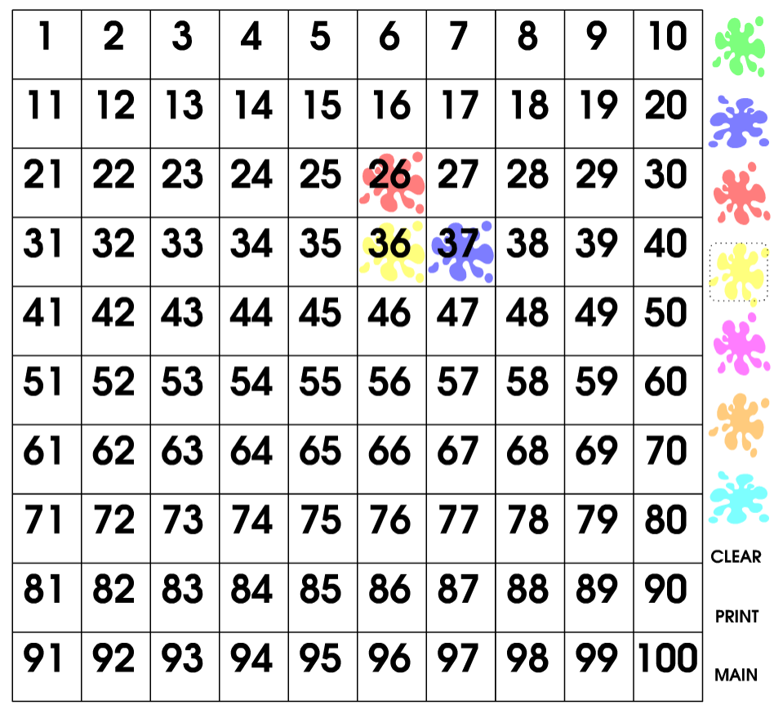
History:
This week we are going to look at landmarks, these are buildings/statues which help you recognise a certain place and are well-known. People visit different countries to look at their landmarks!
Can you research a landmark that you find interesting and find out some facts about it? Use the Kiddle website to help you look for information

Here are some landmark examples:

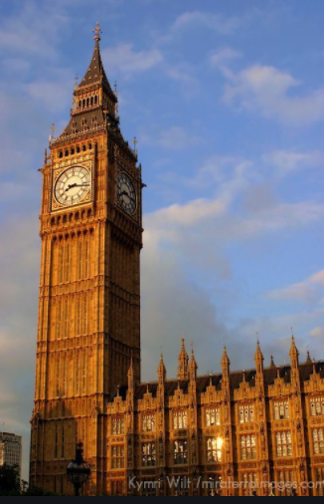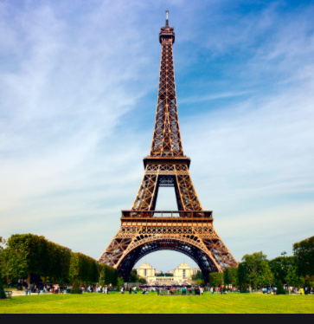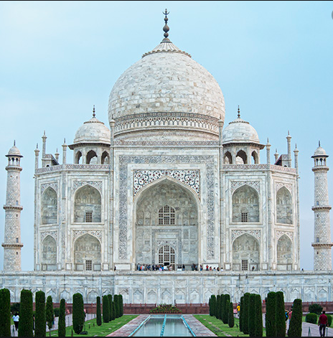
Big Ben, UK The Eiffel Tower, France The Taj Mahal, India

