Monday
Writing task:
We are starting a new book this half term but we are keeping the title a surprise!
We want you to have a go at writing what you think these shadows could be and what they could be doing:
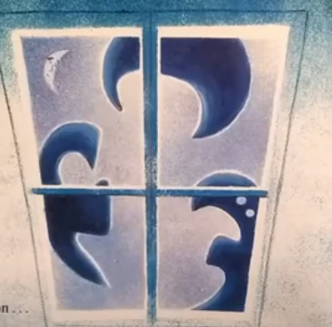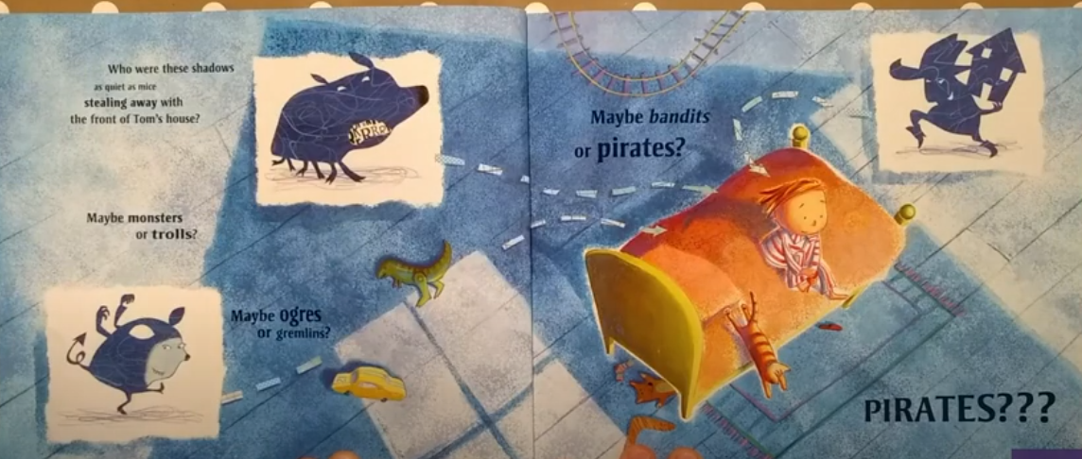

Use these sentence starters to help if you are stuck:
I think it could be… because…
The dark shadow with the teeth is a…
I predict…
If it is a … then it could have…
The ___ shadow might want to…
When the boy sees the shadow it will…

Daisy challenge: use the conjunctions ‘because’, ‘and’ and ‘but’ to make your sentences longer.

Reading task:
Pairs game.
Have a go at this pairs game on phonics bloom.
https://www.phonicsbloom.com/uk/game/word-pairs?phase=4

Alternatively, make your own pairs game using the year 1 common exception words which are on Class Dojo.
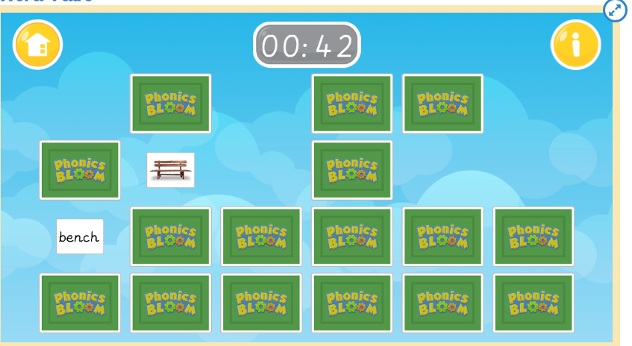

Maths task:
We are going to learn to add more than one 10 to a number. Pick a number (or have your adult pick you a number) between 1-50. Roll a dice, this is how many 10s you’re going to add (e.g 3 = 30). Use your splat square to help you add your 10s to your number & write out your number sentence e.g. 34+30 = 64
Remember when you add 10 you don’t need to count along, move down on your 100 square
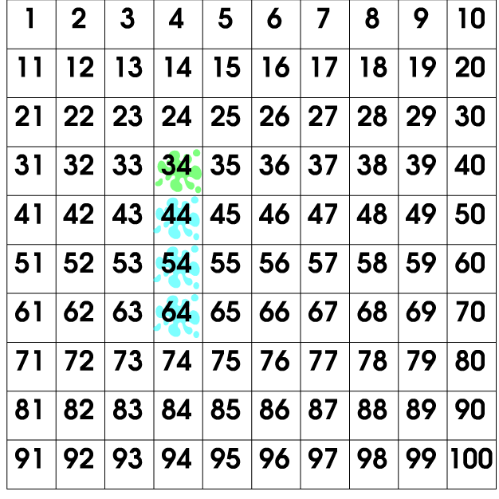

Task:
Daisy challenge: have a go at working out how many 10’s should be where the ? is.

11 + ? = 31
42 + ? = 72
27 + ? = 67
83 + ? = 93
55 + ? = 75
46 + ? = 76

Music:
Listen to your favourite song. Which instruments can you hear? Find out what that instrument looks like. What does your instrument sound like when it is played without the music?

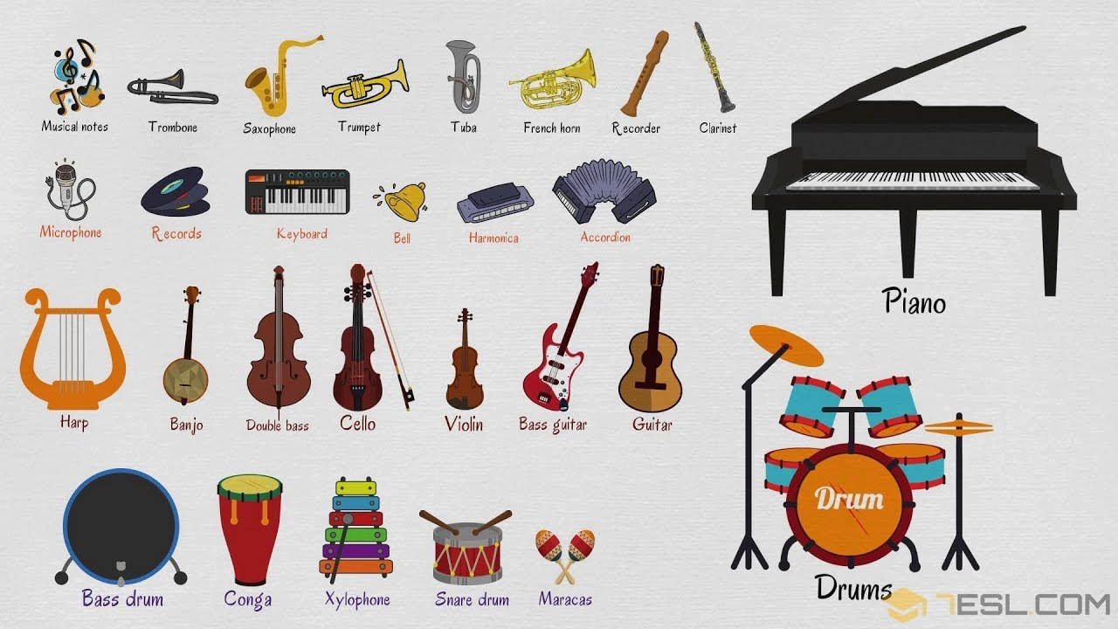

PE:
You are going to make up your own dance routine to your favourite song. You could use your teddies/ toys to make your dance routine exciting or even someone in your family!

If you already know a dance routine, why not have a go at doing that to your favourite song.

