Friday 12th June
Remember –Hive games today for our spellings on Spelling Shed.
1st code posted at 9:45am for a 10am start.
2nd code posted at 11:45am for a 12pm start.
Both games will have the same spellings.

Reading Activity
Read this Cautionary Tale by Hilaire Belloc.
George, who Played with Dangerous Toys
When George’s Grandmamma was told
That George had been as good as gold,
She promised in the afternoon
To buy him an Immense BALLOON.
And so she did; but when it came,
It got into the candle flame,
And being of a dangerous sort
Exploded with a loud report!
The lights went out! The windows broke!
The room was filled with reeking smoke.
And in the darkness, shrieks and yells
Were mingled with electric bells,
And falling masonry and groans,
And crunching, as of broken bones,
And dreadful shrieks, when, worst of all,
The house itself began to fall!
It tottered, shuddering to and fro,
Then crashed into the street below -
Which happened to be Savile Row.
When help arrived, among the dead
Were Cousin Mary, Little Fred,
The Footmen (both of them), the Groom,
The man that cleaned the Billiard-Room,
The Chaplain, and the Still-Room Maid.
And I am dreadfully afraid
That Monsieur Champignon, the Chef,
Will now be permanently deaf -
And both his aides are much the same;
While George, who was in part to blame,
Received, you will regret to hear,
A nasty lump behind the ear.

You can also hear it being read here: https://www.youtube.com/watch?v=oHdAhH1WcH0

Questions:
- Why did George receive a balloon from his Grandmamma?
- How did the balloon pop?
- What happened when the balloon popped?
- Where is Savile Row?
- What happened to the chef?
- What is a ‘nasty lump behind the ear’?
- Do you think a balloon is a dangerous toy?

Writing Activity
Over the past week, we have read 4 different Hilaire Belloc Cautionary Tales. We’ve read about Jim, Matilda, Rebecca and George. Fill in the table below with details of what happened to each child.

Child’s Name | What did they do? | What happened? | Moral of the tale

Choose one character and write an alternative ending for them, it does not have to be in the style of Hilaire Belloc. Think about the moral of the story and what would have happened if the right choice was made.

Maths Activities
Please sing along to the 4 times table song!
https://www.youtube.com/watch?v=_fddxui9y0U

Watch this BBC video as a recap of 3D shapes. There is also a quiz and game for you to play.
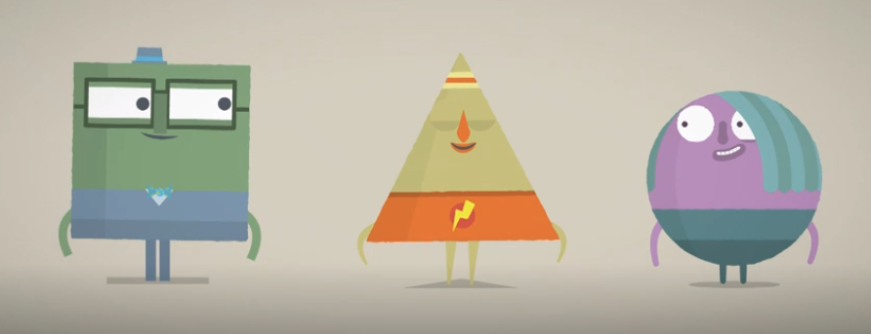
https://www.bbc.co.uk/bitesize/topics/zjv39j6/articles/zcsjqty

Write the name and properties of the 3D shapes below.
Name of shape, number of vertices, faces and edges.
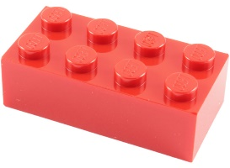

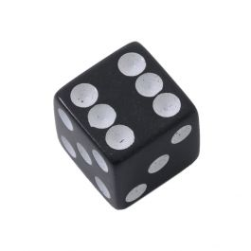

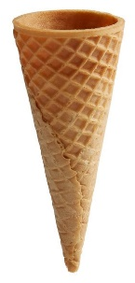
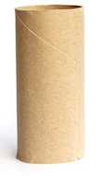

Afternoon Activity
Here is the picture news for this week, with the question: How important is it to have a routine?
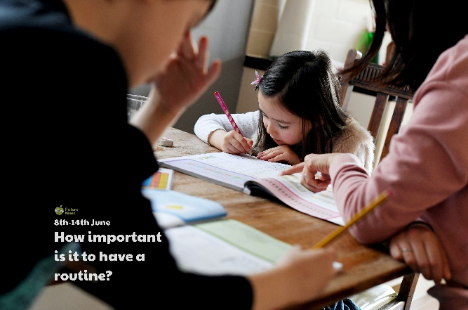

A routine is a sequence of actions followed regularly, like brushing your teeth mouthwash floss
Activity:
Create a timetable for a typical weekday before lockdown and a typical weekday during lockdown. Compare the two timetables. Which timetable do you prefer? Does one have more routine than the other?

Joke for the day
What did zero say to eight?

Nice belt!


