Thursday 11th June
Remember – Keep playing Spelling Shed!
Hive Games tomorrow.
1st code at 9:45am for a 10am game.
2nd code at 11:45am for a 12pm game.

Reading Activity
Continue with your Reading Bingo card! Only today and tomorrow left, see how many squares you can cross off!
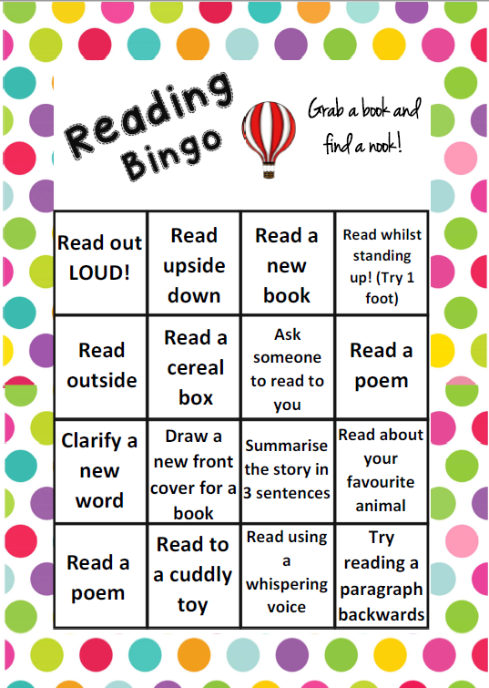

PE
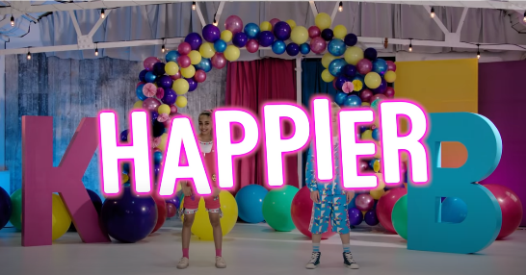
Today, we would usually have PE. Continue with your own workouts or you might like to dance along to Happier. Thank you for the idea Phoebe!
Happier by Kidz Bop.
https://www.youtube.com/watch?v=JaK0Vrkzu80

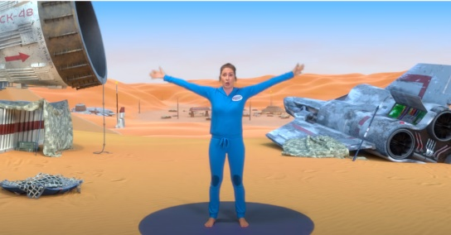
Or you could try Yoga this week.
Star Wars themed.
https://www.youtube.com/watch?v=coC0eUSm-pc

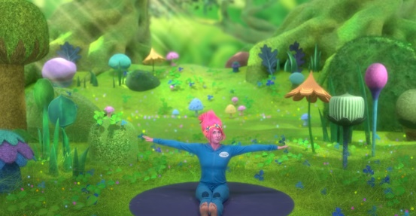
Trolls themed.
https://www.youtube.com/watch?v=U9Q6FKF12Qs

Music
We would usually have a music lesson today. As a school, we have links with the Bromley Youth Music Trust (BYMT) who have created music lessons through video.
The video is on Google Classroom, please watch week 6.
If you can’t access the BYMT video, please watch this clip instead:
https://www.youtube.com/watch?v=5idAk316hpY

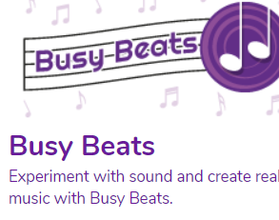
You could also try a new game on PurpleMash called ‘Busy Beats’ to make your own beat, it is lots of fun! We have set this as a 2Do.

Afternoon Activities – Undercover Time Explorer
Step into the shoes of a Tudor servant and go back in time to help prepare a feast of food and drink for Henry VIII in his Tudor Kitchens at Hampton Court Palace. But make sure to avoid being caught as an imposter!
https://www.hrp.org.uk/schools/learning-resources/undercover-time-explorer-tudor-kitchens-game/#gs.7f6gcq

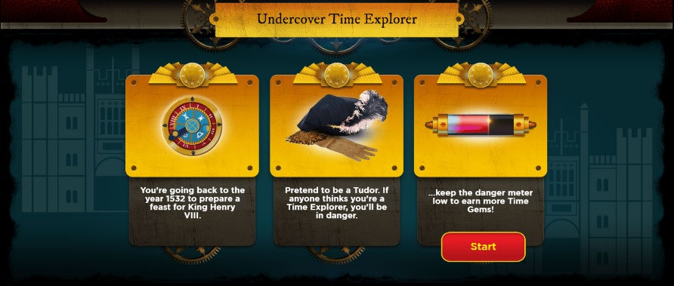

Afternoon Activities – Spanish
This will be our final week on Language Nut so we have assigned you two sentence building activities, for ‘about me’ and ‘where I live’.

Joke for the day
What is small, wobbly and sits in a pram?
A jelly baby!
Thank you for the joke Ronnie!


