Wednesday 10th June
Remember – Keep playing Spelling Shed!
Reading Activity
Read this poem. This could be one of your Bingo squares! Or listen to it here: https://www.youtube.com/watch?v=IWBa_iQDTNY

Rebecca, who slammed doors for fun.

By Hilaire Belloc (The same person who wrote Jim & Matilda)

A trick that everyone abhors
In little girls is slamming doors.
A wealthy banker's little daughter
Who lived in Palace Green, Bayswater
(By name Rebecca Offendort),
Was given to this furious sport.
She would deliberately go
And slam the door like billy-o!
To make her uncle Jacob start.
She was not really bad at heart,
But only rather rude and wild;
She was an aggravating child...
It happened that a marble bust
Of Abraham was standing just
Above the door this little lamb
Had carefully prepared to slam,
And down it came! It knocked her flat!
It laid her out! She looked like that.
Her funeral sermon (which was long
And followed by a sacred song)
Mentioned her virtues, it is true,
But dwelt upon her vices too,
And showed the dreadful end of one
Who goes and slams the door for fun.
The children who were brought to hear
The awful tale from far and near
Were much impressed, and inly swore
They never more would slam the door,
— As often they had done before.

Questions
- What did Rebecca do which she shouldn’t have done?
- Why did Rebecca slam doors?
- What is a marble bust?
- Identify four rhyming couplets.
- How did Rebecca die?
- Clarify the word ‘aggravating’
- What is the moral of the tale?

Writing Activity
Today, we are going to write our tales. Similarly to yesterday, there are two activities. You need to choose the correct one for you.
Activity one – Pete, who ate too many sweets
You don’t need to do this if you are writing your own tale.
To write the tale, you need to remember that each line needs 8 syllables (you can do 7 or 9 but try and stick to this). Try your best to fill in the lines so the words end on the rhyming word. If you are finding this too tricky, then scroll all the way to the end of this document (where the joke is) and there is another activity there.
Pete, who ate too many sweets.
______________________________ Pete.
______________________________ sweets.
______________________________ mates.
______________________________ ate.
______________________________ munch.
______________________________ crunch.
______________________________ saw.
______________________________ jaw.
______________________________ braces.
______________________________ spaces.
Activity two – Your own tale
You don’t need to do this if you are following Pete, who ate too many sweets.
To write the tale, you need to remember that each line needs 8 syllables (you can do 7 or 9 but try and stick to this). Try your best to have a rhyming couplet at the end of every two lines. The rhyming words need to follow on from each other. Remember to start with your title.

Maths Activity
Please sing along to the 4 times table song!
https://www.youtube.com/watch?v=_fddxui9y0U

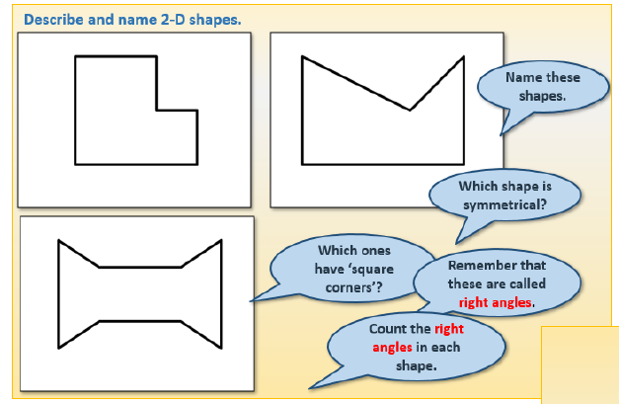
Choose from octagon, hexagon and pentagon. The shapes above are irregular as the sides are not of equal length.

Today, you are going to write clues for each 2D shape based on their properties.

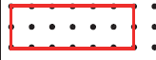
Vertices (corner)

Side
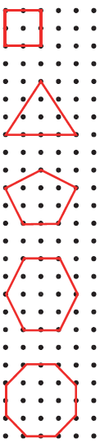

Try to include:
Number of sides
Number of vertices
If it has lines of symmetry

Afternoon Activity- Science
We are currently recapping the first topic of Year 3, which was Animals including Humans. BP have two great resources for you to look at. To access the resources please follow these steps:
- - open the bpES website: bp.com/bpes

- - click on 'Enter a student code' (top right on all pages if you are not logged in)
- - enter the code 84651


After you’ve watched the Heart Rate video, you might like to take part in the activity below:
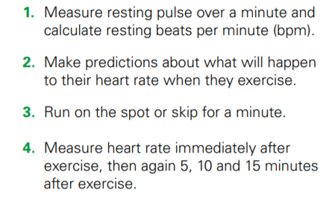

Afternoon Activity- The Queen’s Second Birthday
Elizabeth Alexandra Mary was born on 21st April 1926.
Since her coronation, The Queen has celebrated two birthdays each year. Her actual birthday is in April but her official birthday is usually the second Saturday in June.
The tradition of two royal birthdays was started by George II in 1748. He was born in November and felt that the weather would be too cold for his annual birthday parade on his actual birthday. A solution was to celebrate his birthday again at a warmer time of year and hold the parade on this date.
This became known as the monarch’s official birthday.
The birthday parade is called Trooping the Colour and the tradition still continues today on The Queen’s official birthday in June.
You can watch highlights from Trooping the Colour 2019 below. Please be aware that the comment section of this YouTube video is on so check before your child watches.
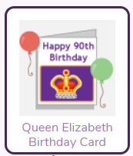
https://www.youtube.com/watch?v=snTubzfk5gQ
You could make a card for the Queen, PurpleMash has a template. It was for her 90th birthday but you can edit the card as she was 90 in 2016. Can you calculate how old she is now?

Joke for the day

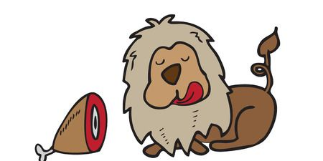
What is a lion’s favourite day of the week?
Chews – day!
Thank you for the joke Ronnie!

Activity three – Pete, who ate too many sweets (easier version)
You don’t need to do this if you’ve already completed activity one or two.
Choose the correct rhyming word to fill in the gap. Remember Hilaire Belloc wrote in rhyming couplets so the rhyming words must follow on from each other.

Pete, who ate too many sweets.
There was a boy whose name was ______
Who used to eat too many ______
He never shared them with his ______
Just stuffed his face and ate and ______
One day Pete was about to ______
When his mouth made an almighty ______
Looking in the mirror, he ______
A toothless gap in his own ______
Where one had been a set of ______
Now was only gummy ______
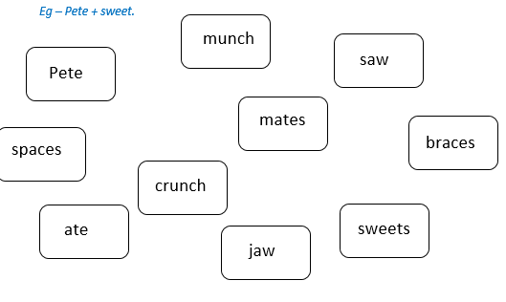
These are the words for you to choose from.

