Tuesday 7th June
Keep playing spelling shed!
Reading Activity
Continue with your Reading Bingo card, remember you may quiz on home books - just like we do at school!
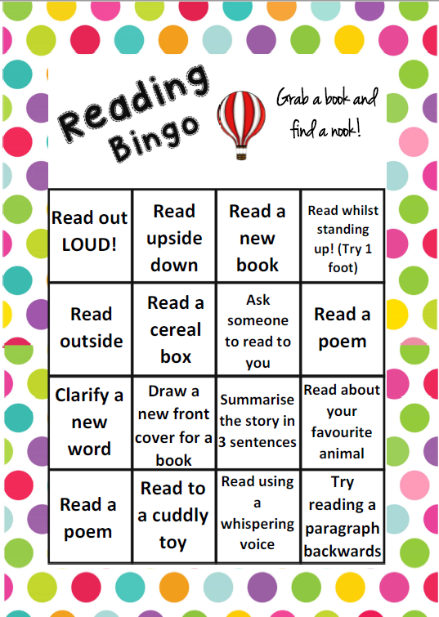
https://ukhosted65.renlearn.co.uk/2240525/

Writing Activity
Today we are going to start thinking of the rhyming couplets for our tale. A rhyming couplet is a pair of words which rhyme continually.
If you are following the class tale called: Pete, who ate too many sweets. Please complete the activity one.
If you are writing your own tale, please complete activity two.

Activity one: Pete, who ate too many sweets
You don’t need to complete this if you are writing your own tale.
Below are the rhyming words which we will use in our tale. Your task is to match the pairing words together by finding the common sound.
Eg – Pete + sweet.
munch
saw
Pete

mates
spaces
braces
crunch

sweets
ate
jaw

Activity two: Writing your own tale
You don’t need to complete this if you are following Pete, who ate too many sweets.
Make a mind map of the words which you might use in your poem as a rhyming couplet. Think of words which are in the same theme as your title.
There is an example below, you can magpie some of these.
share + care
play + away

sad + had (or mad)
Moy, who wouldn’t share her toys
selfish + hellish
alone + moan

Maths Activity
Please sing along to the 4 times table song!
https://www.youtube.com/watch?v=_fddxui9y0U
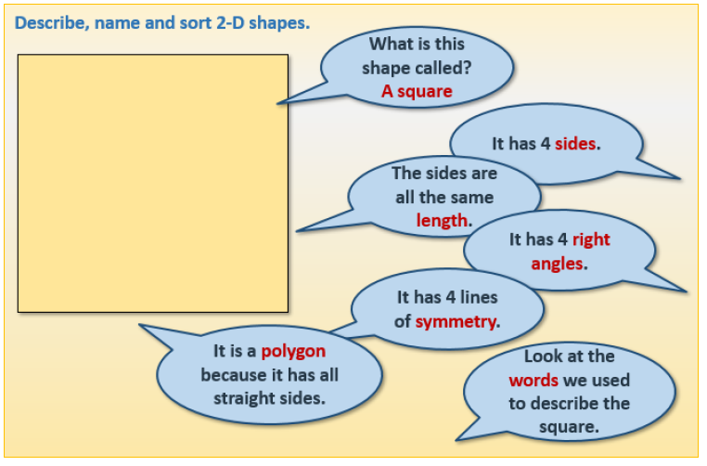

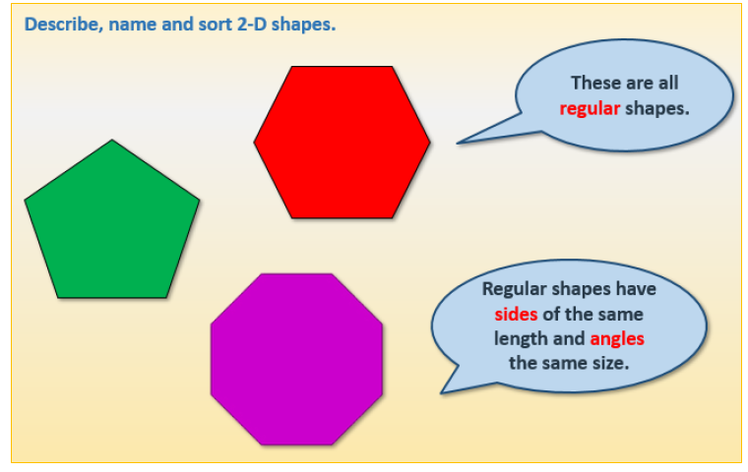

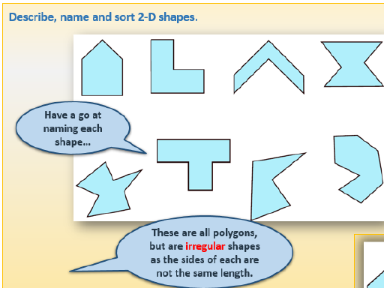

Here are the answers to the question above. These are all irregular (the sides are not the same length) so we would say: an irregular hexagon or an irregular pentagon.
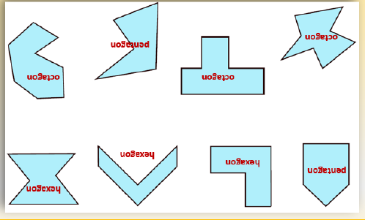

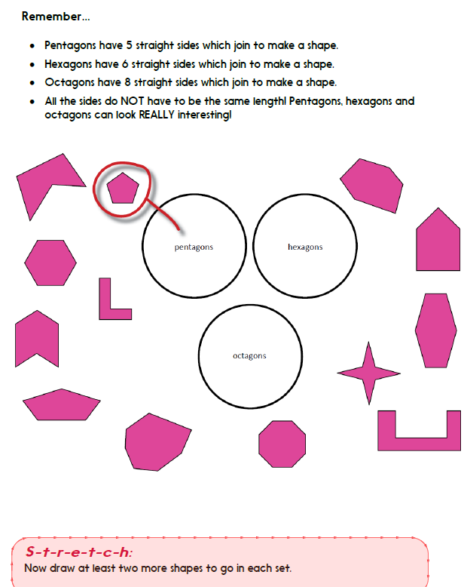

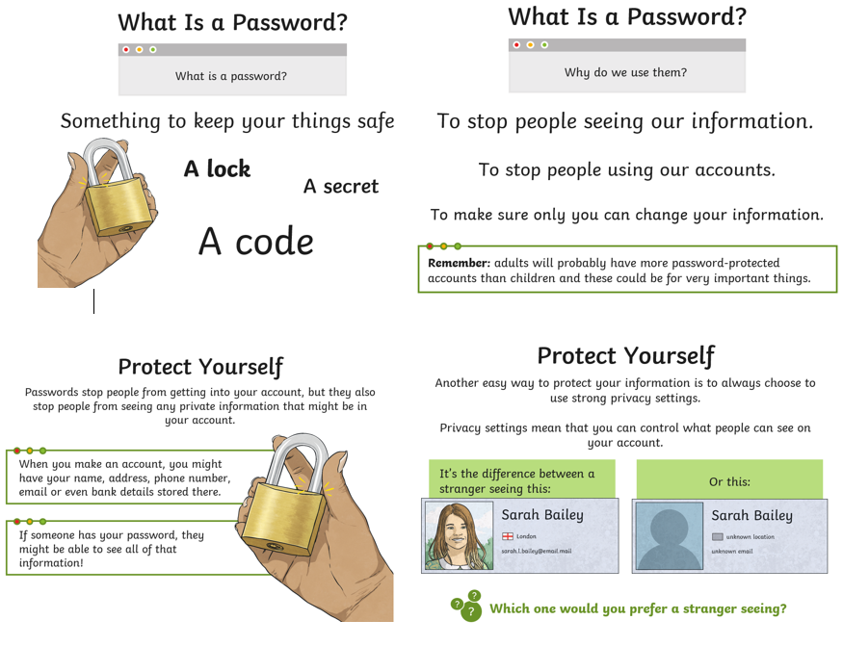
Afternoon Activities
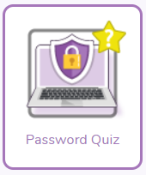
Take this password quiz on PurpleMash to test your knowledge on how to create a safe password.

Play ‘Tower of Secrets’ in Interland https://beinternetawesome.withgoogle.com/en_uk/interland/landing/tower-of-treasure


Joke for the day

What kind of music do mummies listen to?

Wrap music!


