Friday 5th June
Remember – We are going to attempt a Hive game today for our spellings on Spelling Shed.
1st code posted at 9:45am for a 10am start.
2nd code posted at 11:45am for a 12pm start.
Both games will have the same spellings.

Reading Activity
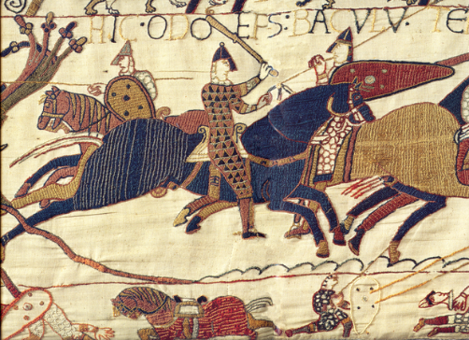
Read this information about Bayeux Tapestry.
The tapestry tells the story of the Norman conquest of England. The two combatants are the Anglo-Saxon English, led by Harold Godwinson, recently crowned as King of England, and the Normans, led by William the Conqueror.
The tapestry is regarded as one of the greatest examples of Anglo-Saxon art, because, though ordered by a Norman, it was made by English (Anglo-Saxon) artisans. It is also extremely important as a historical document.
The main yarn colours are terracotta or russet, blue-green, dull gold, olive green, and blue, with small amounts of dark blue or black and sage green.
You may also find this video interesting:
https://www.bbc.co.uk/news/av/uk-42736514/bayeux-tapestry-explained-by-kids
If you would like to, please complete the fact file about Bayeux Tapestry on Purple Mash. You might like to research this further.

Writing Activity
This week, we read Jim: A Cautionary Tale by Hilaire Belloc. He wrote many famous cautionary tales, we are going to read another one today.

Matilda who told lies
Matilda told such Dreadful Lies,
It made one Gasp and Stretch one's Eyes;
Her Aunt, who, from her Earliest Youth,
Had kept a Strict Regard for Truth,
Attempted to Believe Matilda:
The effort very nearly killed her,
And would have done so, had not She
Discovered this Infirmity.
For once, towards the Close of Day,
Matilda, growing tired of play,
And finding she was left alone,
Went tiptoe to the Telephone
And summoned the Immediate Aid
Of London's Noble Fire-Brigade.
Within an hour the Gallant Band
Were pouring in on every hand,
From Putney, Hackney Downs, and Bow.
With Courage high and Hearts a-glow,
They galloped, roaring through the Town,
'Matilda's House is Burning Down!'
Inspired by British Cheers and Loud
Proceeding from the Frenzied Crowd,
They ran their ladders through a score
Of windows on the Ball Room Floor;
And took Peculiar Pains to Souse
The Pictures up and down the House,
Until Matilda's Aunt succeeded
In showing them they were not needed;
And even then she had to pay
To get the Men to go away,

Hilarire Belloc usually uses 8 syllables in each line. Clap along to check this.

This is not the ending of the poem, we would like you to predict what is going to happen to Matilda. If you are unsure, think about the cautionary tale of ‘The Boy who Cried Wolf’ as there may be some similarities.

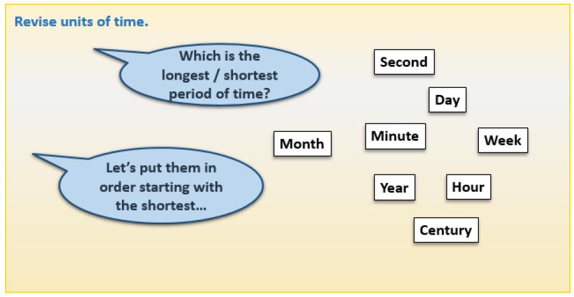
Maths Activities

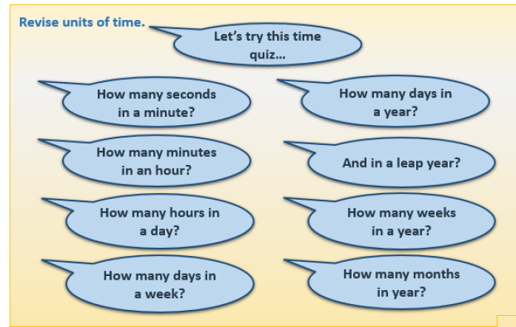

- How many minutes in 2 hours?
- How many months in 1 year and a half?
- How many days in 3 weeks?
- How many days in October?
- How many days in February in a leap year?
- How many seconds in 2 minutes?
- How many days in a leap year?
- How many hours in a week?
- How many days in August and March altogether?
- How many days in June?
Afternoon Activities – Bayeux Tapestry.
Please complete the 2Do on Purple Mash to draw your own Bayeux Tapestry.


Joke for the day
Where do cows go for entertainment?


To the moo-vies!

